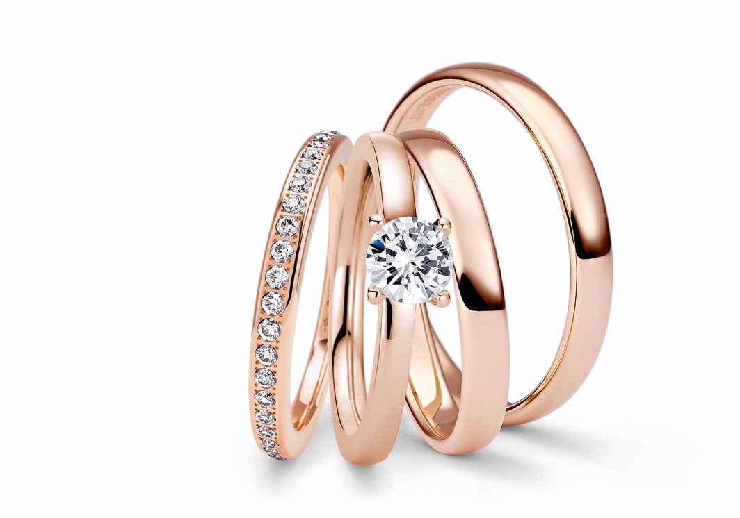

THE NIESSING BRIDAL COSMOS

NIESSING ENGAGEMENT RINGS AND WEDDING RINGS: WHAT IS THE COLOR OF YOUR LOVE?

TABLE OF CONTENTS

3 THE NIESSING BRIDAL COSMOS

What is the Color of your Love?

Straight tot he Heart

6 NIESSING ENGAGEMENT RINGS

5 Steps to the Perfect Engagement Ring

The Ring for the Most Wonderful Vow: The Niessing Spannring®

and Classic Engagement Rings

8 NIESSING WEDDING RINGS

The Niessing Wedding Ring Configurator: 6 Steps to the Perfect

Wedding Ring

Love Story Rings – Wedding Rings with a Story

10 NIESSING MEMORY RINGS

Precious Memories – Held for Eternity

12 NIESSING LOVE WALL

The Guest Book for Eternity

13 SUSTAINABILITY AND OUR COMPANY CULTUR

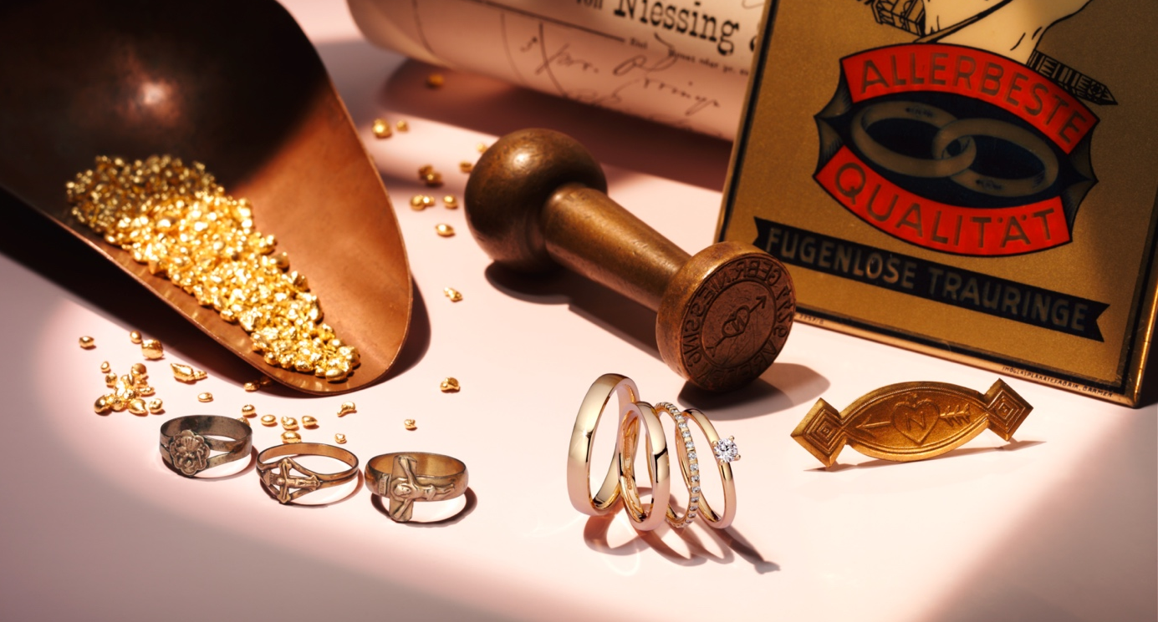

THE NIESSING BRIDAL COSMOS

WHAT IS THE COLOR OF YOUR LOVE?

What is the color of your love? Or do two or three provide the right harmony? Only Niessing has so many extraordinary gold colors: luminous rosé gold with a heart of platinum; gold, soft and warm as sand or softly shimmering gray; gold, as red as only gold can be, or with a subtle hint of green. The color flows of Niessing aura® and Solaris are unique as well: a cool, reddish-gray horizon in the morning or a glowing red sunset in the evening – which world of color reflects your love?

The symbols of love are not merely worn on the hand. They are worn above all in the heart. And the Niessing Colors go straight to the heart!

STRAIGHT TO THE HEART
»Will you marry me?« It’s the most beautiful of all questions. It’s also a very special moment in the lives of two people. An engagement ring gives this decisive step something lasting, and it becomes the symbol of a great vow.

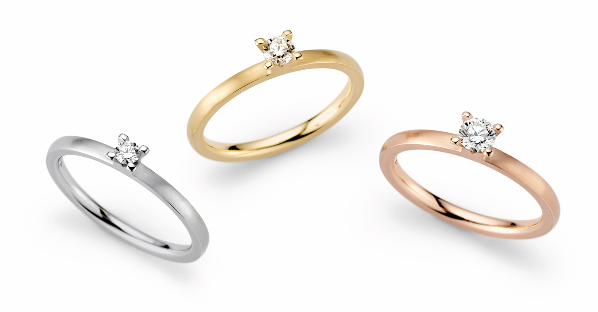

NIESSING ENGAGEMENT RINGS
FROM DAINTY TO OPULENT
A Niessing Spannring® is the contemporary form of this symbol. Its sleek design makes it the diamond solitaire of the modern age. The diamond is held in the ring without any setting: It appears to float above the hand. And the Niessing Bridal Cosmos also offers classic engagement solitaires: they all focus on the sparkling engagement diamond. And all of them later become the perfect companion for a Niessing wedding ring.

NIESSING WEDDING RINGS: TIMELESS, FOR ETERNITY – A PROMISE!
Since time immemorial, wedding rings have been the symbol of commitment and love. In the 1950s, Niessing created the most beautiful symbol of marriage with the seamless wedding ring: a ring with neither a beginning nor an end, as endless as love itself.

Today, every couple can find the right rings for two personalities at Niessing – and the perfect symbol for the one, true love. With the Niessing Wedding Ring Configurator, wedding rings can be designed intuitively and according to personal wishes and requirements. Alternatively, the Niessing Love Story Rings can be selected to create a unique tribute to a personal love story:

»MADE WITH LOVE« FOR LOVERS
Designers and goldsmiths work hand in hand at Niessing to ensure that lovers find the engagement rings and the wedding rings that perfectly suit them and tell their individual story. For 150 years, each and every Niessing ring is »made with love – made in Germany«. And every one of them bears the »Heart and Arrow« Niessing punch mark, stamped by hand and a sign of the original.

NIESSING ENGAGEMENT RINGS

5 STEPS TO THE PERFECT ENGAGEMENT RING

Which shape and design best matches the personality of your most beloved? Does Niessing Platinum compliment the skin tone – or perhaps one of the numerous, unrivaled Niessing Gold Colors? It takes 5 steps for lovers to find the very engagement ring that will crown the love of their lives.

1 NIESSING COLORS: WHAT IS THE COLOR OF YOUR LOVE?
Which precious metal will embrace and hold your diamond? Which gold color is in tune with your favorite diamond, with your complexion, and with your personality? The extraordinary Niessing Colors offer fascinating gold colors as well as moon white platinum.

2 TEXTURE: GLOSS OR MATT?
The texture and finish of the precious metal further distinguishes the Niessing engagement ring. The finish Gloss turns the ring into an entrancing mirror of gold or platinum. Matt textures, such as Satin, Velvet, or Nature, perfectly highlight form and color.

3 FORM: CLASSIC OR MODERN?
Which form reflects your individuality and your love? Is it an engagement ring with a classic diamond setting or a Niessing Spannring® design icon? At Niessing, there is a form that follows your feelings!

4 DIAMOND: AS UNIQUE AS YOUR LOVE
Diamonds are as unique as your love. What size should your engagement diamond have? Do you love bright white or do you prefer a naturally colored diamond? When making a selection, the »4C« – Cut, Color, Clarity, Carat – and the fifth feature Confidence, Trust, provide a reliable guide.

5 ENGRAVING: WHAT IS YOUR MESSAGE OF LOVE?
Life will leave traces – imprint them onto your ring! Tender words, a drawing, a fingerprint... A message written into your Niessing engagement ring by laser, diamond, or manual engraving is inscribed for eternity.

NIESSING ENGAGEMENT RINGS

THE RING FOR THE MOST WONDERFUL VLOW

Sweet Memories: Every glance at the engagement ring, every flash of the precious diamond, is a reminder of love‘s most beautiful vow. A Niessing engagement ring is not merely worn on the hand – you also wear it in your heart!

THE MODERN ENGAGEMENT RING
The design icon Niessing Spannring® is the diamond solitaire of the modern age – and a unique symbol of the most wonderful vow that can be made by two people. The diamond is held in the ring without any setting, and it appears to float above the hand. It is held securely and has the greatest possible freedom – the perfect symbiosis. It is also a wonderful symbol for the beginning of a harmonious and exciting relationship.

More than 40 years after Niessing developed the first Spannring, there are now a wide variety of models: delicate or lavish, dainty or magnificent, softly curved or architecturally clear. Which Niessing Spannring® should be the one to mark the wonderful vow?

CLASSIC ENGAGEMENT RINGS: INSPIRED BY LOVE
Niessing offers a wealth of classic solitaires that focus on the sparkling engagement diamond. The design of Niessing Amatis, for example, is inspired by love: it embraces the diamond with four or six prong elements: It is a timeless beauty and the embodiment of romance.

Or is Niessing Princess the right choice? The magnificent diamond is set almost invisibly in this engagement ring: »Princess for my princess!« Niessing Lily makes the precious diamond float like a drop of water on the tenderly opened leaves of a water lily. Niessing Stella encloses it protectively on all sides – and Niessing Lotus holds the diamond up powerfully like a bursting bud.

Whether modern or classic, dainty or opulent: Niessing offers the perfect engagement ring for every personality.

NIESSING WEDDING RINGS

THE NIESSING WEDDING RING CONFIGURATOR
6 STEPS TO THE PERFECT WEDDING RING

The Niessing Wedding Ring Configurator at niessing.com makes it easy to discover the most beautiful wedding rings: You can intuitively play with shapes, colors, and surfaces – then, with a click of the mouse, experience how sparkling diamonds make the wedding ring shine even more intensely. The Niessing Wedding Ring Configurator brings lovers closer to their personal ideal in 6 easy steps.

1 NIESSING COLORS: WHAT IS THE COLOR OF YOUR LOVE?
The Niessing Colors are absolutely distinctive: gold as warmly shimmering as sea sand or as red as a sunrise. Gold with a touch of soft Rosewood, delicate Ivory, or fresh Green; pure gold in rich yellow, or platinum in radiant white. Whether Grenadine, Rosewood, Ivory, Sand Gray, or Fine Rose – the Niessing Colors shine straight to the heart. The color flows of Niessing aura® and Solaris are also unique worldwide: A cool, reddish-gray horizon in the morning or a glowing red sunset in the evening – which world of color reflects your love?

2 TEXTURE: GLOSS OR MATT?
One ring is highly polished; the other shimmers like velvet. The one finished in Gloss is like a mirror, whereas Matte finishes such as Velvet, Nature or Satin perfectly highlight form and color. Whatever the decision: The time spent together leaves the most beautiful impressions, and only they make the ring a personal symbol of love.

3 FORM: SOFT OR CLEAR?
Which form follows your feelings and suits your personality? Round, curved, geometrically clear, or natural, soft and gentle? Just try it out, wear it and feel how much difference there can be.

4 WIDTH: DELICATE OR POWERFUL?
Should the wedding ring reflect understatement or make a bold impression? Depending on the width, the same shape can appear very delicate or extremely powerful. We make a Niessing wedding ring with ideal proportions for every hand – and for every personality.

5 DIAMOND: A SPOT OF LIGHT OR A STARRY SKY?
Sometimes the precious metal surrounds a single diamond, sometimes tiny points of light are scattered across the entire wedding ring. Their sparkle is always eye-catching ... Life provides many occasions to celebrate love. And only a diamond is equally everlasting.

6 ENGRAVING: WHAT IS YOUR MESSAGE OF LOVE?
What lovers have to say to each other is remarkable. So few words; so much feeling. How should such a tender message be delivered? In your own handwriting? With a drawing or a fingerprint? An individual engraving expresses one‘s innermost feelings.

LOVE STORY RINGS – WEDDING RINGS WITH A STORY

Niessing helps lovers discover their own personal love story and find the wedding rings that perfectly express great emotions. Happiness is where hearts are open …

THE INTENSE ADVENTURE OF LOVE
Niessing Performance Color is such a love story classic: the strong inner core of White Gray gold provides the wedding ring with its foundation – the fine skin of gold in a variety of Niessing Colors gives it the freedom to be shaped. The soft exterior captures memories, the great moments of a heartfelt love. Performance is a wedding ring as a symbol of the intense adventure of love somewhere between security and freedom, between togetherness and individuality.

ROMANTIC AND FROM THE HEART
Or Niessing Art Déco: The wedding ring combines clear Bauhaus-inspired design with the playful decorativeness of Art Deco. The simple, oval-shaped wedding ring is lined with a fine ornamental band, as if the ring were decorated with a thousand tiny pearls: delicate and romantic. Niessing Heart hides what is probably the oldest symbol of love in a ring – and only lovers know the secret: the cross-section of their wedding rings is shaped like a heart. If you wish, you can add a sparkling accent with a small diamond in the ring‘s fugue, a sign of a pure heart.

THE MOST BEAUTIFUL TRACES OF LOVE
When two meet, something new is created. Such is the case with Niessing Traces of Love: each diamond is hand-driven into the precious metal by expert goldsmiths, thereby leaving behind a fascinating trace.
No two rings are alike; each is as individual as the lovers themselves.

OPPOSITES ATTRACT
The luminous, rich gold and cool, luxurious platinum of Niessing Tango form an intimate, unbreakable bond. Should the warm gold be facing the body or should it be the cool platinum? Who gives support? Who gives protection? Will both lovers give the same answer to these questions?
Or perhaps the appeal is in the wedding ring retaining one‘s individuality and emphasize one‘s own personality: Then one ring can be platinum on the outside, and gold on the inside – the other ring vice versa.

With these and many other Niessing Love Story Rings, couples fall in love over and over again with their personal love story.

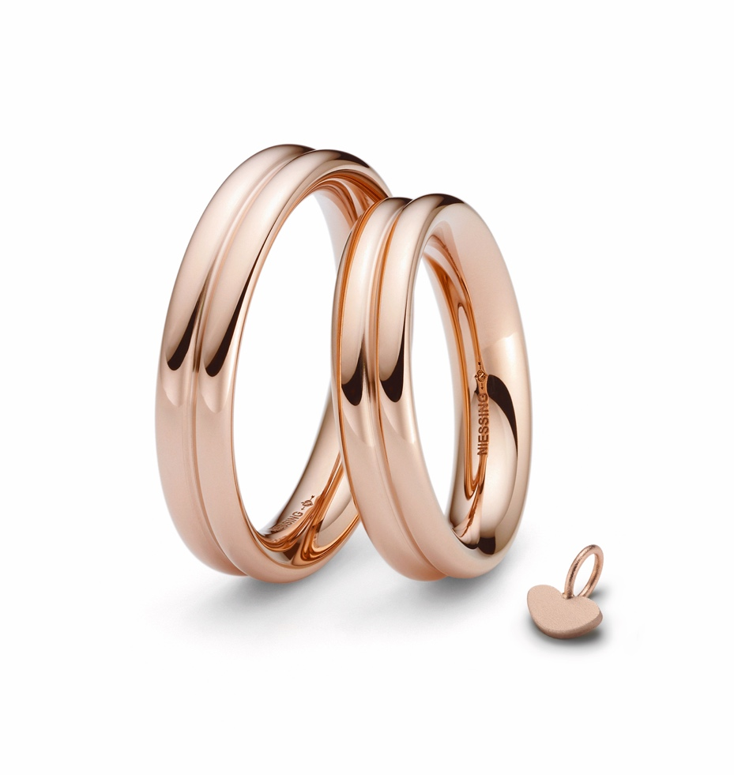

NIESSING MEMORY RINGS

PRECIOUS MEMORIES – HELD FOR ETERNITY

Life is full of precious memories: your wedding day, the birth of your first child, your own home … a Niessing Memory Ring turns each of them into a sparkling souvenir.

MAGNIFICIENT SOLOIST AND PERFECT COMPANY
It is a wonderfully proportioned master of adaptability as well. It nestles alongside its neighbor, the Niessing wedding ring: the perfect companion for every day and for a lifetime. As a jewelry ring, Memory is fully set – or it can grow to suit your own imagination. It also preserves the story of your shared life for eternity.

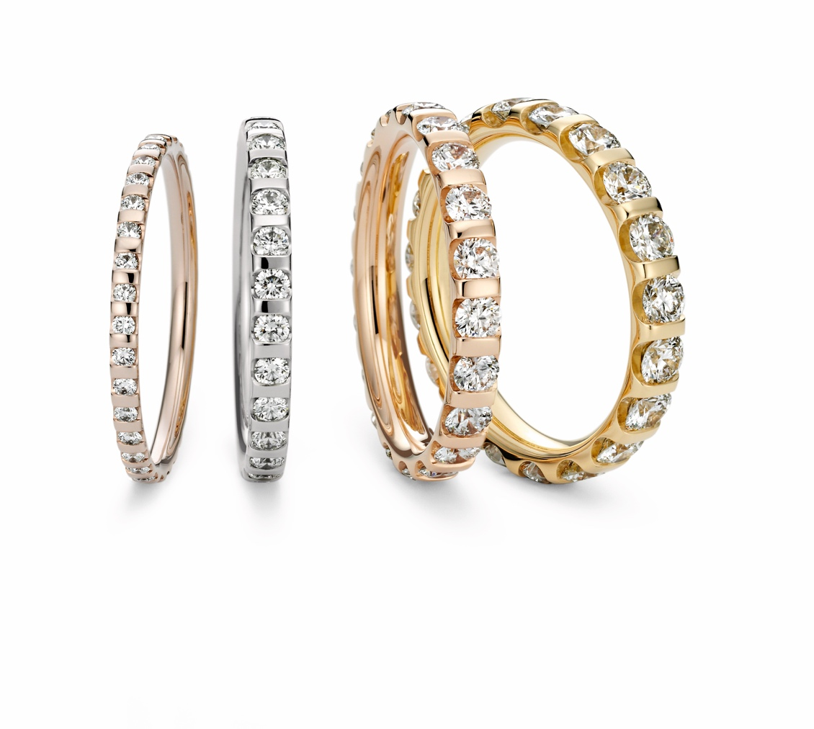

DIAMONDS IN ORBIT
Niessing Satellite sends diamonds into their orbit: the Satellite wedding ring seems as if it is made entirely of diamonds; it is crafted to be as narrow as possible, and the close proximity of the diamonds is almost revolutionary. Satellite Curves is wedding ring as well as the perfect companion for a Niessing Spannring® or an engagement ring such as the Niessing Princess. Satellite Orbit is a wedding ring and a jewelry ring that nestles perfectly against a Niessing engagement ring. Should the diamonds sparkle on only one side of the ring – or closely set and radiant on both sides?
The ring becomes magnificent and luxurious when the diamonds adorn both sides and the top: then Satellite Orbit seems to be made entirely of diamonds.

NIESSING LOVE WALL

THE GUEST BOOK FOR ETERNITY

The Niessing Love Wall transforms the impressions of an unforgettable day into an individual work of art: a wedding guest book for eternity. Guests imprint wishes, messages, or images in copper – there are no limits to the imagination and creativity of young and old.

PUNCH-MARKING MADE EASY
At the Niessing jewelry manufactory, we have been relying on painstaking craftsmanship and traditional goldsmithing techniques such as punch-marking since 1873. This technique is central to the Niessing Love Wall: the wedding guests punch fine indentations into small copper plates, they punch letters, words and images. Each stroke is a symbol of eternity! The copper plates, arranged on the corresponding wall, create a puristic, individual work of art.

THE INDIVIDUAL WEDDING GUEST BOOK
Niessing Stores and Niessing Partner jewelers help with the planning: the bridal pair themselves or family and friends, who are guaranteed a wonderful surprise with the Love Wall. And, of course, the Love Wall Set provides everything needed: a hammer, various steel punches, copper plates, and the Love Wall itself. You can select from walls with 45, 84, and 144 copper plates, depending on the number of wedding guests. The exclusive Niessing Love Wall: for a keepsake – as unique as the love of two people.

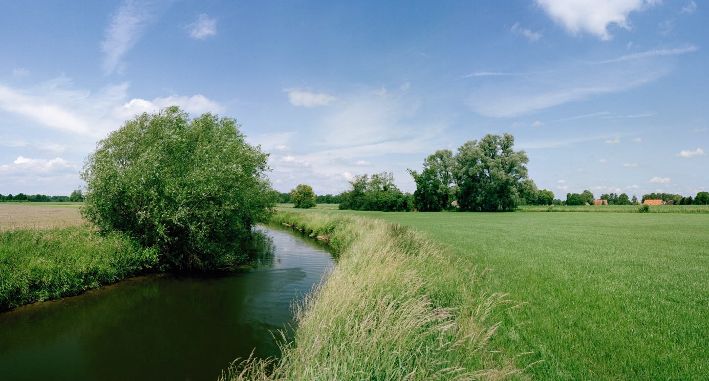

SUSTAINABILITY AND OUR COMPANY CULTURE

THINK SUSTAINABLY – ACT WITH ENVIRONMENTAL AWARENESS

All Niessing precious metals are obtained in a sustainable manner. The gold we use is exclusively from the recovery of secondary resources (recycling) – also referred to as urban mining – and we obtain precious metals from certified German and Swiss refineries. The entire alloying process takes place at Niessing in the manufactory, where recycling and reutilization also have top priority. Recycled precious metal is the most sustainable source for our exclusive pieces of jewelry.

CERTIFIED BY THE RESPONSIBLE JEWELLERY COUNCIL
Niessing – a certified member of the Responsible Jewellery Council since January 2021 – publishes a comprehensive sustainability report once a year with an overview of its commitment to manufacturing and design, supply chains, employees, the environment as well as social responsibility.

Status: June 2023

