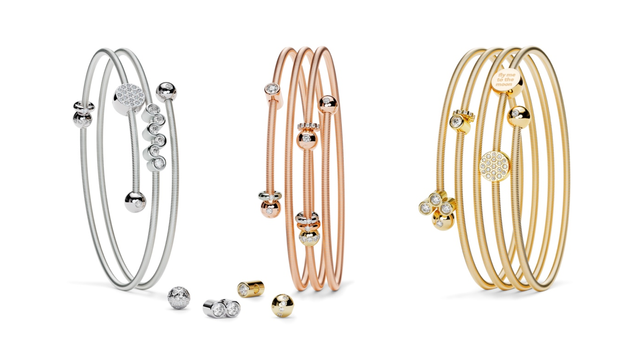

TC NIESSING COLETTE C BRACELET

NIESSING COLETTE C BRACELET

SLOGAN
NIESSING COLETTE C - Click, create, collect!

DESCRIPTION
The new addition to the Niessing Colette C collection now brings movement into the world of Niessing Colette. The oval bracelet for collecting fine pendants is now available in double, triple, and quadruple winding forms.

The Niessing Coil, with a thickness of 1.6 mm, gently curves around the wrist and, thanks to its high flexibility, always returns to its original shape. A separate closure is not necessary. There are various sizes and, thanks to the oval cross-section, it fits snugly around the wrist. Possible widths are 50 / 53 / 56 / 59 / 62 / 65 / 68 mm.

For the Niessing Colette C, the inner core of the Niessing Coil is made of an innovative high-tech material. This ensures the high clamping force: It appears light as air when the windings are finely spaced from each other – full of excitement when they are slightly intertwined with each other.

One of the two polished end spheres can be turned and removed with a quiet click and, after placing on different pendants, put back on with a click.

The end spheres of 5 mm are crafted without or set with fine 0.01 ct diamonds. Click, create, collect!
Niessing Colette C is available in platinum and in gold in the Niessing Colors Classic Yellow, Fine Rose, Classic Red and Rosewood.

COMMENT
Niessing Colette turns a subtle, casual gesture into intricate jewelry. Everyone knows the game: a delicate band, loosely coiled around the wrist, the ends knotted. With Niessing Colette, the band becomes the Niessing Coil, and the knot becomes a sphere.

With the Niessing Colette C, Niessing is giving this unique design a modern interpretation, and it is turning collecting into a passion. New pendants capture your most precious memories for eternity: fine diamonds, Diamond Waves, roundels for your individual engraving – and the classic Niessing Spannring® and Niessing Memory, smaller and more delicate than ever before. The Niessing Sphere Hold can be used to fix all pendants in the desired position on the bracelet. Capture special moments!
Good memories carry our lives, according to Japanese wisdom. The Niessing Colette C captures your most beautiful memories forever: small steps and great bonds, valuable experiences and daring dreams ...

ESSENCE
The Niessing Coil wraps itself around the arm in fine sweeps: winding two, three, or even four times, silky soft and sensuous. One of the two shiny spheres can be removed to collect sparkling pendants that allow each bracelet to tell your personal story on your wrist. Simply beautiful!

