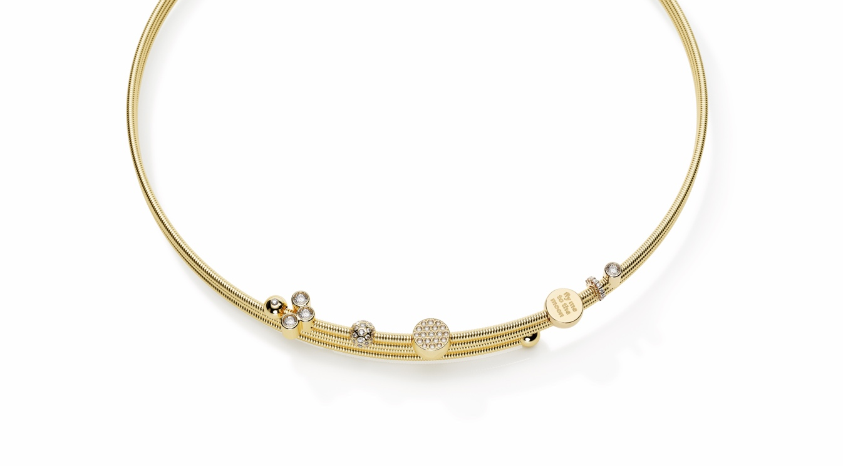

TC NIESSING COLETTE C COLLIER

NIESSING COLETTE C COLLIER

SLOGAN
NIESSING COLETTE C - Click, create, collect!

DESCRIPTION
The new Niessing Colette C necklace wraps around the neck two or three times. Two polished 5 mm spheres form the closure of the Coil. One of the two end spheres of the bracelet and necklace can be turned and removed with a quiet click. This allows you to thread the pendants. The end spheres can be optionally without or set with fine diamonds of 0.01 ct each.

The inner core of the Niessing Coil is made of an innovative, high-tech material. This ensures the high clamping force: A separate closure is not necessary, as the necklace is wrapped around the neck like a silk scarf. The exquisite 1.6 mm thick Coils overlap dynamically.
New Niessing Colette C pendants turn it into personalized and changeable jewelry. Existing Niessing pendants can also be threaded onto the new necklace. The elements can be placed with the help of stopper spheres. Click, create, collect!

It is available in the sizes 115 / 125 / 135 / 145 mm, and it is easy to find the perfect, snug fit for the neck.

In its pure form the Niessing Colette C necklace embodies modern understatement.
It is available in platinum and in gold in the Niessing Colors Classic Yellow, Fine Rose, Classic Red and Rosewood.

COMMENT
Since its invention in the mid-1980s, the Niessing Coil has been a real quick-change artist: With a wide variety of jewelry pendants, it can be presented again and again in entirely new ways. Exactly ten years ago, the Niessing Coil became delicate jewelry as the Niessing Colette.
The new Niessing Colette C necklace now fits snugly around the neck: double or triple overlapping Coils full of lightness and vitality. With the Coil’s unique flexibility, it is easy to wear, and the jewelry always returns to its original shape.
Good memories carry our lives, according to Japanese wisdom. The Niessing Colette C necklace collects the loveliest moments of your life. Colorful gold and platinum pendants with sparkling diamonds preserve your most precious memories. Allow the necklace to grow according to your own vision with fine diamonds and Niessing design icons in miniature: Click, create and capture!

ESSENCE
The Niessing Colette C necklace wraps around the neck two or three times. Two shining spheres form the closure of the Coil, and one of the two can be removed with a quiet click, so that precious pendants can be threaded on it as a symbol of your most cherished memories. Discover the most tender embrace!

