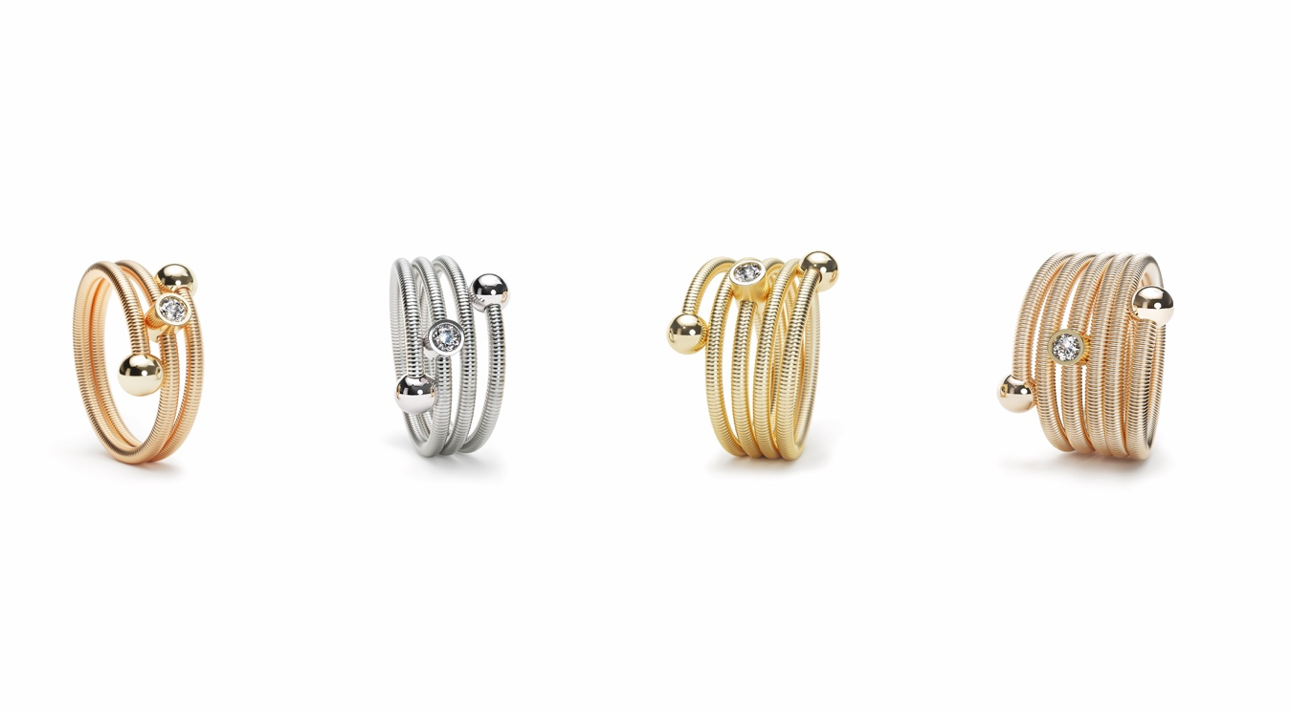

TC NIESSING COLETTE C RING

NIESSING COLETTE C RING

SLOGAN
NIESSING COLETTE C - Click, create, collect!

DESCRIPTION
As a flexible ring with multiple windings, the Niessing Coil has two shining spheres as a closure. The two 4 mm end spheres are firmly joined to the jewelry. The end spheres are either without or set with a fine 0.01 ct diamond. Available are variants with two, three, four and five windings.

Upon request, a radiant diamond of 0.05 ct sparkles on your finger: It dances on the Niessing Coil, it can be moved as desired, and it can be fixed in the desired position by the ring's own spring force. The diamond setting cannot be added later.
The inner core of the Niessing Coil is made of an innovative, high-tech material. This ensures the high clamping force: Various ring sizes are available, making it easy to find the perfect fit for your finger.
The Niessing Colette C rings are available in platinum and in gold in the Niessing Colors Classic Yellow, Fine Rose, Classic Red and Rosewood.

COMMENT
Niessing Colette turns a subtle, casual gesture into intricate jewelry. Everyone knows the game: a delicate band, loosely coiled around the wrist, the ends knotted. With Niessing Colette, the band becomes the Niessing Coil, and the knot becomes a sphere.
For the Niessing Colette C ring, the Niessing Coil winds around the finger up to five times, with two gleaming spheres forming the closure, optionally with a fine, sparkling diamond. Vibrant and flexible – the ring is extremely comfortable to wear despite its width. Smooth gold and platinum encircle your finger with lightness and elegance. Feel the most tender embrace.

If you wish, a fine, set diamond adds that extra sparkle to every day. Its position in the ring can be changed to suit your mood: »Today, the focus is on me – tomorrow, I’ll shine for the world.«

ESSENCE
Fine, soft and smooth: For the Niessing Colette C ring, the Niessing Coil winds around the finger up to five times, with two gleaming spheres forming the closure. Optionally, a freely moving diamond on the coil adds an extra sparkle to each and every day. Its position in the ring can be changed to suit your mood: » Today, the focus is on me – tomorrow, I’ll shine for the world.« Simply beautiful!

