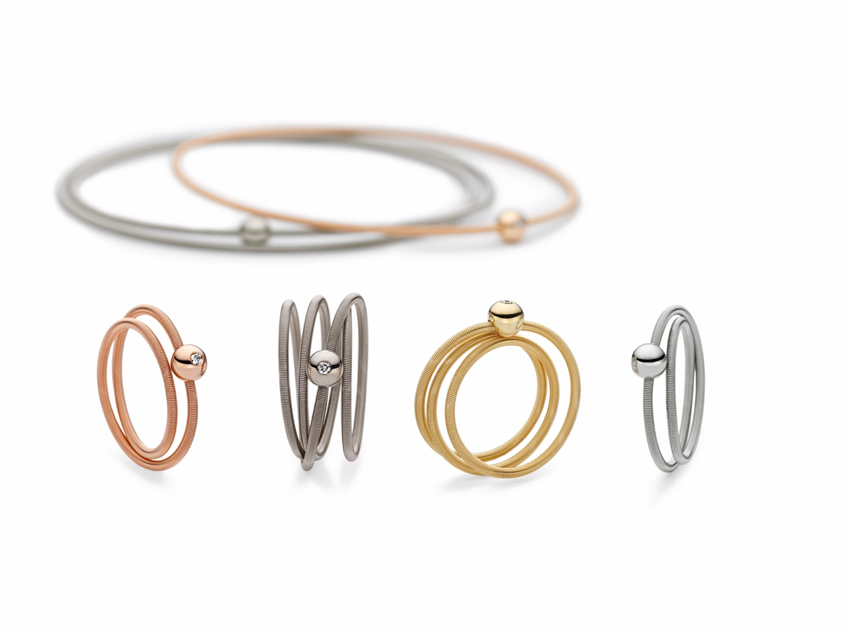

TC NIESSING COLETTE

NIESSING COLETTE

SLOGAN
Niessing Colette – Joy for every day

ESSENCE
The Niessing coil, presented as a delicate bracelet, a soft ring, and a fine creole, brings joy for every day with Niessing Colette. With Colette bracelets, you have a choice: Perhaps just a single bracelet today, delicate and very discreet; tomorrow, several, making a strong statement. The Colette rings almost seem to float: Delicate coils of gold or platinum, casually wrapped around the finger, in single or multiple windings. And the fine Colette hoop earrings playfully follow all your moves: The Colette must-have for absolutely every occasion!

IDEA
A PLAYFUL GESTURE BECOMES JEWELRY
Niessing Colette turns a small, casual gesture into delicate jewelry. Everyone knows the game: A delicate ribbon, loosely wound around the finger or wrist, with the ends knotted together. A fine piece of jewelry is created quite intuitively.

NIESSING COIL MEETS NIESSING SPHERE
Niessing has taken this idea a step further with Colette: The delicate ribbon becomes the fine Niessing coil, and the small knot becomes a polished sphere. Thanks to the unique structure of the Niessing coil, Colette shimmers like a silk ribbon in the most beautiful Niessing colors. This is jewelry
for every day: Playful and delicate, always new. With Niessing Colette, a little spark of everyday inspiration writes design history.

THE JOY OF COMBINING
Colette rings and bracelets are available with one or more windings. They can be worn individually or combined with each other as the mood takes you. Sometimes the small sphere shines in its pure form, and sometimes a diamond flashes from its center. Fine hoop earrings complete the collection: The absolute Colette must-have, perfect for any outfit.

FEATURES
COLETTE BRACELETS
THE NIESSING COIL FOR THE WRIST
Delicate coils of gold and platinum adorn the arm. One or up to six windings are possible. The shiny sphere circles the wrist like a planet in orbit. Sometimes it is visible, sometimes it is hidden. If you wish, a small diamond can give the sphere a fascinating glow. Today perhaps just a single bracelet, fine and very discreet; tomorrow several, a strong statement: Colette is light and lively and always new!

COLETTE RINGS
SLEEK, CASUAL, ELEGANT
The fine Colette rings almost seem to float above the finger. The "simple" rings, each adorned with a small sphere, are perfect for collecting and combining: Discover the mix of Niessing Colors that suits your complexion and mood! The Colette rings with up to four windings are both jewelry and a game: Sometimes the sphere appears in the middle, sometimes on the edge. It is particularly beautiful when a diamond flashes out of the spheres from time to time. Sleek, casual, elegant - Niessing Colette is a gift for your hand.

COLETTE CREOLES
PLAYFUL AND RAVISHINGLY BEAUTIFUL
Earrings that playfully follow every move: Sometimes small and delicate, sometimes expansive and generous, always present and decorative. Colette hoop earrings are perfect for every occasion, whether in the office, in your free time or at an event ... Hardly any other piece of jewelry can be worn so naturally. Give yourself the gift of joy every day!
All Niessing Colette jewelry is available in Niessing Platinum and Gold in many Niessing Colors. The sphere on the bracelet and ring can be chosen plain or with a diamond.

