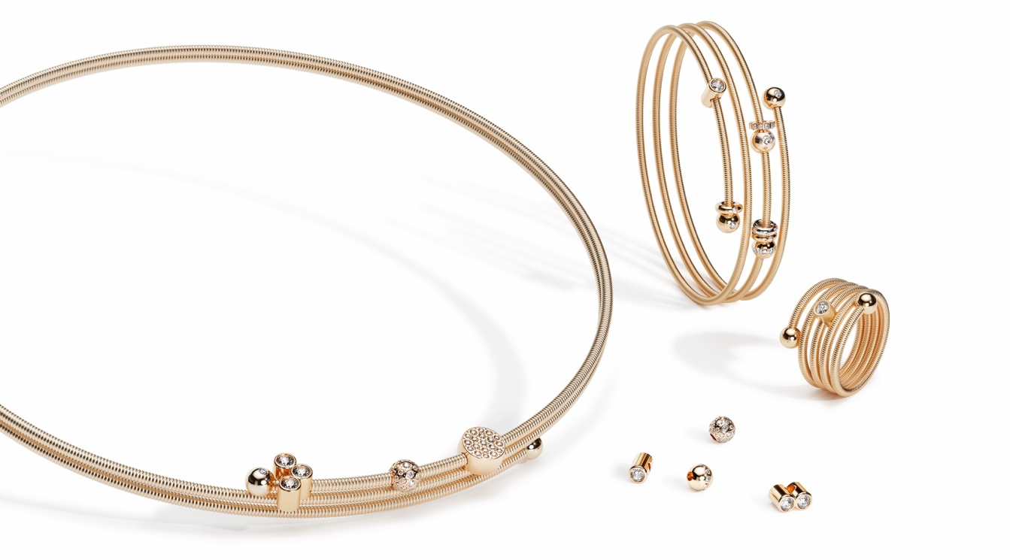

TC NIESSING COLETTE C COLLECTION

NIESSING COLETTE C COLLECTION

SLOGANS NIESSING COLETTE C
Simply beautiful!
Click, create, collect!
Capture special moments!
Click, create and capture!
Create memories!

SLOGANS NIESSING COLETTE C COLLECTION
Full of spirit and charm
Light, sensuous and smooth
Sweeping and smooth
Delicate, sensuous and smooth

Feel the most tender embrace
Discover the most tender embrace

ESSENCE
NIESSING COLETTE C COLLECTION
The Niessing Colette C Collection brings even more fantasy to the world of the Niessing Colette: Click, create, collect! Discover how fine coils, winding several times, naturally fit the wrist and around the arm, how they decorate the neckline full of spirit and charm: Discover the most tender embrace!
Shining spheres, sparkling diamond pendants, precious roundels for your personal engraving, and exquisite Niessing design icons in miniature make the Niessing Colette C bracelet and necklace symbols of your personal history. Capture unforgettable moments forever: Full of spirit and charm.

NIESSING COLETTE C BRACELET
The Niessing Coil wraps itself around the arm in fine sweeps: winding two, three, or even four times, silky soft and sensuous. It appears light as air when the windings are finely spaced from each other – full of excitement when they are slightly intertwined with each other.
NIESSING COLETTE C BRACELETS are worn on the wrist with ease and, thanks to their high flexibility, always return to their original shape. Two gleaming spheres form the closure, making a conventional one unnecessary. Radiant pendants and exquisite Niessing design icons in miniature make each Niessing Colette C bracelet a symbol of your personal history. Click, create, collect!
NIESSING COLETTE C NECKLACE
Delicate, yet so present: The NIESSING COLETTE C NECKLACE wraps around the neck two or three times. The unique flexibility of the coil makes it easy to wear, and the jewelry always returns to its original shape. Discover the most tender embrace! Two gleaming spheres form the closure, making a conventional one unnecessary. In its pure form without pendants, the precious Niessing Colette C necklace embodies modern understatement. With pendants, the Niessing Colette C Collection becomes personal and incredibly versatile jewelry. Click, create and capture!

NIESSING COLETTE C PENDANT
The NIESSING COLETTE C PENDANTS make every Niessing Colette C bracelet and necklace your very personal piece of jewelry: Create memories! Collect sparkling diamonds framed by Niessing Platinum and the most beautiful colors of gold, small spheres set entirely with diamonds, precious roundels with your personal engraving, and extravagant Diamond Waves. Discover the design icon Niessing Spannring® and Niessing Memory: now not only as a ring, but also in the finest design to wear on the wrist and, highly sensual, snugly around the neck – always providing a new look. It’s up to you: Click, create, collect!

NIESSING COLETTE C RING
Delicate, soft and smooth: The NIESSING COLETTE C RING winds around the finger up to five times, with two gleaming spheres forming the closure. If you wish, a fine, set diamond adds that extra sparkle to every day. Its position in the ring can be changed to suit your mood: »Today, the focus is on me – tomorrow, I’ll shine for the world.« Simply beautiful!

IDEA
A CASUAL GESTURE BECOMES A PIECE OF JEWELRY
Niessing Colette turns a subtle, casual gesture into intricate jewelry. Everyone knows the game: a delicate band, loosely coiled around the
wrist, the ends knotted. A fine piece of jewelry is created very intuitively in this way. With Niessing Colette, the band becomes the Niessing Coil, and the knot becomes a sphere.

THE NIESSING COLETTE WORLD HAS A BRAND NEW RADIANCE
The new Niessing Colette C Collection now brings movement into the world of Niessing Colette. The intricate bracelets, rings and necklaces tell your own personal story with passion: minimalist and elegant, authentic and full of pure joy.

SWEEPING, GENTLE AND SENSUOUS
The uniquely flexible coils wind delicately around the finger and wrist, hugging the neckline. Wound two to five times, the rings are stunning on their own or with a fine diamond as a radiant eye-catcher. The multi-wound bracelet and necklace are timeless minimalist highlights in their own right – and with the unique pendants from the Niessing Colette C collection, they become personal pieces of jewelry: Full of spirit and charm.

FULL OF SPIRIT AND CHARM
With Niessing Colette C pendants, you collect the loveliest moments in your life. Colorful spheres and fine diamonds set in platinum and gold in unique Niessing Colors preserve your most precious moments. Extravagant Diamond Waves become radiant secrets full of happiness and fantasy, fine roundels can be engraved with a personal text or an individual drawing: So you always wear your loved ones very close to you. And even the design icon Niessing Spannring® and Niessing Memory are available in the Niessing Colette C collection in the very finest design. It’s up to you: Click, create, collect!

CREATE PERSONAL IMAGES
Highly polished spheres sit at both ends of the intricate pieces of jewelry: In the case of the Niessing Colette C ring, both are firmly connected to the Coil. In the bracelet and necklace, only one sphere is fixed, whereas the other can be removed with a quiet click to thread on pendants, which then move freely on the Coil. If you want to create individual images with your collected pendants, you can fix them in a specific position in the jewelry with Niessing Hold spheres.

SOFT AS SILK, SMOOTH AND FLEXIBLE
The Niessing Coil nestles around the arm and neck in fascinating sweeps. Thanks to the unique flexibility of the fine coils made of gold and platinum, the necklace and arm jewelry are very easy to
slip on. The jewelry always returns to its original shape; a separate clasp is not necessary. The fine coils have a silky soft texture that shows off the particular beauty of Niessing Colors.
For all pieces of jewelry belonging to the collection, the inner core of the Niessing Coil is made of an innovative high-tech material. This ensures the high clamping force and flexibility: the shape of the delicate pieces of jewelry is retained.

FALL IN LOVE OVER AND OVER AGAIN!
Niessing Colette C invites you to collect, yet it can also be worn unadorned as a delicate, minimalist highlight on the arm and neckline. You can add more and change the design as you desire –
making a perfect combination with the classic Niessing Colette bracelets. Fall in love with life over and over again!

STORY
THE NIESSING COIL: WONDERFULLY CHANGEABLE
Since its invention in the mid-1980s, the Niessing Coil has been a genuine quick-change artist: with a wide variety of jewelry pendants, it can be presented in ever-changing ways. Exactly ten years ago, the Niessing Coil became a delicate bracelet and ring as the Niessing Colette.

ANNIVERSARY WITH A NEW INTERPRETATION
The Niessing Colette C is giving this unique design a modern interpretation: As a simple coil around the wrist, Niessing Colette C Embrace and Space made a start in the spring of 2020. Combined with a great Niessing classic, the Niessing Sphere, collecting became a passion.
COLLECTING MEMORIES WITH A PASSION
The Niessing Colette C Collection now makes it even more exciting to collect memories: Silky soft, highly flexible Niessing Coils nestle around the arm and neck in several gentle windings, and fine rings are crafted with up to five windings. In addition to the spheres, many new pendants reveal their charm on bracelets and necklaces: fine diamonds, Diamond Waves, roundels for your personal engraving – and the classic Niessing Spannring® and Niessing Memory: smaller and more delicate than ever before. Capture special moments!
With Niessing Colette C, the most beautiful memories can be captured forever: small steps and great bonds, valuable experiences and daring dreams... The first child, passing an exam, the wedding day, or a shared dream vacation…
Niessing Colette C provides endless possibilities and is constantly developing, just the way you want it – jewelry as lively and fascinating as your life!
FEATURES
NIESSING COLETTE C BRACELET
The Niessing Coil wraps itself around the wrist in fine sweeps. It appears light as air when the windings are finely spaced from each other. The delicate coils create an image of excitement when they are close together and slightly intertwined with each other.
The bracelet is worn on the wrist with ease and, thanks to its high flexibility, always returns to its original shape. A separate clasp is not necessary. There are various sizes and, thanks to the oval cross-section, it fits snugly around the wrist.

It is now available in double, triple, and quadruple winding forms in Niessing Platinum and Gold in the Niessing Colors Classic Yellow, Fine Rose, Classic Red and Rosewood. Thanks to the texture, which looks like a fabric, the unique Niessing Colors are shown off to their best advantage.
One of the two polished end spheres can be turned and removed with a quiet click, and after placing on different pendants put them back on with a click. The system is easy to handle and highly secure – typical of Niessing. The end spheres are crafted as unset or set with fine diamonds.

NIESSING COLETTE C NECKLACE
A necklace with two or three windings and two gleaming spheres forming the closure. The windings overlap dynamically. The flexibility of the jewelry makes it easy to wear, and the necklace always returns to its original shape. A separate clasp is not necessary.
One of the two spheres can be removed with a quiet click, which allows you to thread the pendants of the Niessing Colette C Collection. The end spheres can be optionally unset or set with a fine diamond. In its pure form, the elegant Niessing Colette C necklace embodies modern understatement.
Various sizes are available, making it easy to find just the right necklace that wraps around the neck and caresses it like a silk scarf.
Available in Niessing Platinum and in gold in the Niessing Colors Classic Yellow, Fine Rose, Classic Red and Rosewood.

NIESSING COLETTE C PENDANTS
NIESSING COLETTE C SPHERES
Up until now, the spheres in the collection were either unset or set with diamonds: as fine highlights or sparkling lines. Fully set spheres are a new feature. Thanks to Niessing's own pointed setting technique, the surface of the spheres is pleasantly smooth, and even delicate surfaces such as silk or cashmere will not get caught. Spheres without diamonds can be personally engraved.
The Niessing Colette C Hold spheres can create personal images for the bracelet and necklace, and they can be used to fix pendants in the desired position.

NIESSING COLETTE C ARCHITECTURE DUO, TRIO, VIS-A-VIS
Fine diamonds framed by Niessing Platinum and the most beautiful colors of gold. The diamonds crafted as a duet or in threes as a small sparkling cluster: They seem to float on the Niessing Coil. In the Niessing Colette C Diamond Vis-a-vis, two diamonds sparkle from a slender pillar setting: One shines at the wearer of the jewelry, the other at her counterpart. A brilliant idea!

NIESSING COLETTE C RONDO
Niessing Colette C Rondo can be engraved according to your personal wishes with a short text or a symbol. Alternatively, the entire surface of the roundels can be set with diamonds. Rondo is also a coveted collector's item in its pure, unset form in many Niessing Colors.

NIESSING COLETTE C DIAMOND WAVE
An extravagant pendant with six diamonds, held securely by a fine wave of Niessing Platinum or Gold. The Niessing Diamond Wave ripples on the arm and on the neck: Let your fascinating sparkle carry you through each and every day.

NIESSING COLETTE C SPANNRING
A great Niessing design icon as a pendant for the Niessing Colette C Collection. The smallest crafted Niessing Spannring® is more delicate than ever before.

NIESSING COLETTE C MEMORY
Niessing Memory, the ring for life‘s loveliest memories, becomes a delicate, sparkling highlight in miniature for the Niessing Colette C bracelet or necklace.
All pendants of the Niessing Colette C Collection are available for neck and arm jewelry in Niessing Platinum and in gold in the Niessing Colors Classic Yellow, Fine Rose, Classic Red and Rosewood.

NIESSING COLETTE C RING
As a delicate and smooth ring, the Niessing Coil has two shining spheres as a closure. Available are variants with two, three, four and five windings. Upon request, a radiant diamond sparkles on your finger: it can be moved as you like, and it can be fixed in the desired position. The diamond cannot be added later.
Available in Niessing Platinum and gold in many Niessing Colors.

