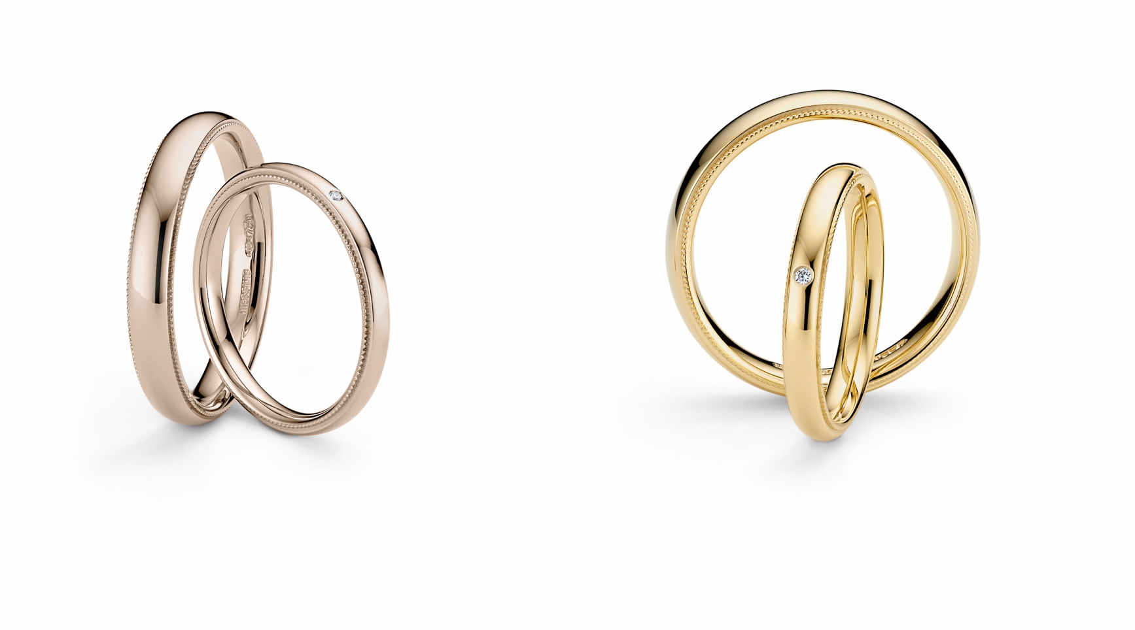

TC NIESSING ART DÉCO

NIESSING ART DÉCO

DESCRIPTION
A simple wedding ring, oval-shaped and gently curved inside, with a fine, ornamental band on both outer edges.
The fine perlage, the so-called milgraine decoration, is an ancient craft technique that the experienced Niessing goldsmiths are very familiar with: It requires great skill, sensitivity, and a great love of detail.
The rings are available in widths from 2.5 mm to 6 mm, in Niessing Platinum and all Niessing Gold colors. Upon request, a fine diamond of 0.01 ct embellishes the ring: it is set into the wedding ring by hand with great care. A ring resizing is possible if no diamonds are set. Ring resizing for rings with diamond on request.

COMMENT
„Art Déco“ - derived from the French „l‘art décoratif“ for „decorative art“ - designates a style in design, architecture and fine arts, for which decorative elements are typical.
Among others, the formal theory of the Bauhaus had a great influence on the Art Déco movement.
Niessing Art Déco combines clear, Bauhaus-inspired design with the playfully decorative elements of Art Déco. The simple, oval-shaped wedding ring is lined with a fine ornamental band: This further development of a

design from the 1980s is deeply rooted in the history and tradition of the Niessing manufactory.
Niessing Art Déco looks as if the ring were adorned with a thousand tiny pearls: delicate and romantic. A fine ornament with a long tradition lines your love.
A wedding ring with a touch of nostalgia for eternity.

ESSENCE
A fine ornament with a long tradition lines your love. Niessing Art Déco is a wedding ring with a touch of nostalgia for eternity.

