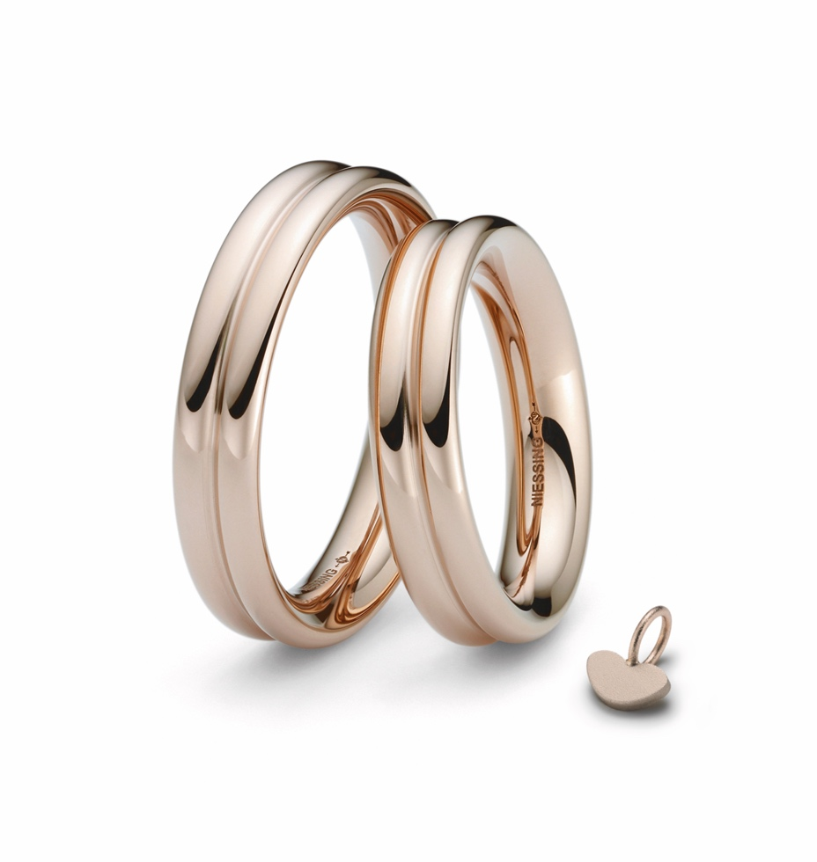

TC NIESSING HEART

NIESSING HEART

DESCRIPTION
The cross-section of the Niessing Heart wedding rings has a heart shape: the soft, double-curved ring hides the tip of the heart deep inside, only a small hint.
The ring is soft and generously rounded: It is soft and pleasant to wear and is very comfortable. The texture Gloss emphasizes the beauty of the well-rounded shape particularly well. Alternatively, Niessing Heart is available with the texture Satin, Velvet or Nature.
If requested, a fine diamond in the joint adds a sparkling accent.
The rings are available in Niessing Platinum and in all Niessing gold Colors, in widths ranging from 3 to 7 mm. Ring resizing is conditionally possible if no diamonds are set.

COMMENT
Probably the oldest symbol of love, hidden in a ring - and only the lovers know the secret. The Niessing Heart wedding rings give romance and great feelings the most beautiful form. Can you feel the heartbeat?

Only the lovers know: The cross-section of their wedding rings is shaped like a heart. Seen from the outside, Niessing‘s heart is a double-curved ring; the wearer can only sense the tip of the heart deep inside. But the lovers know the secret of their bond: Their hearts beat in harmony.

If you wish, you can set a sparkling accent with a small diamond in the ring‘s fugue, a sign of a pure heart. Discover the most romantic symbol of your love!

ESSENCE
Probably the oldest symbol of love, hidden in a ring - and only the lovers know the secret. The Niessing Heart wedding rings give romance and great feelings the most beautiful shape. Can you feel your heart beating?

