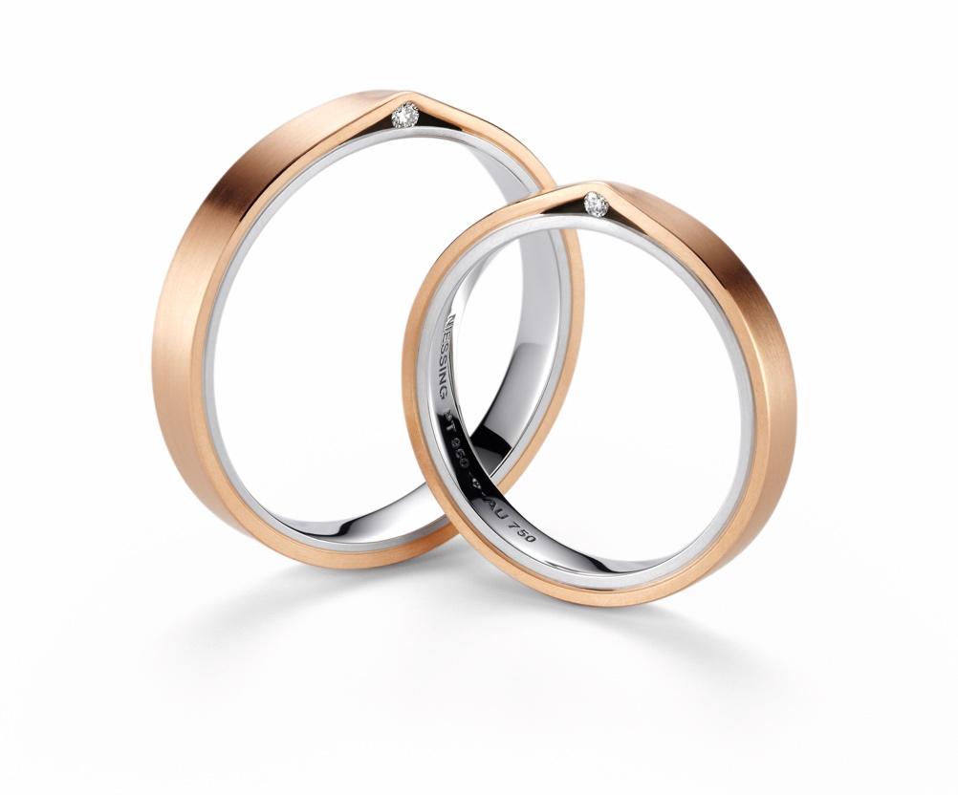

TC NIESSING REFUGE

NIESSING REFUGE

DESCRIPTION
The flowing wedding ring with a rectangular profile in a width from 3 to 6 mm consists of two interlocking bands, which are firmly connected to each other at their surfaces.
A small gap opens at one point only between the sides of two precious metal layers, where a fine diamond peeks out. The ring is also available without diamond.
The ring is now also available in narrow widths from 3 mm to 6 mm and is available in many Niessing Gold Colors or platinum. It is also possible to combine two colors. Resizing is not possible.

COMMENT
Two bands of gold or platinum nestle together. The clear shape of the wedding rings is elegantly restrained. In this tranquility you can discover a small gap that opens to give space and hold to a diamond. What direction will the stone have on your finger: Does it shine just for you - or does it show itself to your counterpart?
A genuine Niessing classic from 1990 that has been given a modern interpretation with new, fine proportions and a change of color. The clear design expresses pure understatement. Even the small diamond is almost hidden discreetly in a tiny gap between the two precious metals.

Which colors does your love have? Does the inner ring made of platinum provide support and stability? Does warm gold lie on the outside like a soft blanket protecting the diamond?
Niessing Refuge: A small, inward-looking gift, a secret place of reflection and tranquility that you can visit every day.

ESSENCE
The Niessing Wedding Ring Refuge: Gold or platinum nestle softly around a place of peace and contemplation where a small treasure is waiting to be discovered anew each day.

