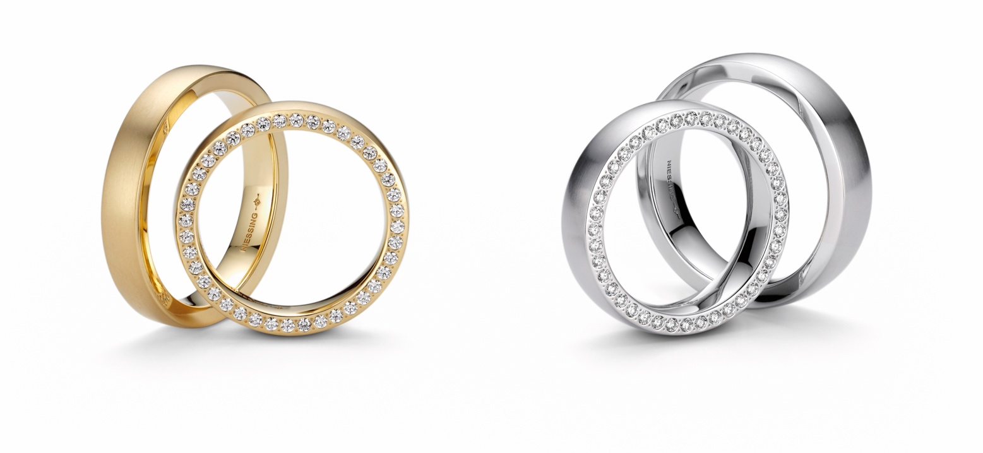

TC NIESSING SATELLITE ORBIT

NIESSING SATELLITE ORBIT

DESCRIPTION
Niessing Satellite Orbit are wedding and jewelry rings that can be worn by themselves, with other Niessing Satellite Rings, or as a companion for a Niessing engagement ring.
Niessing‘s typical pointed setting technique has been continuously developed so that also the finest brilliants can be set close together, now even on the sides.
The generously proportioned, gently rounded ring with clear, straight edges is available in several variations: the diamonds can embellish one or both sides of the ring like a radiant crown. If the upper side of the ring is also set, it appears to consist of sparkling diamonds only.

Without diamonds, Niessing Satellite Orbit becomes the perfect ring for men: voluminous and present - and thanks to its high wearing comfort, it is also a pleasant, lifelong companion. Niessing Satellite Orbit is available in Niessing Platinum and in all Niessing Gold colors with the textures satin, velvet, nature and gloss. The available widths vary from 2 to 10 mm.
A resizing is possible if no diamonds have been set.

COMMENT
Niessing Satellite Orbit is a wedding ring, a jewelry ring and the perfect companion for a Niessing engagement ring: the fine diamonds are set close

together. The ring seems to radiate from within - as magically as a night sky full of stars.
If the sparkling diamond crown embellishes only one of the two sides of the ring, Niessing Satellite Orbit becomes the wedding ring highlight on your hand. And it is a sparkling companion for other Niessing Satellite Rings or a Niessing engagement ring. An endless row of shining stars, diamonds in their orbit: the most beautiful symbol of your endless love.
The diamonds should shine close together on both sides? As a soloist on your hand, the ring sparkles for you - and for your vis-à-vis at the same time.
Niessing Satellite Orbit becomes magnificent and luxurious when the diamonds embellish both sides and the top: The ring then seems to consist only of diamonds - magical like a night sky full of stars.

ESSENCE
Niessing Satellite Orbit sends radiant diamonds into their orbit: a symbol of endless love. The ring seems to radiate from within - as magical as a night sky full of stars.

