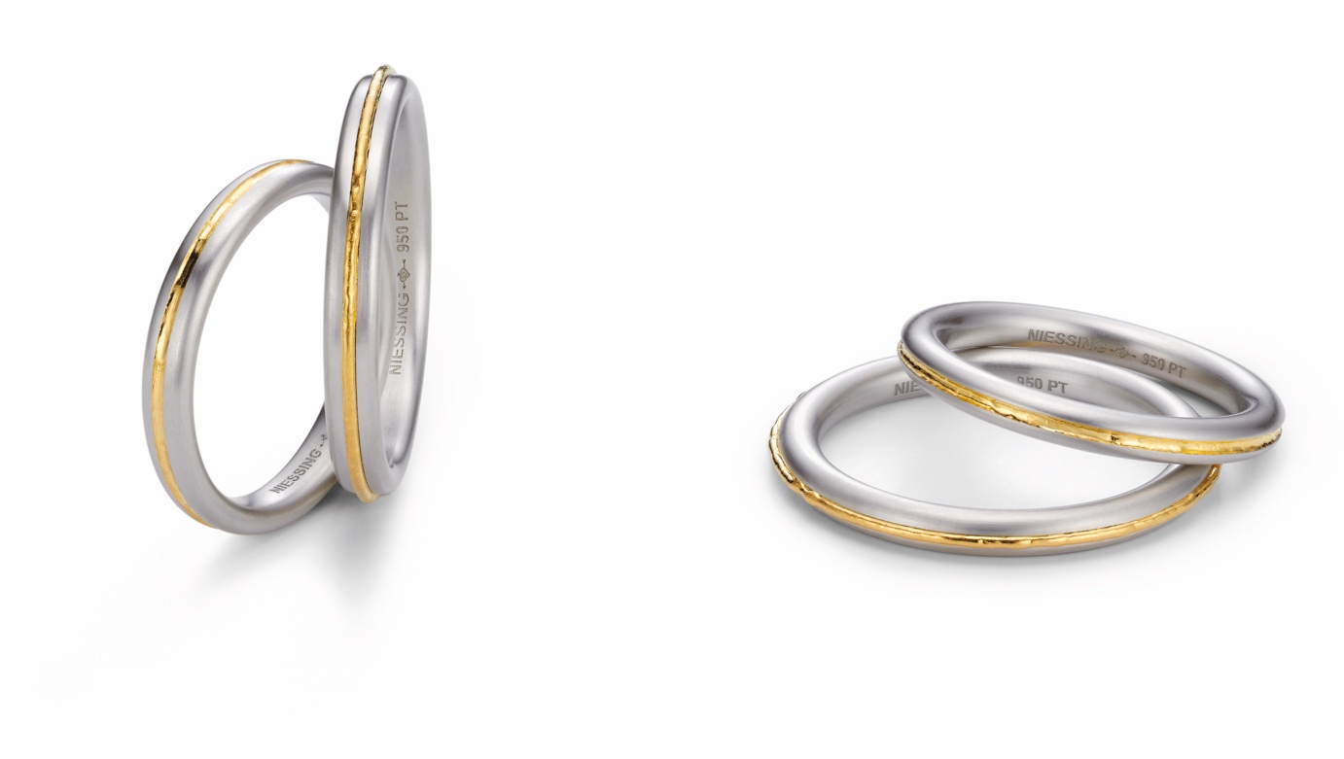

TC NIESSING SOULMATE

NIESSING SOULMATE

DESCRIPTION
Delicate wedding rings with round or oval profiles made of Niessing Platinum are interspersed with a fine line of fine gold. It is melted by hand in an elaborate process and therefore shows slight irregularities - like an artist‘s brushstroke.
In one of the two rings, the line is slightly raised, in the other one it is gently embedded.
Niessing Soulmate wedding rings with a round profile are 2.5 mm wide, those with an oval 3 mm. The Niessing Platinum texture is velvet, and the fine gold acquires its own unique luster by melting it down.

COMMENT
Aren‘t lovers always also soulmates, connected in the depth of their hearts? Niessing Soulmate translates this intimate image into an unusual wedding ring.
A fine line of precious fine gold runs down the center of the fine rings made of Niessing Platinum: slightly raised in one case, gently embedded in the other.
Like the lovers themselves, the rings are meant for each other: When brought together, they fit perfectly into each other, circle each other, and never lose contact with the other.

In this way, they become the most beautiful symbol of the spiritual kinship of two people.
The combination of precious Niessing platinum and radiant fine gold has a noble and sublime effect. The fine golden line warms the cooler platinum from within; it seems to throw out magical sparks.
Niessing Soulmate: meant for each other, forever connected. Discover the most beautiful symbol of a magical relationship!

ESSENCE
Niessing Soulmate wedding rings are the most beautiful symbol of a magical kinship: meant for each other and forever connected.

