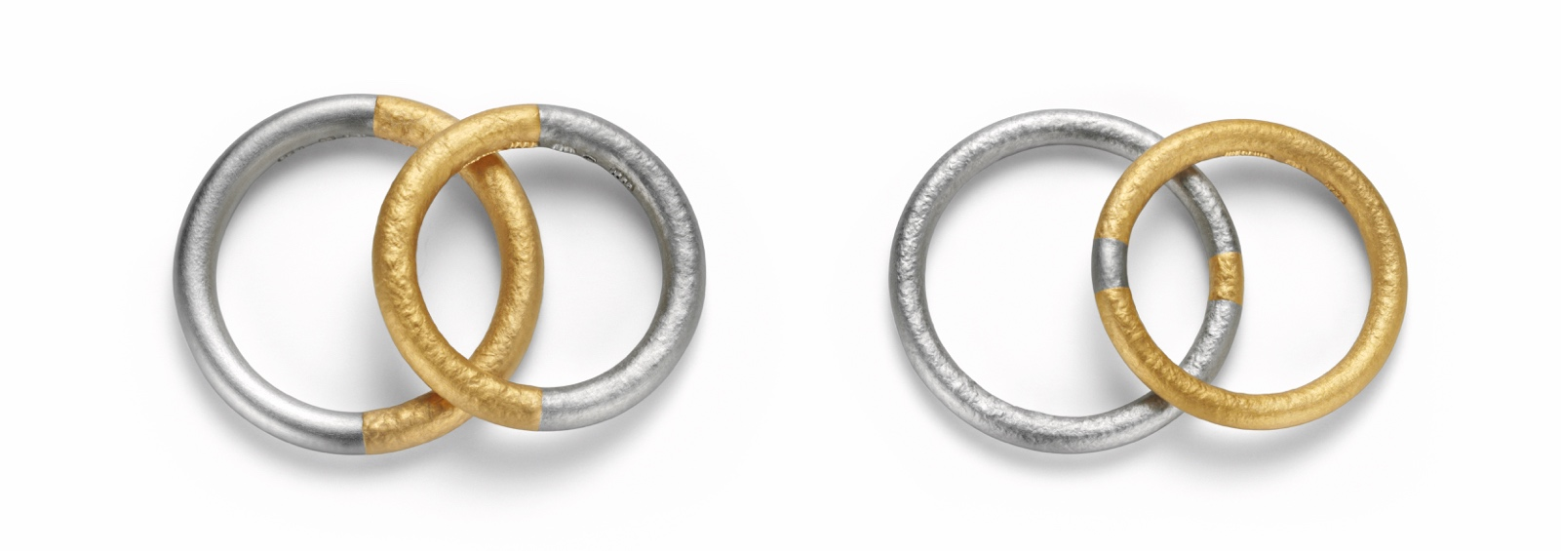

TC NIESSING SYMBOLON

NIESSING SYMBOLON

DESCRIPTION
Niessing Symbolon is now also available as a narrow version starting from a width of 2.5 mm. Symbolon rings with a round shape can have a diameter of 2.5 to 4 mm, in an oval shape they are available from 3 mm to 5 mm.
As an expression of pure love, one ring is made of pure platinum, the other of pure gold. There are three possible divisions for the size of the segment to be exchanged: 90/10, 66/33 or 50/50.
The special feel of the texture with its archaic appearance is created by special processing using pressing and upsetting. Such a surface only occurs with pure precious metal. A ring resizing to a smaller width is only conditionally possible.

COMMENT
Niessing Symbolon, two rings, two elements, one made of pure gold, the other of pure platinum: together they shine with the pure, original power of true love.
In ancient times, a simple clay ring that was broken through in the middle served to recognize each other by the way the halves fit

together. This ring was called „symbolon“. Niessing has reinterpreted the symbol of togetherness and replaced clay with gold and platinum.
A segment of the same size is taken from each of the rings and inserted into the other. Both lovers wear part of the ring from the other as a beautiful symbol of their togetherness.

„I give you my heart, my love, my life.“ Three different divisions give you the choice of how big the exchange is. What corresponds to your life together? A pledge as a promise to preserve their individuality? Or do you want more from the other? Shall half the ring stand as a symbol of sharing?
The deep, magical glow and the warm, archaic texture convey a feeling of eternity. In the course of time the surface will change, but the inside lives on with the durability of the precious metals.

ESSENCE
The Niessing Symbolon wedding ring unites what belongs together. Pure gold and pure platinum are exchanged in a covenant for eternity with the promise: No matter where we are, we always carry a part of the other with us.

