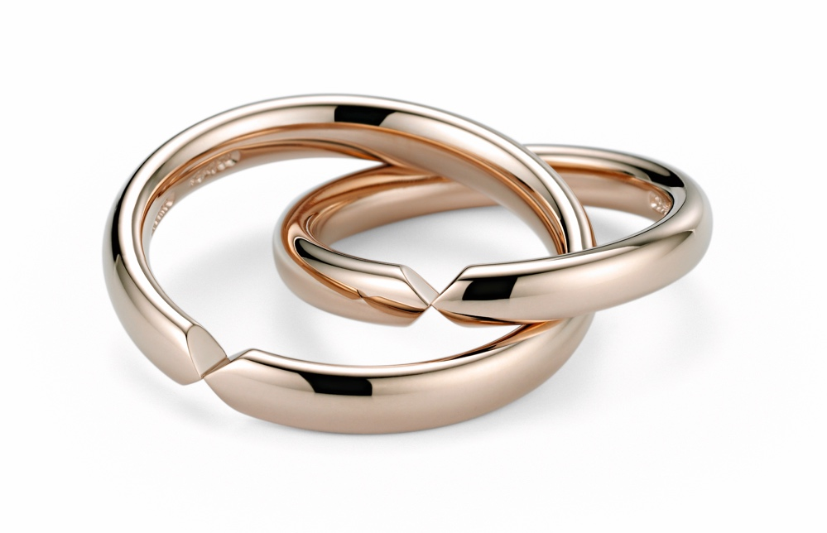

TC NIESSING UNITA

NIESSING UNITA

DESCRIPTION
Niessing Unita wedding bands are manufactured with the classic oval wedding ring profile. The rings are available in widths starting from 3 mm up to 6 mm, in Platinum and all Niessing Gold Colors in the textures Gloss or Satin.
The rings can be inserted into one another at the recess and separated again. At the same time, the incision forms a sophisticated optical feature of this wedding ring for couples who love special design and appreciate the Bauhaus maxim „form follows function”. A ring resizing is not possible.

COMMENT
Niessing Unita wedding rings are ingeniously cut; the arrow-shaped recess gives the rings their unusual and characteristic appearance.
The two rings of a wedding ring pair can be playfully put together and removed again. This is a game with a deeper background, because the images created this way correspond to the idea of connection and commitment.
Intertwined, the rings seem to form a unity. There is almost a little riddle: How will they be wearable? If we pull them apart, an eight is created.
The sidewards turned eight, ∞, has neither beginning nor end: a perfect sign of infinity. Each of the two Niessing Unita wedding rings forms one half of the symbol; together they form a whole.

ESSENCE
The wedding band Niessing Unita tells the story of holding on and letting go. Everyone can be without the other. But only together do they become an image of infinity.

