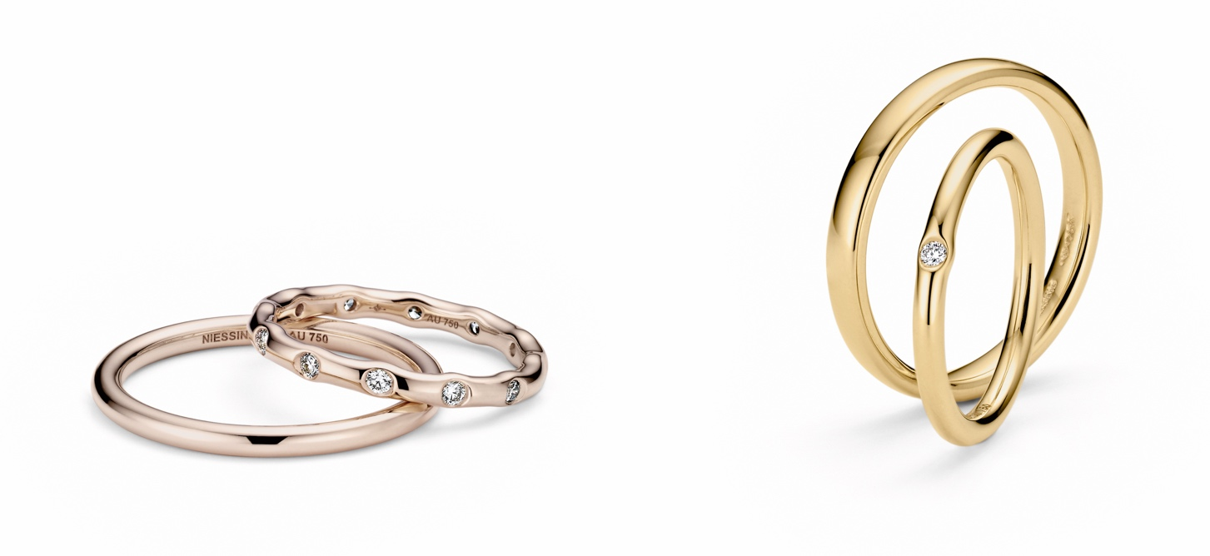

TC NIESSING TRACES OF LOVE

NIESSING TRACES OF LOVE

DESCRIPTION
Niessing Traces of Love is a wedding and jewelry ring that plays with the fascination of the formability of precious metals. The shape is created according to traditional craftsmanship and afterwards the diamonds are artfully set.
Whether a single diamond or a maximum of twelve: each diamond lends uniqueness to the simple round ring shank, only through them the ring profile changes from round to oval. The more diamonds, the more dynamic the impression: the outer contour is reminiscent of gently undulating waves, an expression of an organic design language.

Niessing Traces of Love is a perfect addition for a simple Niessing wedding ring. And it is also available without a diamond: simple and pure.
The rings will be produced in a width of 2 to 3 mm in Niessing Platinum as well as in all Niessing Gold colors. You can choose between the textures satin and gloss, whereby the glossy texture enhances the soft and flowing design language. A ring resizing can be done for rings with one diamond only, if more diamonds are set, a resizing will not be possible.

COMMENT
The traces that love leaves behind are unique - and these traces are always as individual as the lovers and their story itself.

Niessing Traces of Love is a wedding ring and a jewelry ring that only takes on its unmistakable, organically curved shape when precious metal and diamond come together.
Niessing Traces of Love plays with the formability of gold and platinum, which has inspired people since time immemorial - a fascination that is also deeply rooted in Niessing‘s design history. When a diamond meets precious metal, it gently bulges outward: The diamond is safely protected, becoming one with gold or platinum. Whether a single diamond or several - up to twelve brilliants leave their mark and form a unique ring.
On Niessing Traces of Love, each diamond leaves its very own, incomparable trace. Whether as a jewelry ring, a wedding ring, or as an addition to a Niessing wedding ring: Niessing Traces of Love seems to be worn on soft waves. Discover the most beautiful traces of your love!

ESSENCE
When brilliants meet precious metals, something unique is created: each brilliant-cut diamond gently curves the precious metal outwards, becoming one with it. Niessing Traces of Love immortalizes the most beautiful traces of your love.

