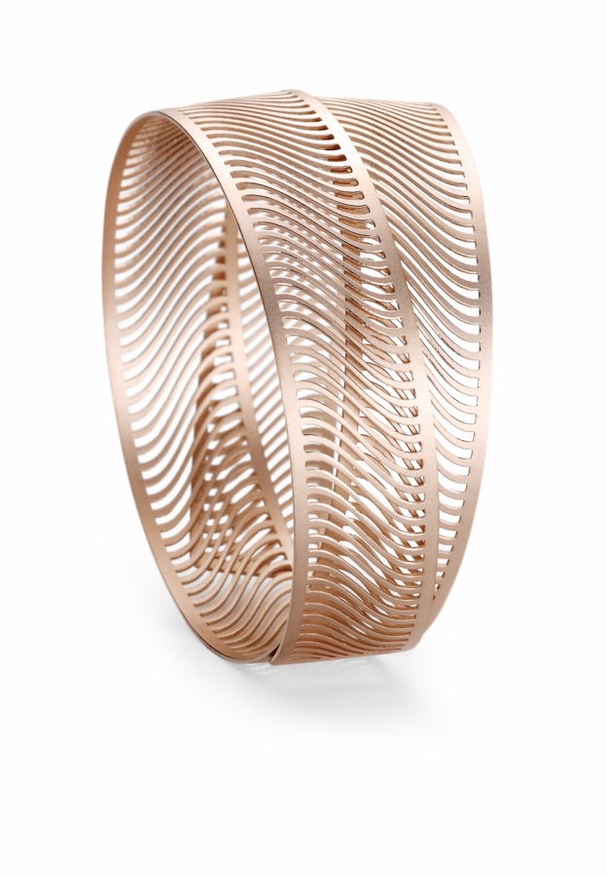

TC NIESSING MIRAGE BANGLE

NIESSING MIRAGE BANGLE

DESCRIPTION
Softly resilient bangles of slender precious metal strips extend easily to be fitted over the hand onto the wrist, where they return to their original form. A clasp is not needed. With a material thickness of 0.5 millimeters, the bangles are comfortable to wear and strong at the same time.

Shorter bangles coil around the wrist twice, resting around the arm in an expressive yet discreet statement. The two layers of slender precious metal strips shift in relation to each other with the moves of the wearer. The longer bangles form a triple loop, with the individual layers smoothly interlacing in a spacious yet weightless presence around the wrist.
The greatest challenge for Niessing‘s designers and goldsmiths lies in processing the precious metal to such a fine degree that it acquires this very light, feathery character. Only by our advanced laser methods and our new, in-house developed manufacturing techniques did this jewelry line become feasible.
Niessing Mirage Bangles are manufactured in platinum and in many of the Niessing Colors of gold.

COMMENT
Mirage means »reflection« or »Fata Morgana«. We took inspiration from optical illusions, from the play of light and shade, and from nature—autumn

leaves, feathers, dragonfly wings ... We were also influenced by architecture, particularly by the clear lines of the Bauhaus style. Niessing Mirage translates the sensuous minimalism of Bauhaus into jewelry.

Slender strips of precious metal overlap to create a world of illusions, presenting a different pattern, a new reflection, a fresh image with each move. Gold and platinum acquire a unique shimmer and a dazzling, mesmerizing sparkle. Pendants for the Niessing Coil, a brooch, earrings, or the new bangle are light as a feather and swing along with every move. In an unusual haptic experience, Niessing Mirage jewelry is surprisingly silky and smooth to the touch. The bangles circle the arm in a smooth embrace. With the play of ever-changing patterns, of light and shade, the jewelry develops a lively spirit and exciting dynamics of its own on the wearer’s body.

ESSENCE
Softly resilient, slender strips of precious metal circle the arm in a smooth embrace with an enigmatic shimmer and a mesmerizing sparkle. In their constant movement in relation to each other, the slender precious metal strips cause a splendid shimmer and dynamically different patterns and images to magically draw the eye. A playful illusion of shimmering light, a beautiful vision of weightlessness, a dream come true …

