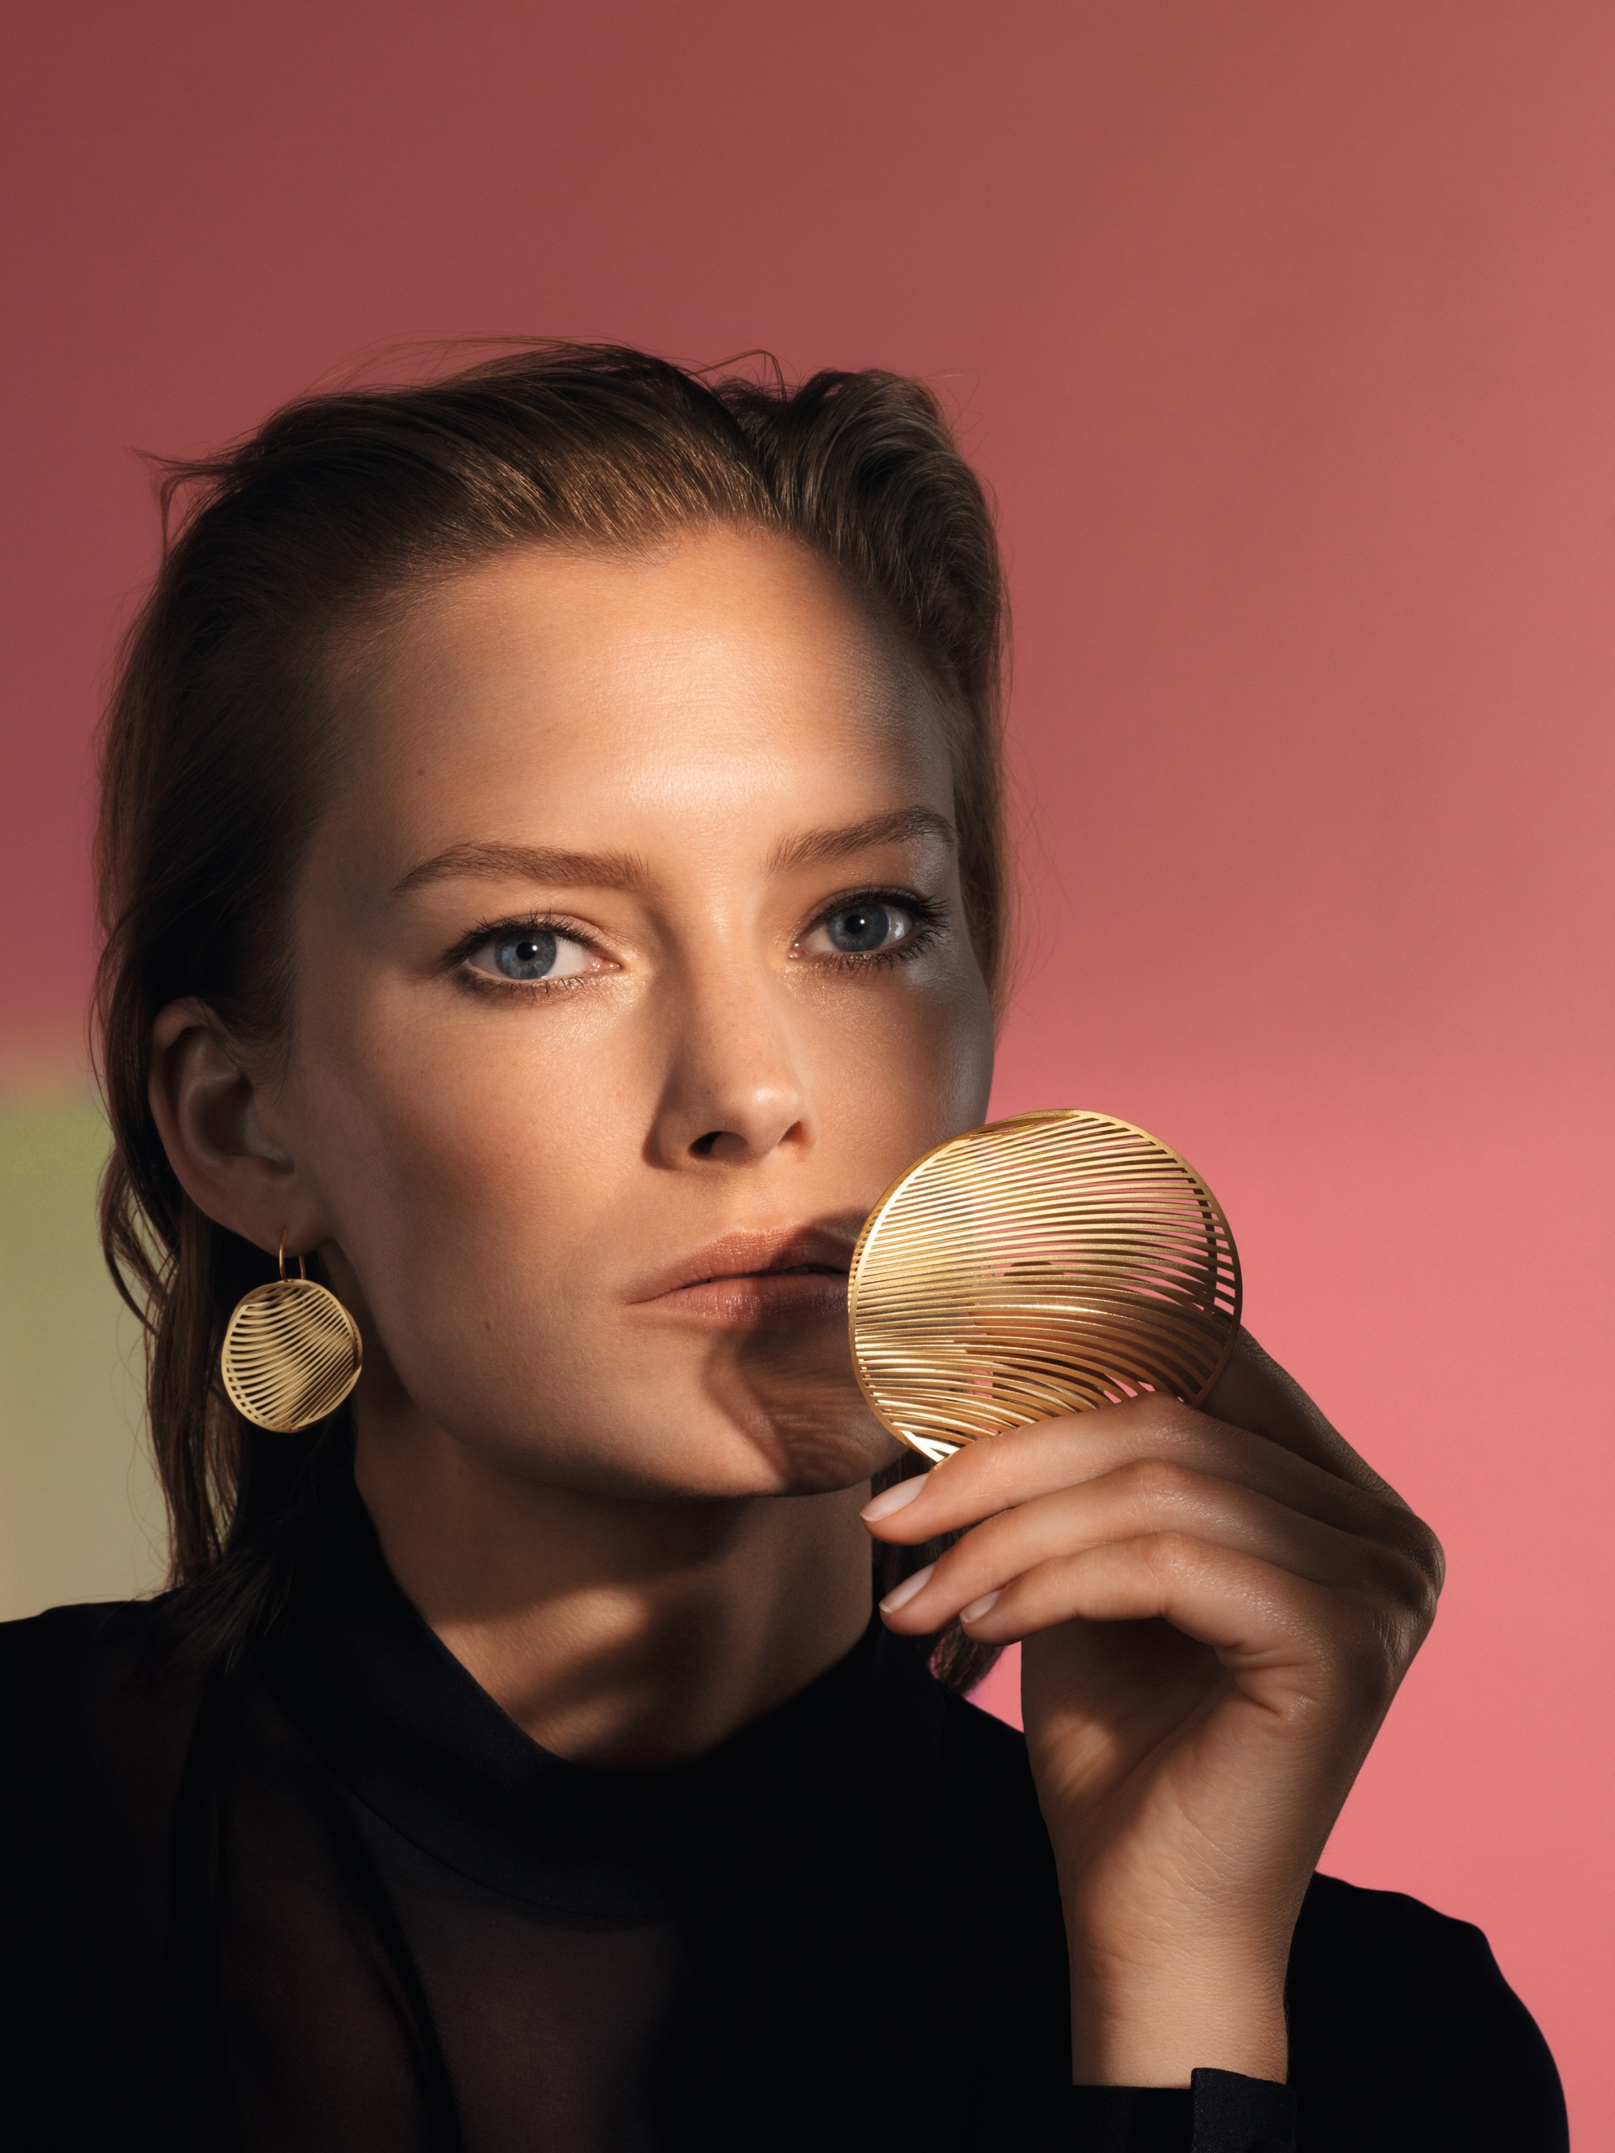

NIESSING MIRAGE
DISCOVER THE SHIMMERING PLAY OF ILLUSIONS!

TABLE OF CONTENTS

3 UNIQUE PLAY OF VISUAL EFFECTS
Gossamer Jewelry Objects Made of the Slenderest Strips

4 NIESSING MIRAGE PENDANTS AND EAR JEWELRY

Which vision captivates you?

6 NIESSING MIRAGE COLLIER AND BANGLES

Every Movement Reveals a New Secret

7 NIESSING MIRAGE LOOP

The Loveliest Symbol of Eternity

7 NIESSING MIRAGE LIMITED EDITION

Reach for the stars!

9 SUSTAINABILITY AND OUR COMPANY CULTURE

UNIQUE PLAY OF VISUAL EFFECTS

GOSSAMER JEWELRY OBJECTS MADE OF THE SLENDEREST STRIPS

Niessing Mirage jewelry plays with the visual effects and illusions of fascinating images created by overlapping strips of gold or platinum. They develop beautiful dynamics of their own on the wearer’s body. New patterns and shapes that resemble architectural forms and natural phenomena emerge: transparent dragonfly wings, delicate leafy structures, shimmering bird feathers.

VISUAL AND HAPTIC EXPERIENCE
Niessing Mirage offers not merely a unique visual but also an unusual haptic experience: Gold and Platinum feel as silky and smooth to the touch as never before.

VISION OF WEIGHTLESSNESS
Niessing Mirage is a beautiful vision of weightlessness in gold and platinum. Precious metal has never been seen like this before: shimmering and flickering, supple and velvety soft. Discover a fascinating play of illusions!

AWARD WINNER!
Niessing Mirage received the Red Dot Design Award Best of the Best in 2017, as well as the »German Design Award Winner 2018«.

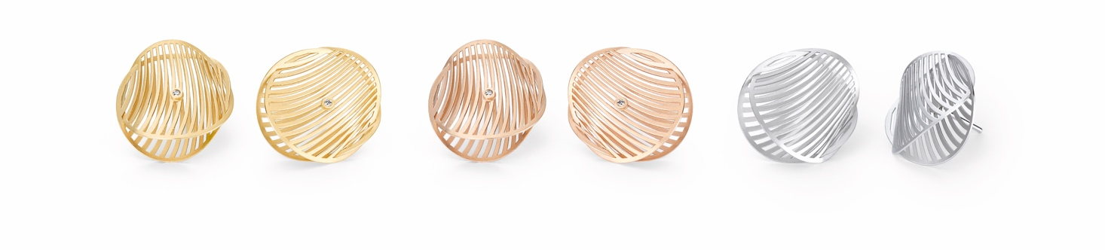

NIESSING MIRAGE PENDANTS AND EAR JEWELRY

WHICH VISION CAPTIVATES YOU?

FASCINATING PLAY OF ILLUSIONS
A mirage refers to something illusory: a »Fata Morgana«. Niessing Mirage plays with illusions. It took innovative Niessing laser
technology, which has been further developed, and new manufacturing and programming techniques to make this jewelry series possible.

FASCINATING IMAGES EMERGE
The expansive pendants for the Niessing Coil and ear jewelry absorb and reflect the light in all its facets. Thanks to the unique design, the Niessing Colors are also enhanced, and they shine with an intensity never seen before.

The individual forms with their slender strips overlap and create the illusion of a transparent body. The air inside the jewelry seems to shimmer and flicker. Gold and platinum acquire a new look that is both dazzling and transparent. Fascinating images emerge, reminiscent of delicate dragonfly wings or flying leaves in the golden autumn light. The glitter of lights dances on the gold strips like rays of sunlight on a swirling surface of water.

AN UNUSUAL HAPTIC EXPERIENCE
Light as a feather and vibrant with each touch, Niessing Mirage also creates an unusual haptic experience that is surprisingly silky and smooth to the touch.

CHANGEABLE AND FLEXIBLE
The Niessing Coil passes smoothly through the two halves of the pendant; it completely disappears in the shimmering inside. Niessing Mirage has neither top nor bottom, neither front nor back. Each side is different and displays a new pattern, a new reflection, a new shape.

The expansive Niessing Mirage jewelry pieces can be worn as pendants on the Niessing Coil or with a separate pin as an expressive brooch. Smaller ones can easily be transformed into pendants for ear jewelry. Whether as pendant, ear jewelry or brooch – which vision captivates you?

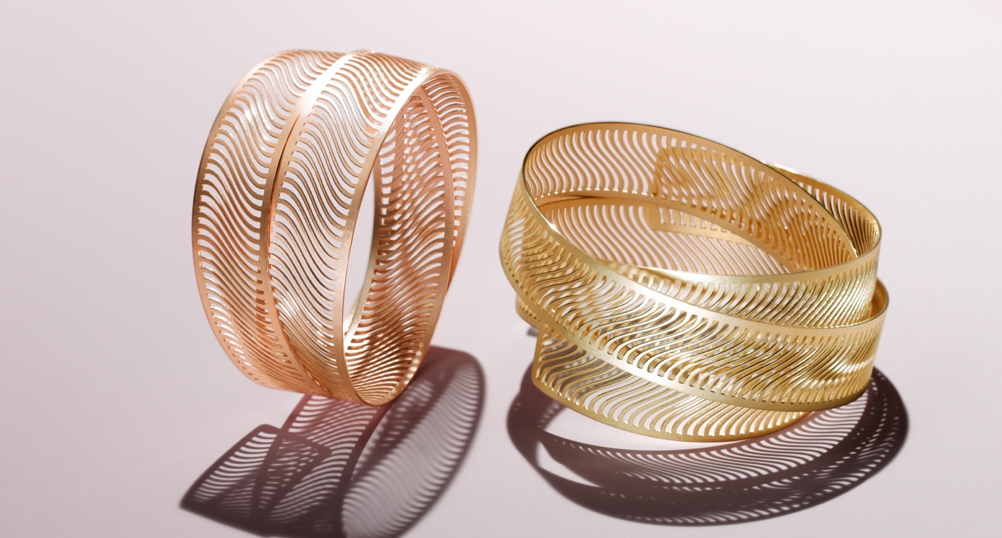

NIESSING MIRAGE COLLIER AND BANGLES

EVERY MOVEMENT REVEALS A NEW SECRET

PRECIOUS, VIBRANT JEWELRY
Flexible bands of slender strips encircle the neck and wrist, delicately and with iridescence. Every move creates a new and fascinating
pattern: exquisite, captivatingly vibrant jewelry that develops its very own dynamics.

EXQUISITELY SHIMMERING AT THE NECKLINE
The Mirage Collier is a twice wound band with dynamic, sweeping strips. Where the ends of the piece of jewelry meet, a push-in connection is worked into the band of precious metal: barely visible, easy to handle, and absolutely secure.

The two layers of fine strips shift in relation to each other through movement when worn. The impression is fascinating: shining and iridescent, the ever-changing structures give the necklace a continuously changing appearance. The handcrafted edges of the fine strips are polished to a high gloss. This creates the unique iridescent effect of the Niessing Mirage necklace.

EXTRAVAGANT AND PRESENT
Shorter variants of the Mirage Bangle loop around the wrist twice, resting around the arm. The two layers of slender, dynamic, sweeping strips shift in relation to each other. The longer Mirage bangle forms a triple loop, with the individual layers smoothly interlacing; the jewelry gains an extraordinarily spacious yet extravagant presence.
Discover the fascinating play of illusions!

NIESSING MIRAGE LOOP

THE LOVELIEST SYMBOL OF ETERNITY

ARCHITECTURE IN MINIATURE
An iridescent band with slender strips, artfully intertwined, becomes a delicate pendant. Mirage Loop plays with illusions: an architectural work of art, self-contained without beginning or end. What shape of the infinite do you see? A vortex in the ocean that magically captivates the viewer's gaze? A shimmering seashell on the beach? Whatever the eye beholds: Discover the magic of eternity!

MORE INTRICATE FOR THE NIESSING SELECTION
For the Niessing Selection – our »handpicked selection« of unique design classics for the Niessing Coil – we have made Mirage Loop even more intricate and delicate. It appears different from every new perspective and change of light – and always unique.

NIESSING MIRAGE LIMITED EDITION

Reach for the stars!

WE LET MIRAGE SPARKLE
This strictly limited edition celebrates the Mirage design, which has won numerous awards – only 99 pieces of each shape and Niessing Color will be produced. Twelve diamonds meet the delicate pendants. The seemingly random arrangement of the precious gems on the slender strips of the jewelry pieces creates a fascinating symbiosis and additionally enhances the Mirage effect: it shimmers even more from within, exuding greater luster and vibrancy.

UNIQUE SETTING TECHNIQUE FOR FINE DIAMONDS
Thanks to the innovative setting technique, as well as those further developed especially for this Limited Edition, the diamonds and the dazzling precious metal outdo one another in their radiance: mysteriously twinkling points of light against the midnight blue sky, like magic stardust…

Reach for the stars!

SUSTAINABILITY AND OUR COMPANY CULTURE

THINK SUSTAINABLY – ACT WITH ENVIRONMENTAL AWARENESS

All Niessing precious metals are obtained in a sustainable manner. The gold we use is exclusively from the recovery of secondary resources (recycling) – also referred to as urban mining – and we obtain precious metals from certified German and Swiss refineries. The entire alloying process takes place at Niessing in the manufactory, where recycling and reutilization also have top priority. Recycled precious metal is the most sustainable source for our exclusive pieces of jewelry.

CERTIFIED BY THE RESPONSIBLE JEWELLERY COUNCIL
Niessing – a certified member of the Responsible Jewellery Council since January 2021 –
publishes a comprehensive sustainability report once a year with an overview of its commitment to manufacturing and design, supply chains, employees, the environment as well as social responsibility.

Status: July 2023

