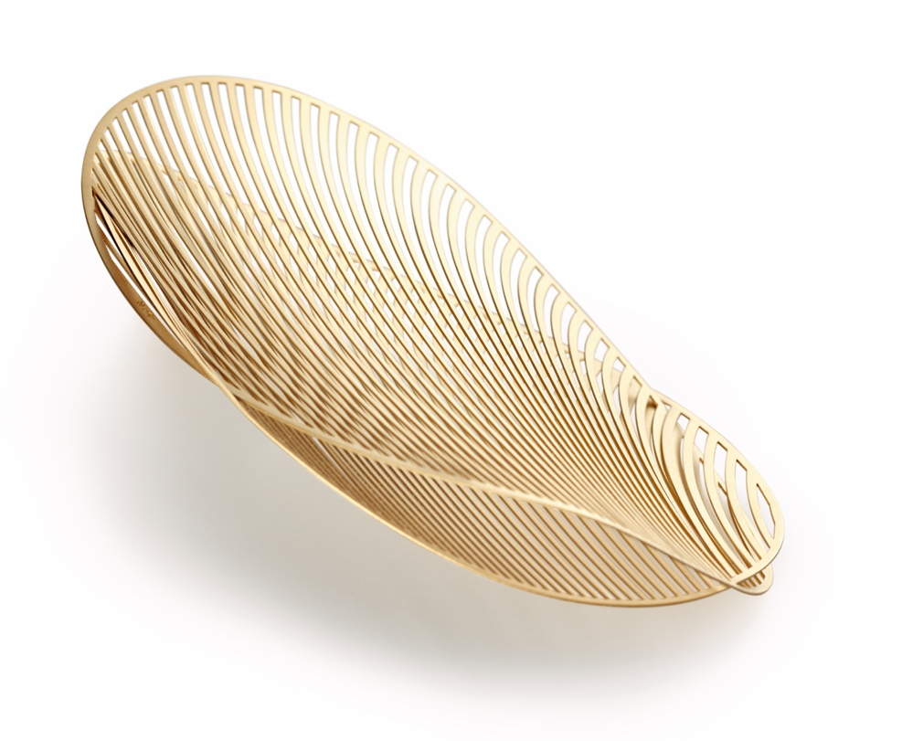

TC NIESSING MIRAGE

NIESSING MIRAGE

DESCRIPTION
Niessing Mirage is a jewelry concept, a study, an experiment.
We took our inspiration from nature, as we often do: delicate, leafy structures, feathers, dragonfly wings.
The challenge lies in processing the precious metal to such a fine degree that it acquires this very light, feathery character.
Only a refined, innovative laser method and new manufacturing andprogramming techniques developed by Niessing have made Mirage possible.

The basic, geometric shapes of Mirage—circles and ovals—are 0.3 mm thick and manufactured in various sizes: The circular shapes are available in diameters of 20, 30, 50 and 70 mm. The oval shapes are available in the sizes 30 x 50, 40 x 70 and 50 x 80 mm.
Delicate, slender strips form a gracefully sweeping bridge across each shape, increasing from 0.3 to 0.9 mm.

To form a piece of Mirage jewelry, two basic shapes are inserted into each other using a clever technique; no further parts are required for joining the two. New outlines and free, organic shapes are the result: Niessing Mirage plays with its traits of an art object.
Pieces of Niessing Mirage jewelry adapt to their surroundings: they can be worn as pendants on the Niessing Coil or with a pin as a brooch.
Smaller pieces of Mirage jewelry easily transform from pendants to earrings: to do this, the earrings are simply threaded in or out. The earrings are crafted for the left and the right ear, respectively – the jewelry provides a perfect frame for your face.

The Niessing Coil runs naturally through the two halves of the jewelry object; it all but disappears in the shimmering interior. Mirage has neither top nor bottom, neither front nor back. Each side is different and presents a different pattern, a new reflection, a fresh image with each move.

Mirage is manufactured in platinum and gold in the Niessing Colors Classic Yellow and Classic Red. The velvety matt texture of the surface Velvet and polished edges perfectly highlight the shimmering effect.

Each piece of Mirage jewelry can be provided with a diamond between 0.01 and 0.02 ct for the area between the strips.

COMMENT
Mirage means »mirror«, »reflection«, »Fata Morgana«. Niessing Mirage plays with illusions.
The great jewelry absorbs the light in all its facets and reflects it.
The singular structure of Mirage deepens the Niessing Colors, letting them glow in surprising intensity.

The individual shapes with their slender strips overlap and create the illusion of a transparent body. The air inside the jewelry pieces seems to shimmer and flicker. Gold and platinum in a surprising new appearance: dazzling, whirring, transparent.
Fascinating images emerge, reminding us of the delicate wings of dragonflies or of leaves swirling in the golden winds of fall. Glittering lights dance on the gold strips like sunshine on flowing water.
Light as a feather and vibrant with each touch, these slender jewelry objects also create an unusual haptic experience. Mirage feels surprisingly soft and smooth.

The overlapping strips of precious metal create an effect of flow and motion, enchanting for the person wearing the jewelry—and for anyone around her.
The jewelry has a different appearance from each perspective, always working its spell on the observer. It invites us to touch it, look at it from all sides, and playfully discover new images. The visual effects turn the fine, graphic lines into an organic object that reminds us of feathers or fine-veined leaves.

Niessing Mirage is a fascinating play of illusions, a vision of weightlessness in gold or platinum. Enter into a surreal dream world with Mirage: Which image emerges in the mind‘s eye?!
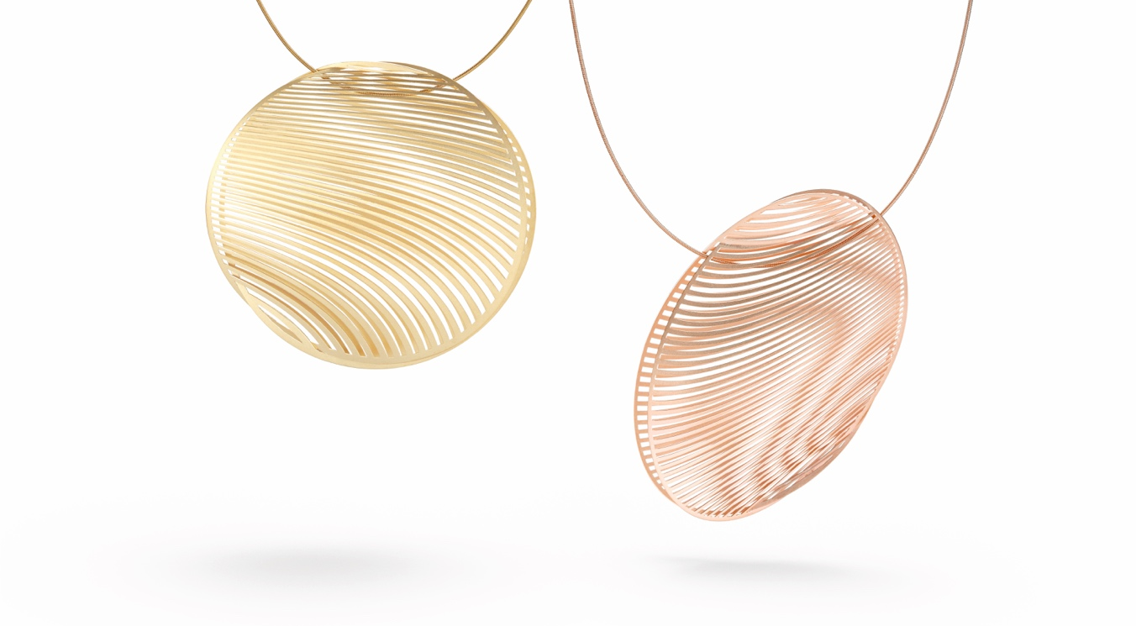

THIS KIT CONTAINS:

MIRAGE OVAL
- 1 x Pendant Mirage Oval, 50 mm length, N333050, AU 750 Classic Red
- 1 x Coil, Ø 1.2 mm, 450 mm length, N163112-VS, AU 750 Classic Red
- 1 x Pendant Mirage Oval, 70 mm length, N333950, PT 950 Platinum, 0.02 ct
- 1 x Coil, Ø 1.2 mm, 600 mm length, N163112-VS, PT 950 Platinum
- 1 x Pendant Mirage Oval, 80 mm length, N333050, AU 750 Classic Yellow
- 1 x Coil, Ø 1.0 mm, 730 mm length, N163110-VS, AU 750 Classic Yellow
- 2 x Earrings Mirage Oval, 50 mm length, N334950, AU 750 Classic Red, each 0.02 ct
- 2 x Carrier Elements Mirage, 27 mm length, NFTE033, AU 750 Classic Red

MIRAGE CIRCLE
- 1 x Pendant Mirage Circle, Ø 30 mm, N333930, PT 950 Platinum, 0.02 ct
- 1 x Coil, Ø 1.2 mm, 450 mm length, N163112-VS, PT 950 Platinum
- 1 x Pendant Mirage Circle, Ø 50 mm, N333930, AU 750 Classic Red, 0.02 ct
- 1 x Coil, Ø 1.2 mm, 600 mm length, N163112-VS, AU 750 Classic Red
- 1 x Pendant Mirage Circle, Ø 70 mm, N333030, AU 750 Classic Yellow
- 1 x Coil, Ø 1.0 mm, 730 mm length, N163110-VS, AU 750 Classic Yellow
- 2 x Earrings Mirage Circle, Ø 30 mm, N334030, AU 750 Classic Yellow
- 2 x Carrier Elements Mirage, 27 mm length, NFTE033, AU 750 Classic Yellow
- 2 x Earrings Mirage Circle, Ø 20 mm, N334920-SF incl. Stopper NFST018, AU 750 Classic Red, each 0.01 ct
- 2 x Earrings Mirage Circle, Ø 20 mm, N334020-SF incl. Stopper NFST018, PT 950 Platinum

- 1x Niessing pin jewelry 80 mm, N175023, AU 750 Classic Yellow/Steel inclusive stopper NFST018, AU 750 Classic Yellow
- 1 x Display Set incl. Marketing Tools

