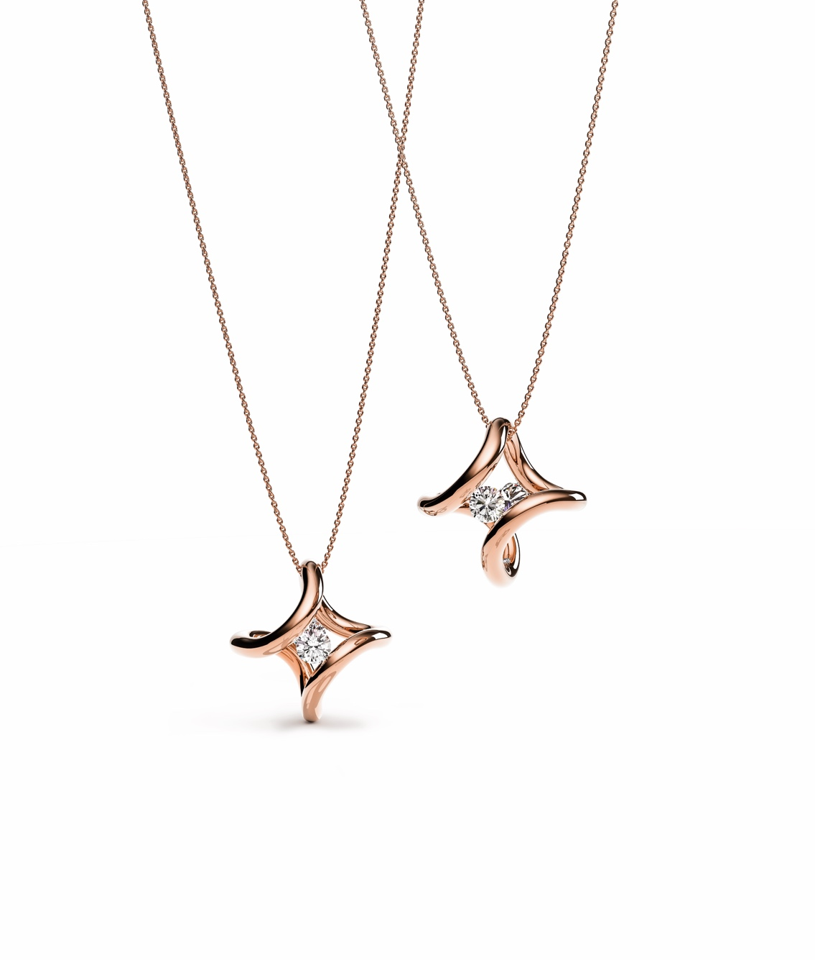

TC NIESSING SPANNRING® ERA PENDANT

NIESSING SPANNRING® ERA PENDANT
Pendant

SLOGAN
NIESSING SPANNRING® ERA HIGHLIGHTS – Are you ready for the original of a new Era?

ESSENCE
A delicate, endless band of gold or platinum encircles two precious diamonds. Its fascinating design with fine, curved arches eliminates the need for an eyelet in the new Niessing Spannring® Era pendant: the Niessing Coil or Niessing Chain are simply pulled through it – one of the sparkling diamonds always faces forward. The pendant perfectly complements the bold statement tension ring Era. Are you ready for the original of a new era?

DESIGN OF A NEW ERA
The Niessing Spannring® embodies our deep roots in Bauhaus design like no other piece of Niessing jewelry. Since its invention over 40 years ago, this ring, which allows the diamond to float above the hand without any setting whatsoever, has become an icon of jewelry design that has won numerous awards. What could be a more appropriate way to celebrate the manufactory’s 150th anniversary than with a design that takes an entirely new look at the Niessing Spannring® and turns it into an opulent statement ring and fascinating pendant highlighted by two diamonds?

FOLLOW YOUR EMOTIONS: »FORM FOLLOWS EMOTION«
The Niessing Spannring® Era pays tribute to the original form of the Niessing tension ring and reinterprets it in a spectacular way. The ring’s perfectly round, endless band encircles the finger: Curving into two fine arches in an entirely organic manner, it gently and securely holds the precious diamond. A bold statement for the hand.
The Niessing Spannring® Era pendant is the perfect complement: a delicate, endless band of gold or platinum encircles two precious diamonds. Its extraordinary form eliminates the need of an eyelet for the Niessing Spannring® Era pendant. The Niessing Coil or Niessing Chain are simply pulled through it – one of the sparkling diamonds always faces forward.

INSPIRED BY THE IDEALS OF BAUHAUS DESIGN
The design of Era is inspired by the work of the Bauhaus movement. In 1926, leading architects founded an association called »Der Ring« (The Ring), among them the father of the Bauhaus, Walter Gropius, and Ludwig Mies von der Rohe. At the same time, Mies van der Rohe designed the first flexible cantilever chair. It was later reported that van der Rohe created the design using a few strokes carried out with a mere »flick of the wrist«.

SENSUOUS MINIMALISM MEETS PURE BEAUTY
The seemingly endless, curved form of the new Niessing Spannring® Era pendant also appears exceedingly light and natural – as if drawn on paper in a single, powerful stroke. This design gives the two diamonds spectacular freedom, at the same time providing them with the greatest possible security. The pendant represents the sensuous minimalism of Bauhaus design and translates the motto »form follows function« into »form follows emotion«. Sweeping, free, and graceful: Are you ready for the original of a new era?

VIBRANT SETTING FOR PRECIOUS DIAMONDS
The new Niessing Spannring® Era pendant is available in platinum and in gold in the Niessing Colors Classic Yellow, Classic Red, Fine Rose, Rosewood and in the new, historic Supla Grenadine: a rosé-colored, warmly shimmering gold with the fascinatingly luminous luster of platinum.

A perfectly round, endless band, organically curving into two fine arches, securely holds two precious diamonds of 0.15 ct each. The pendant requires no eyelet: the Niessing Coil or Niessing Chain are simply pulled through it. With its unique design, one of the sparkling diamonds always faces forward.

An exclusive engraving makes the Niessing Spannring® Era pendant even more precious on the occasion of the anniversary. The engraving is strictly limited to the year 2023.

