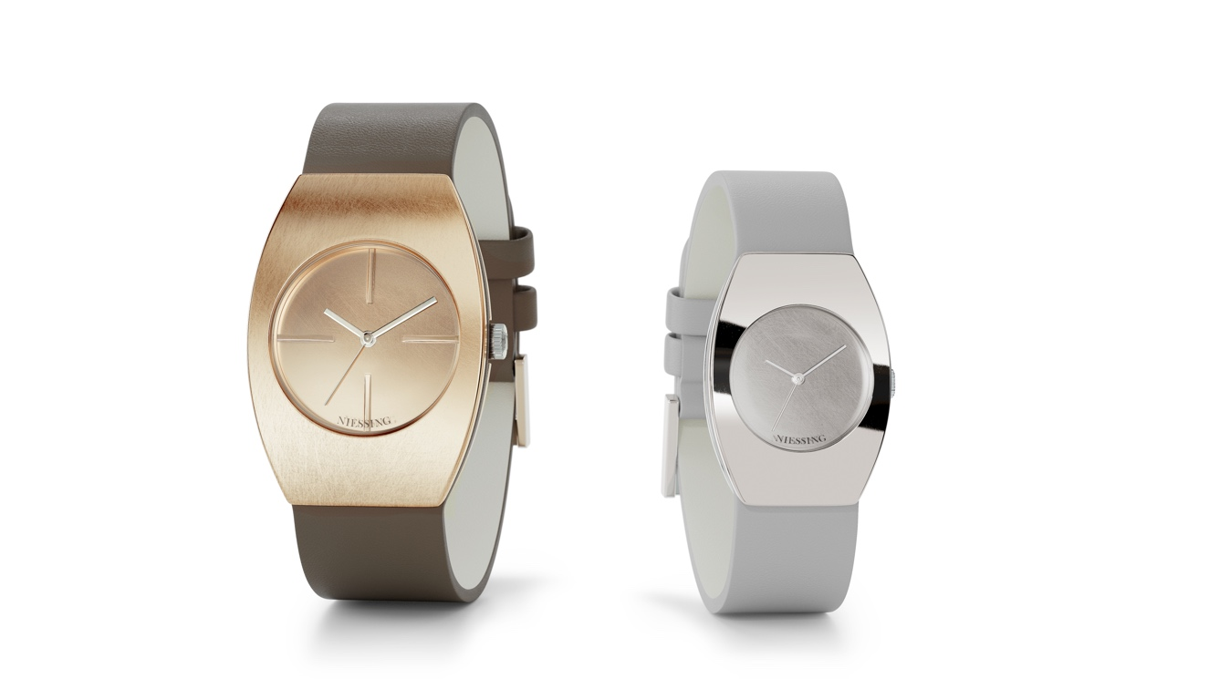

TC NIESSING RADIUS 9 FORMA

NIESSING RADIUS 9 FORMA

DESCRIPTION
The Niessing Radius 9 family has a new member: The gentle tonneau shape of the new Niessing Radius 9 Forma takes the classic rectangular watch design to the next level. The distinct design inspired by Bauhaus meets the power of colors: Niessing Platinum and unique Niessing Gold Colors can be freely combined with leather watch straps in 28 shades from taupe and gray to pink, azure and mint.
The Niessing Radius 9 Forma is crafted in sizes M and L, with the circumference of the wrist and personal taste solely determining which size fits best.
The structure of the watch models is identical: two plates of precious metal enclose the movement, and the leather watch strap runs between them – viewed from the side, the watch appears to be divided into three parts, as if it followed a »sandwich principle« design.

The precious metal plates for Niessing watches are fashioned from a solid bar of gold or platinum. The case and dial are made of the same precious metal and form a single piece. The watches are optionally matt or glossy. All models are available with a quartz movement; the L versions are optionally available with an automatic movement. Custom engraving on the back of the watch is possible for models with a quartz movement.

The watch straps are each offered in three different lengths. The colors black and taupe are always available as standard colors.
All of the technical information can be found in the training folder.

COMMENT
Elegant, unconventional – and typical of Niessing‘s Bauhaus-inspired design. The design of the new watch is based on the Niessing Radius 9 Classic, allowing the shape to grow organically from the austere rectangle. The precious metal plates are curved to form a circle segment with a radius of 9 centimeters, a design detail in accordance with the Bauhaus principle »form follows function« and at the same time the origin of the name »Radius 9«. The curved contours of the Niessing Radius 9 Forma fit the wrist perfectly.

And it is just as colorful, because for Niessing, the color of a piece of jewelry is at least as important as its shape. Create your own personal piece of jewelry for the wrist – and redesign your time in a whole new way with the Niessing Radius 9 Forma. What is the shape of your time?

ESSENCE
Feel time with all your senses! An elegant shape meets numerous exciting Niessing Colors and 28 extravagant leather colors. The Niessing Radius 9 Forma takes the iconic design of the Niessing Radius 9 Classic to the next level: a rectangle becomes a gentle tonneau, and the curved contours fit the wrist perfectly. What is the shape of your time?

