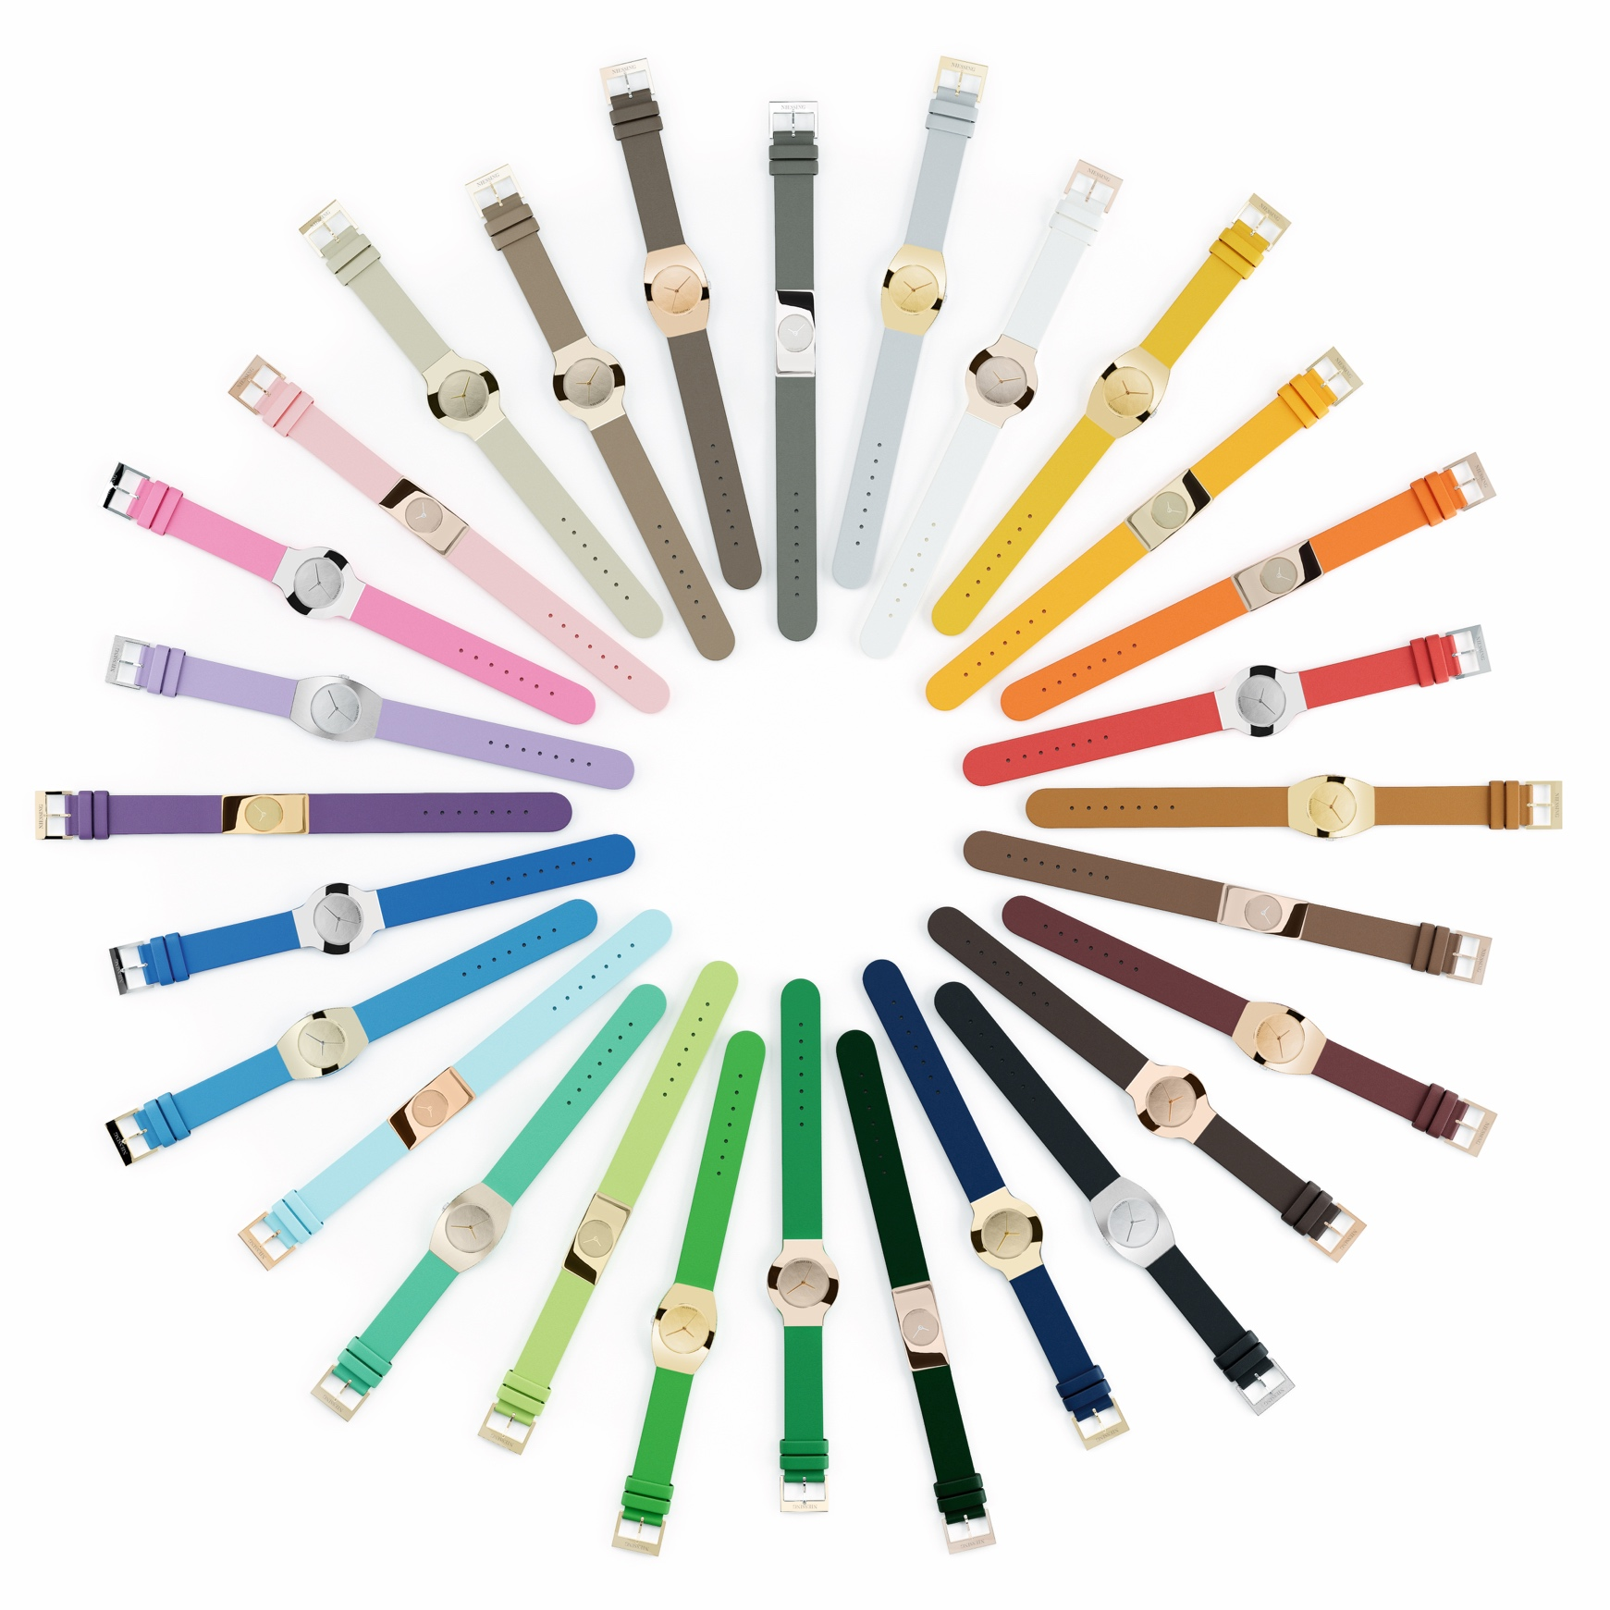

NIESSING RADIUS 9 –

WHAT IS THE COLOR OF YOUR TIME?

TABLE OF CONTENTS

3 RADIUS 9: THE NIESSING WATCH
Short version / News: The luxury of a new era
Long version: What is the color of your time?

4 THE NIESSING WATCH AND BAUHAUS
Form follows function – and emotion

5 RADIUS 9 CLASSIC – FORMA – KONTURA
The metamorphosis of a watch design

5 6 STEPS FOR A PERSONAL RADIUS 9
What is the expression of your time?

7 SUSTAINABILITY AND OUR COMPANY CULTURE

RADIUS 9: THE NIESSING WATCH
– SHORT VERSION / NEWS –
THE LUXURY OF A NEW ERA
The iconic Radius 9 Classic and the two new models, Radius 9 Forma and Kontura, are more colorful than ever before: Platinum, eight unique Niessing gold colors and leather straps in 28 exciting shades from azure to turquoise to mint, from pink to lilac add a bit more color and joy to every day. Enjoy colorful times!
Extravagant and personal: The twice-wrapped leather strap of the smallest Niessing Radius 9 Classic is the perfect showcase for your favorite color. Whether strong contrasts or subtle harmony: Feel the spirit of color!

RADIUS 9: THE NIESSING WATCH
– LONG VERSION –
WHAT IS THE COLOR OF YOUR TIME?
THE WATCH OF A NEW ERA
Can a timepiece be timeless? Niessing and the designer Günter Wermekes have been pondering this question for over 30 years now. The Niessing Radius 9 Classic has become a timeless piece of jewelry that indicates the time. The geometrically clear design and the structural features of the Niessing Radius 9 Classic remain pioneering to this day.

»FORM FOLLOWS FUNCTION«
The distinct, serene form appears sensual and soft at the same time, because the precious metal plates are curved to form a circle segment with a radius of 9 centimeters – its soft curvature fits perfectly to the wrist. It is a design detail in accordance with the Bauhaus principle »form follows function« and at the same time the origin of the name »Radius 9«.

UNIQUE CONTRUCTION – ICONIC DESIGN
The simple yet unique construction of the watch has made design history: two plates of precious metal enclose the movement, and the leather watch strap runs between them – viewed from the side, the watch appears to be divided into three parts, as if it followed a »sandwich principle« design. A slight but clear protrusion of the leather strap further emphasizes this impression.

METAMORPHOSIS OF A FORM
To mark the 25th anniversary of the award-winning Radius 9 Classic, Niessing has begun collaborating with designer Günter Wermekes to develop two new Niessing watches that consistently take the iconic design to the next level: The result is the metamorphosis of this iconic form and a new chapter in the history of Niessing watch design.

DESIGN MEETS COLOR
In addition, all Radius 9 models are now available in many exclusive Niessing Colors and with fine leather watch straps in 28 exciting shades. Its minimalist, Bauhaus-inspired form has already made design history. Its sensual colorfulness now lends time a new dimension full of ease and vitality. Warm Niessing Rosewood Gold with a watch strap in taupe, Niessing Platinum combined with cool light blue, or Niessing Spring Green Gold with fresh mint: What is the color of your time?

AWARD WINNER: PRIZES FOR THE RADIUS 9
In 1993, the Niessing Radius 9 Classic was awarded the honorary prize for product design by the state of North Rhine-Westphalia and the »Platinum Design of the Year 1993« prize by the Platinum Guild International. A year later, the watch received the »Red Dot Design Award Winner« prize. In addition, the Niessing Radius 9 Classic can be found in one of the largest design collections in the world, the »Neuen Sammlung« of the Pinakothek der Moderne in Munich.

THE NIESSING WATCH AND BAUHAUS

FORM FOLLOWS FUNCTION – AND EMOTION

DEEPLY ROOTED IN BAUHAUS PHILOSOPHY
»Niessing should not only design jewelry, but a watch as well!« declared Jochen Exner, the Niessing owner at the time, and designer Günter Wermekes made that decision in 1991. The fact that the idea arose during a visit to Dessau of all places – more precisely: in front of the Bauhaus building by Walter Gropius – could not have been more fitting, once again illustrating the deep roots of the Vreden jewelry manufactory in Bauhaus philosophy.

AN IDEA TAKES SHAPE
It took two years from the idea to the finished watch: the Niessing Radius 9 Classic was launched on the market in 1993 and has long since become a design icon. Two plates of precious metal enclose the movement. The leather watch strap runs between them – viewed from the side, the watch appears to be divided into three parts, as if it followed a »sandwich principle« design.

»FORM FOLLOWS FUNCTION«
The distinct, serene form appears sensual and soft at the same time, because the precious metal plates are curved to form a circle segment with a radius of 9 centimeters – its soft curvature fits perfectly to the wrist. It is a design detail in accordance with the Bauhaus principle »form follows function« and at the same time the origin of the name »Radius 9«.

ICONIC BAUHAUS DESIGN
The Niessing Radius 9 Classic has perfectly combined form and function for 30 years now; it provides a contemporary expression to the experience of time. Its clear, rectangular design is discreet and at the same time very present. Thanks to its slightly curved anatomical shape, it merges with the wrist – a very pleasant everyday companion.

»FORM FOLLOWS EMOTION«
With the new color range of the Niessing watch – making it possible to combine platinum and eight unique Niessing gold colors with leather straps in 28 exciting shades – we translate yet another Bauhaus statement into modern jewelry design: »My favorite color is colorful.« This declaration by
Bauhaus founder Walter Gropius inspires Niessing time and again. Niessing designers love colors: they are convinced that the color of a piece of jewelry is at least as important as its shape. Color expresses personality, it touches our innermost being – colors are pure emotion.
The three Niessing Radius 9 models turn »form follows function« into »form follows emotion«.

CLASSIC – FORMA – KONTURA

THE METAMORPHOSIS OF A WATCH DESIGN

RADIUS 9 CLASSIC: ICONIC DESIGN
The Niessing Radius 9 Classic has perfectly combined form and function for 30 years now. Its clear, rectangular design is discreet and at the same time very present. Thanks to its slightly curved anatomical shape, it merges with the wrist – a very pleasant everyday companion.

RADIUS 9 CLASSIC AND WATCH STRAP WITH DOUBLE WINDING
The smallest model of the Niessing Radius 9 Classic is available with an extra-long leather watch strap: Wrapped twice around the wrist, it brings out the 28 exciting shades of the fine leather straps with particular beauty: for an extravagant and very personal look.

EVOLUTION FROM CLASSIC TO FORMA …
The gentle tonneau shape of the new Niessing Radius 9 Forma takes the clear Bauhaus design of the rectangular Radius 9 Classic to the next level, reinterpreting the traditional tonneau in the process. The design is based on the Niessing Radius 9 Classic, allowing the shape to grow organically from the austere rectangle. Elegant, unconventional – and typical of Niessing's Bauhaus-inspired design. The curved contours of the Niessing Radius 9 Forma fit the wrist perfectly.

… AND FROM FORMA TO KONTURA
The Radius 9 Kontura is a further step in the Niessing watch evolution, and it is perfectly rounded. Round watches are classics. Yet the Niessing Radius 9 Kontura is more than that: Its shape, typical of Bauhaus design, has evolved from the rectangle of the Niessing Radius 9 Classic and the gentle tonneau of the Niessing Radius 9 Forma. The result of this metamorphosis: a modern classic that is more a piece of jewelry than a watch. Minimalist and distinct, an expression of individuality and pure vitality.

6 STEPS FOR A PERSONAL RADIUS 9

WHAT IS THE EXPRESSION OF YOUR TIME?

1 SHAPE
SOFT OR CLEAR?
Which shape is right for you and suits your personality? The three models of the Niessing Radius 9 watch stand for the evolution of an

iconic design: From the geometrically clear rectangle of the Classic to the gentle tonneau of the Forma, and on to the perfectly rounded Kontura. Follow your feelings!

2 SIZE AND MOVEMENT
GRACEFUL OR POWERFUL?
The Niessing Radius 9 Forma does not distinguish between a model for men or women: The circumference of the wrist determines which size fits best, as well as your personal sense of style. Depending on the size, you can choose between quartz and automatic movements.

3 COLOR
WHAT IS THE COLOR OF YOUR TIME?
Color is pure emotion – lending an iconic design new sensuality. Discover gold as warmly shimmering as a sandy beach, gold with a hint of rosewood and platinum in radiant white. Whether Sand Gray or Rosewood, Classic Yellow, Classic Red, Fine Rose, Fine Gray, Spring Green, Ivory or Platinum – one of the unique Niessing Colors is sure to capture the essence of your time.

4 TEXTURE
REFLECTIVE OR MATT?
The surface determines the look of your watch as well. With the matt, shimmering Nature texture, the watch is understated, purist and elegant. With the Gloss texture, polished to a high gloss, it appears modern and extravagant. Both textures are crafted by hand and enhance each of the unique Niessing Colors in a very special way.

5 WATCH STRAP
DISCREET OR EXTRAVAGANT?
Combine the Niessing Colors with leather watch straps in 28 exciting colors. Platinum with black: a powerful contrast. Rosewood Gold with shades of brown: an expression of subtle harmony. Ivory Gold with gray straps: natural and refined. Straps in shades such as pink, azure, turquoise, mint or sunny yellow guarantee a grand entrance. Give time your very own color!

6 ENGRAVING
WHAT IS YOUR MESSAGE?
Would you like to have your watch personally engraved? Perhaps a message for yourself? Or a dedication for a loved one? Whether a short text or a personal sketch: our specialists gladly make your wish a reality. Only Radius 9 watches with a quartz movement can be engraved on the back.

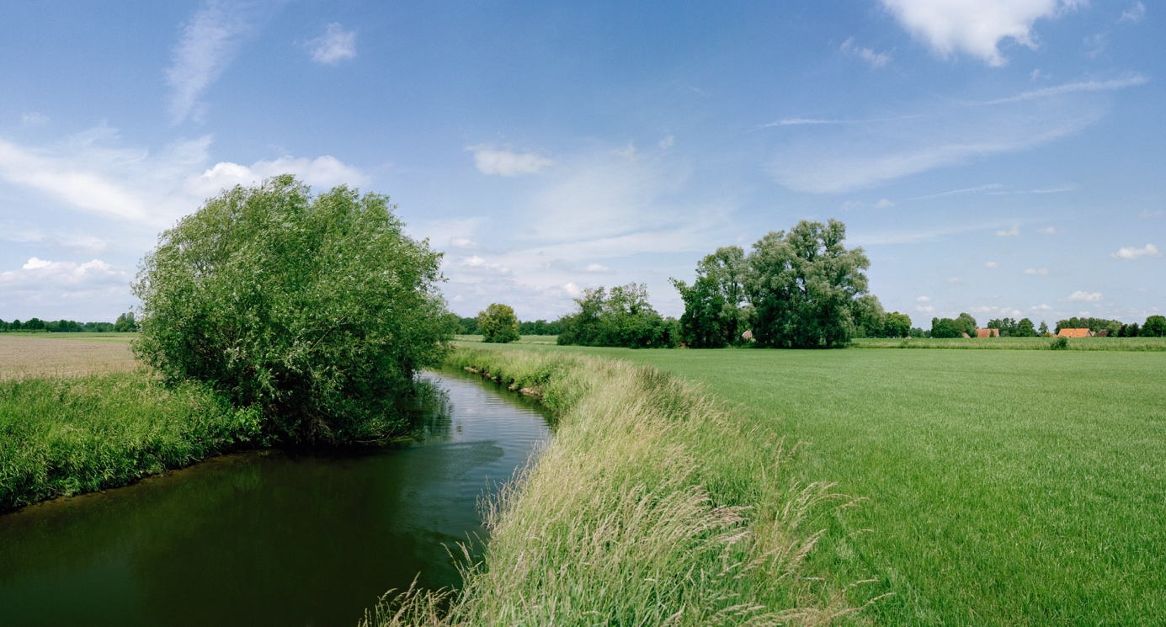

SUSTAINABILITY AND OUR COMPANY CULTURE

THINK SUSTAINABLY – ACT WITH ENVIRONMENTAL AWARENESS

All Niessing precious metals are obtained in a sustainable manner. The gold we use is exclusively from the recovery of secondary resources (recycling) – also referred to as urban mining – and we obtain precious metals from certified German and Swiss refineries. The entire alloying process takes place at Niessing in the manufactory, where recycling and reutilization also have top priority. Recycled precious metal is the most sustainable source for our exclusive pieces of jewelry.

CERTIFIED BY THE RESPONSIBLE JEWELLERY COUNCIL
Niessing – a certified member of the Responsible Jewellery Council since January 2021 – publishes a comprehensive sustainability report once a year with an overview of its commitment to manufacturing and design, supply chains, employees, the environment as well as social responsibility.

Status: August 2023

