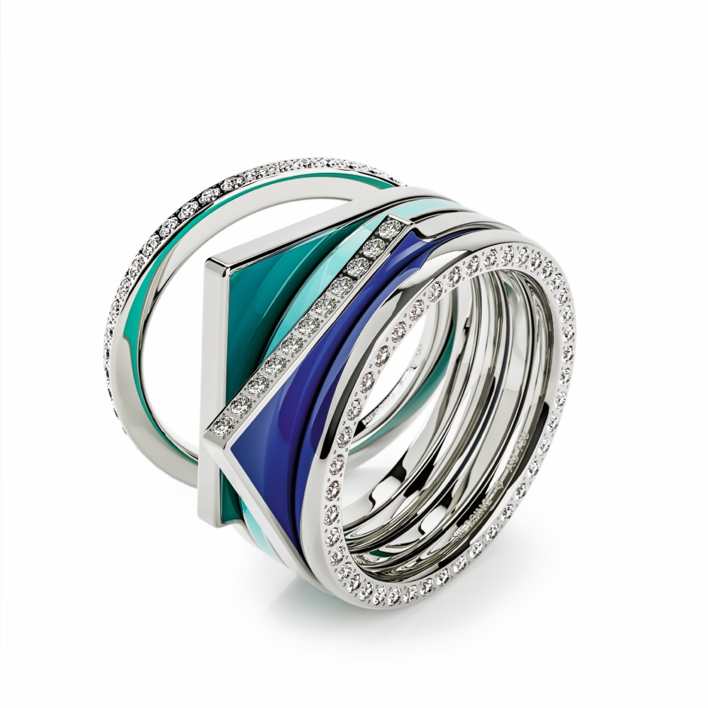

TC NIESSING SETARIO

NIESSING SETARIO

SLOGAN
NIESSING SETARIO - Discover the magical kiss of color!

ESSENCE
In this anniversary year, we completely reinterpret the first great Niessing jewelry classic: Setario. Inspired by the Bauhaus theory of colors and forms, the elegant rings in gold or platinum play with shapes, exclusive enamel colors and sparkling diamonds. Since its invention in the mid-1970s, Setario‘s name, a neologism derived from the words »set« and »variation,« says it all. Setario is synonymous with collectible rings that can be combined over and over again for colorful creations. Setario makes trendy ring stacking possible not only with its own kind, but also with a Niessing Spannring®, with Niessing color rings, with Amatis or Satellite.
Depending on your mood, create beautiful color tones and ever-changing, unique images.
Discover the magical kiss of color!

SETARIO ANNUAL RING 2023
Exclusively for the 150th anniversary of the manufactory and limited to the year 2023, the Setario annual ring is available in the new Niessing Color Supla Grenadine. Sparkling diamonds meet a historic Niessing Color and colorful enamel: an intricate masterpiece of the goldsmith‘s art. It is also a

precious collector‘s item that will make your Setario creations even more unique.
Collect, explore – and discover the magic!

SETARIO DESIGNER´S SELECTION
Niessing‘s designers have made an exclusive pre-selection of color combinations for you. In this Designers‘ Selection, platinum, the Niessing Gold Colors, and the Niessing enamel colors are coordinated to perfection. The selection includes seven Line and three Wave models. A new look for each and every day. Discover splendid variations!

COLORFUL CREATIONS FOR YOUR HAND
The new, elegant Setario rings are modeled after a great design with the same name. In the early 1970s, Niessing launched Setario, the manufactory‘s first jewelry line, an idea of Ursula Exner, then owner of Niessing and granddaughter of the manufactory‘s founder.

SET COLORFUL ACCENTS
Setario‘s name, derived from the words »set« and »variation,« says it all: A variety of ring forms with soft curves has been crafted in gold with various color tones of enamel – with or without diamonds. Ever since, Niessing Setario has been synonymous with collectible rings that can be combined over and over again for colorful creations. They also set lovely accents, whether worn alone or combined with one another

INSPIRED BY THE BAUHAUS THEORY OF COLORS AND FORMS
For the 150th anniversary of the manufactory, the new Setario debuts as a tribute to the Bauhaus theory of colors and forms, as well as to the creative, playful approach to jewelry.
The delicate Setario rings turn ring stacking into an expression of pure vitality: They provide endless possibilities for individual creations – new every single day, according to your desire for unique creations.

DISCOVER MAGICAL VARIATIONS
Today, Setario provides even more possibilities than in the 1970s: at that time, the rings could only be combined with one another – today, every Setario also fits perfectly to the Niessing Spannring®, an engagement ring such as Amatis, to Niessing colored rings or Satellite. Discover the magic!

RING TO RING: GET CREATIVE!
Three ring shapes, five Niessing Colors, and ten exclusive Niessing enamel colors: this selection makes collecting and combining fun. Setario Line is a minimalist, linear color accent; Setario Wave ripples around the finger in delicate curves. Setario Square is gently rounded on the one side, and strikingly rectangular on the other.

THE MAGICAL KISS OF COLOR
Each ring is crafted in Niessing Platinum and in gold in Classic Yellow, Classic Red, Rosewood, and Fine Rose. These unique Niessing Colors can be

combined with ten exclusive Niessing enamel colors to suit every taste. The colors are specially mixed at Niessing and elaborately prepared by hand. Exclusively for the 150th anniversary of the manufactory and only in 2023, the Setario annual ring is available in the iconic Niessing Color Supla Grenadine with enamel and diamonds.
In Setario Line and Setario Wave, the enamel decorates the entire ring centrally, whereas in Setario Square it adorns both sides of the ring. All three rings can alternatively be set with the finest diamonds – for that extra sparkle that makes every single day special.

EXPRESS YOUR FEELINGS WITH SETARIO
Will you choose the colorful enamel nuances harmoniously coordinated with the Niessing Colors? Or will you go for striking contrasts? Discover how a complementary color can increase the radiance of gold and platinum! Discover anew every day the colors that suit your mood and your look: Does Setario reflect the color scheme of your wardrobe or do the rings provide a counterpoint? Choose fresh hues in spring, cheerful colorful ones in summer, warm shades in fall and cool ones in winter. Express your feelings with Setario!

RING TO RING: GET CREATIVE!
Combine Setario Line with Setario Wave, collect Setario Square with or without diamonds, and wear it together with Setario Line. Discover how well Setario goes with your Satellite or Spannring Heaven. Ring to ring to ring: ever varying shapes and colors make for endless possibilities.

Collect, explore – and discover the magical kiss of color!

A FORM FOR EVERY PERSONALITY
The new line of Setario rings includes three different models: Setario Line, Setario Wave and Setario Square.

FIVE NIESSING COLORS MEET TEN ENAMEL COLORS
They are crafted in Niessing Platinum and in gold in Classic Yellow, Classic Red, Rosewood, and Fine Rose.
Each Niessing Color can be combined with all of the enamel colors, which can be selected from a total of ten shades. The colors of cold enamel are specially mixed at Niessing and prepared by hand. In Setario Line and Setario Wave, the enamel decorates the entire ring centrally, whereas in Setario Square it adorns both sides of the ring. It is possible to choose two different colors for this ring.
As an alternative to the colored design, all three ring models can be set with the finest diamonds using Niessing‘s own pointed setting technique.

SETARIO ANNUAL RING 2023
Exclusively for the 150th anniversary of the manufactory and only in 2023, the Setario annual ring is available in the iconic Niessing Color Supla Grenadine. This ring combines sparkling diamonds with a historic Niessing

Color and colorful enamel: an intricate masterpiece of the goldsmith’s art and a valuable collector’s item.

SETARIO DESIGNER´S SELECTION
Niessing‘s designers have made an exclusive pre-selection of color combinations. In this Designers‘ Selection, platinum, the Niessing Gold Colors, and the Niessing enamel colors are coordinated to perfection. The selection includes seven Line and three Wave models: for a new look each and every day.

