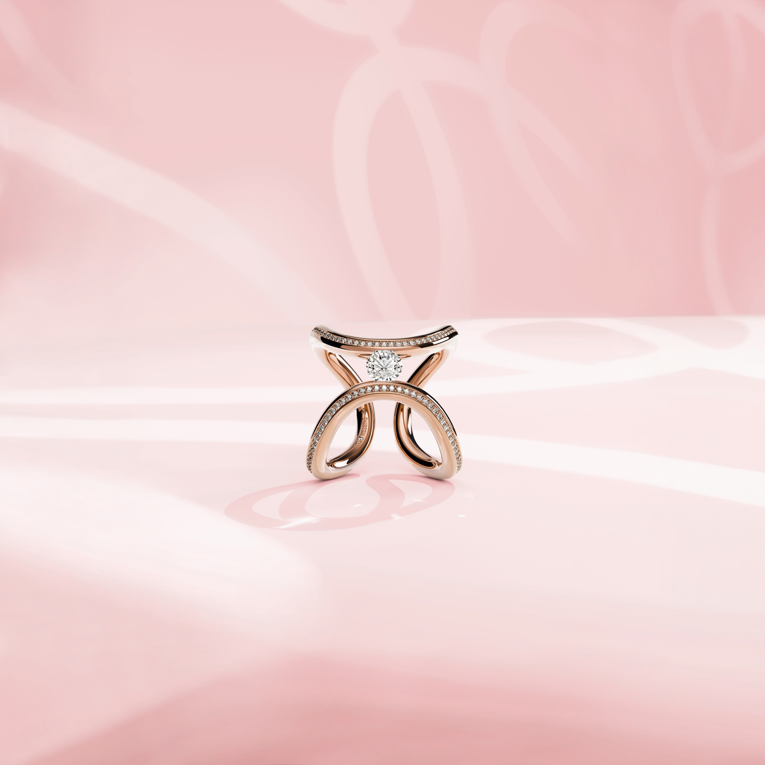

THE NIESSING SPANNRING®

THE MAGIC OF A GRAND IDEA

TABLE OF CONTENTS

3 THE MAGIC OF THE FLOATING DIAMOND

SHORT VERSION: Focus on the Radiant Diamond

LONG VERSION: A Burning Passion for Precious Diamonds

6 THE »HEART AND ARROW«: A SIGN OF THE ORIGINAL

7 PURE FORM – PURE HARMONY

The Many Facets of a Grand Idea

8 NIESSING SPANNRING® GALLERY

More Than 40 Years of Exclusive Spannrings

11 NIESSING DIAMONDS

5C for the Perfect Selection

15 SUSTAINABILITY AND OUR COMPANY CULTURE

THE MAGIC OF THE FLOATING DIAMOND
-SHORT VERSION-

FOCUS ON THE RADIANT DIAMOND
Can a diamond be held by a ring without a setting? In order for light to entirely surround and ignite its fascinating fire that has been hidden for millions of years? Would it not even be possible to let the sparkling diamond »float« above the hand, so that it enjoys the greatest possible freedom, and at the same time is safe and secure?

The Niessing Spannring® answers all of these questions. It is simply the most beautiful way to hold a diamond: a ring and a floating diamond is all it takes!

The Niessing Spannring® was invented over 40 years ago and has long been considered a design icon as well as a classic of modern jewelry design. It focuses on the radiant diamond: nothing distracts from its precious beauty. The Niessing Spannring® is an aesthetic unit, a sculpture that gets to the heart of the matter. It is a wonderful example of the great art of reduction and the Bauhaus credo »less is more«.

The original design has long since been elevated to the status of a work of art, and museums throughout the world display such a Niessing original with the »Heart with Arrow« punch mark in their collections.

Are you ready for the original?

THE MAGIC OF THE FLOATING DIAMOND
-LONG VERSION-

A BURNING PASSION FOR RADIANT DIAMONDS
Forging a Niessing Spannring requires extensive knowledge about the precious materials, a great deal of craftsmanship, and a generous portion of innovative spirit. But the most important thing, as always, is the people involved: our designers, goldsmiths, and stone setters are passionate team players. It is their trained eye and their love for detail that make the diamond float in every single Niessing Spannring®: free, yet safe and secure.

SURROUNDED ENTIRELY BY LIGHT
The principle of the Spannring is as simple as it is revolutionary: the diamond is set in a band at two of the smallest possible points and held securely; it is visible from all sides, appearing to float. The light surrounding it brings it to life, making it shine in every color. A band, a floating diamond – that‘s all it takes for the original..

DEEP ROOTS IN BAUHAUS DESIGN
The Niessing Spannring® is an aesthetic unit, a sculpture that gets to the heart of the matter. It is also a wonderful example of the great art of reduction and the Bauhaus credo »less is more«. Like no other piece of Niessing jewelry, the Niessing Spannring® embodies our deep roots in Bauhaus design.

A RING BECOMES A WORK OF ART
In 2001, the Niessing Spannring® Round was protected by copyright (© Walter Wittek) and elevated to the rank of a work of art. Museums all over the world display such a Niessing original in their collections. Only the Niessing Spannring® is the original with the »Heart and Arrow« punch mark.

Great craftsmanship, sophisticated technologies, and special forging techniques are required to make a Niessing Spannring®. Niessing has over 40 years of experience in this area and has mastered all the necessary techniques to perfection. Special metal alloys were developed especially for the Niessing Spannring®: Only these allow the tension force to be precisely regulated and permanently maintained.

ICONIC DESIGN IN A VARIETY OF SHAPES
With its circular cross section, the Spannring Round gets to the heart of the aesthetics and the idea of the Spannring. Over the years, Niessing designers and goldsmiths have further developed this original shape and created a variety of different Spannrings. There are simple shapes as well as unusual ones; Spannrings that securely hold smaller diamonds and those that perfectly showcase large diamonds. On the occasion of the 150th anniversary of the manufactory, we are celebrating our icon with an extravagant design that takes an entirely new look at the Niessing Spannring®.

Are you ready for the original?

THE »HEART AND ARROW«: A SIGN OF THE ORIGINAL

FOCUS ON THE DIAMOND
Whichever Spannring is selected, the idea remains the same: the focus is on the diamond. The Niessing Spannring® allows it to float above the hand, held firmly in place solely by the invisible tension in the ring. To ensure that it can withstand the special demands of a Niessing Spannring®, each diamond is thoroughly inspected by our experts and precisely fixed in the band of the ring.

EACH RING IS ONE OF A KIND
All Niessing Spannrings bear an individual number that helps us identify them even after many years: Important data such as the tension force in the ring, the ring width and size, color, and quality of the diamond are recorded at Niessing.

Only the Niessing Spannring® is the original with the »Heart and Arrow« punch mark. It is an original that is solely about the beauty of the diamond and the simple shape of the ring. It is also an expression of the personality of its wearer.

PURE FORM – PURE HARMONY

THE MANY FACETS OF A GRAND IDEA

FROM THE ORIGINAL SHAPE TO THE SPANNRING
It‘s difficult to believe: In the beginning, every Niessing Spannring® looks the same! All models have the same origin and are crafted from the same original shape. Even according to our most experienced goldsmiths, it is a magical moment when the work with the glowing metal begins.

JEWELRY RING, ENGAGEMENT RING AND WEDDING RING
The Niessing Spannring® is a jewelry ring, an engagement ring, and a wedding ring. In the Niessing Spannring® collection, it becomes a delicate pendant for the Niessing Coil, an intricate ear ornament, and a Bouton for a T-shirt or lapel.

We have taken great pleasure in experimenting with the Niessing Spannring® in the more than 40 years since its invention and have created numerous unusual designs: delicate and magnificent, modest and extravagant, sensuously curved as well as those that are almost austere and architectural.

A JOURNEY THROUGH THE YEARS OF SPANNRING DESIGN
Join us on a journey through more than 40 years of Spannring design – and discover the many ways in which Niessing designers have interpreted the principle of »less is more«!

NIESSING SPANNRING® GALLERY

MORE THAN 40 YEARS OF EXCLUSIVE SPANNRINGS

NIESSING SPANNRING® ROUND – 1979
The circular cross section of the original shape takes the aesthetics and the idea of the Spannring to the heart of the matter. The Niessing Spannring® Round (© Walter Wittek) has been elevated to the rank of a work of art and is displayed by numerous museums all over the world.

NIESSING SPANNRING® HIGHEND – 1981
Graphically clear in its contour, logical and powerful in its shape. There are virtually no limits to the size of the diamond. A magnificent ring for magnificent diamonds: confident and radiant.

NIESSING SPANNRING® OVAL – 1998
The precious diamond is free and yet safely secured in the gently oval shape. The Spannring is extremely comfortable to wear, even with larger diamonds.

NIESSING SPANNRING® EVEREST – 1998
Rounded on the inside and flat on the outside: a thrilling, extravagant design – the pinnacle of beauty.

NIESSING SPANNRING® TAPERED – 1998
The ring of flowing transitions: Delicate and narrow at the bottom, it grows gently and naturally towards the top. Even with large diamonds, it nestles perfectly upon the hand.
NIESSING SPANNRING® OPENEND – 2005
Sensual fullness is combined with graphic clarity. The diamond rests in a gently ascending form like a blossom in a bud. Even very large diamonds are presented in their perfectly natural setting.

NIESSING SPANNRING® HEAVEN – 2014
Delicate and magnificent: The gently rounded ring opens upward with a sweeping flourish and holds the large diamond floating at a spectacular height. Towards the sky … The design continues the take the two Spannring classics HighEnd and OpenEnd to the next level.

NIESSING SPANNRINGE HIGHLIGHTS – 2015
The Spannrings Heaven, HighEnd, Tapered and Lucia continue the legend of the design icon as Spannring Highlights. Fine lines of light accentuate the beauty of the solitaire, drawing all eyes to it and emphasizing the uniqueness of the design. One of a kind!

NIESSING SPANNRING® LUCIA – 2016
The ring unites expressive contours and flowing curves in perfect balance. Lucia, »she who brings light, graceful light«, combines the warmth of candlelight with the cool sparkle of a starry sky.

NIESSING SPANNRING® ANTARES – 2018
Niessing is entering new galaxies with Antares: Up until its development, extremely delicate Niessing Spannrings were available exclusively in platinum; Antares is the first to shine in gold in selected Niessing Colors.

NIESSING SPANNRING® BAUHAUS – 2019
Bauhaus celebrates its 100th birthday in 2019 – and Niessing celebrates the sensual minimalism of Bauhaus design with an extraordinary Spannring. The brilliant-cut, princess-cut, or trilliant-cut diamond is set laterally in the broad ring: dynamic and spectacularly different.

NIESSING SPANNRING® COLLECTION – 2019
The design icon becomes a delicate ear ornament and a pendant for a long, fine textile cord or the Niessing Coil. As a Bouton on the lapel, shirt or blouse collar, the Spannring sets a subtle accent. The collection is only available in 2020 in the unique Niessing Colors Peach Pink and Purple Gray.

NIESSING SPANNRING® ZÜRICH EDITION – 2020
A ring with a soft, triangular profile sets the floating diamond – a tribute to the beauty of Zurich. The limited-edition Niessing Gold Color Alpenglühen captures the fascinating glow of light in the mountains. The collection includes a ring, intricate earrings, and a jewelry pendant – only available in the Niessing Store Zurich.

NIESSING SPANNRING® BAMBOO – 2022
The natural beauty and incomparable strength and flexibility of bamboo, translated into precious jewelry. Princess cut or baguette cut diamonds further accentuate the clear elegance of the design. The perfect Niessing Spannring® for men.

NIESSING SPANNRING® ERA – 2023
On the occasion of the 150th anniversary of the manufactory: a tribute to Bauhaus and to the round original shape of the Niessing Spannring. A delicate ring, curved organically into two gentle arches, holds the precious diamond gently and securely. A bold statement for the hand – perfectly complemented by an extravagant pendant for the Niessing Coil or Chain.

NIESSING DIAMONDS

5 C FOR THE PERFECT SELECTION

The diamond is the focus of every Niessing Spannring. The most valuable precious stone in the world holds tremendous fascination. Each one is a natural product, and no two diamonds are alike. Only the appropriate cut provides the perfect brilliance. And then there is, of course, the size of the diamond: it determines the proportions of the Spannring. Some designs are more suitable for small diamonds, some for large ones ...
Each individual diamond has its own special character that is worth discovering.

PRECIOUS, ORIGINAL AND UNIQUE
Anyone who begins the search for their personal diamond often feels love at first sight: a feeling that can be trusted without hesitation. Moreover, the 4C – Carat, Cut, Color, Clarity – and the fifth feature Confidence, Trust, provide a reliable guide.

CARAT – THE WEIGHT
A unit of measurement with a historical background: The term is derived from the seeds of the carob tree (Greek: kerátion), which were formerly used as a unit of measurement. The weight of the seeds averages 0.2 grams and varies only slightly. To this day, one carat (ct) is equivalent to 0.2 grams.

CUT – THE FACETS
The cut of a diamond defines its shape and its brilliance. Only the perfect cut brings forth its typical fire and turns an unremarkable rough diamond into a sparkling gem. Niessing principally uses diamonds in the brilliant cut with 57 facets. Proportions, symmetry, and the quality of its polish are crucial to the brilliance and valuation of a diamond. At Niessing, we use only diamonds in cut qualities between good and excellent.

Niessing incorporates diamonds with two extremely seldom cuts into selected pieces of jewelry:
We obtain diamonds with the ideal HEARTS & ARROWS cut exclusively from Canada. Less than one percent of all diamonds are made in the ideal cut. A special magnifying glass reveals eight arrows on the upper side of the diamond with eight hearts hidden in the facets on the underside: a mark of the perfect cut and a guarantee of the unique fire of the Hearts & Arrows diamonds.

DESTINÉE ROYALE is a distinctive Hearts & Arrows cut: With a special magnifying glass, ten hearts and ten arrows become visible in the diamond. Only the best diamond cutters in the world can produce this cut by hand: The diamond has 81 facets instead of the usual 57, along with perfect symmetry: a prerequisite for the unique fire of each Destinée Royale diamond.

COLOR – THE TINT
Experts distinguish the finest shades of color; the palette ranges from diamonds in particularly precious, ultra-fine white to white and slightly tinted diamonds. Colored diamonds reveal a whole cosmos of visual phenomena: from yellow to warm brown tones to bluish or pink – it‘s all natural. Niessing searches the world over for the most beautiful colored diamonds, and it has created its own color designations for them: Cinnamon (C1 – C3), Sherry (C4 – C7), Lemon (M – Z) and Canary (Fancy intense yellow).

CLARITY – THE PURITY
This feature describes whether and how many inclusions a diamond has, e.g. tiny mineral traces, fine cracks or growth marks. Internally flawless (IF) diamonds show no inclusions at a magnification of 10 times; they are particularly precious. Very good clarities are also VVS and VS: Here, a magnification of 10 times reveals only »very, very small« or only »very small« inclusions that are not visible to the naked eye.

CONFIDENCE – THE TRUST
Purchasing a diamond is a matter of trust. Niessing confirms that all diamonds are subject to the »System of warranties« of the »Kimberley Certificate« i.e., that only diamonds of ethically safe origin are used. Entirely independent of the certificate, Niessing inspects the quality of all diamonds once again in its own diamond laboratory.

CANADIAN DIAMONDS
Those who desire complete transparency and would like to trace the path of a Niessing diamond from the mine to the rough crystal to the manufactory will choose a Canadian Niessing diamond. Canada‘s diamond deposits are mainly located north of the Arctic Circle in the Northwest Territories and have only been developed in recent years. The diamonds are mined under high environmental standards and processed according to well-defined rules. Canadian Niessing diamonds come from four of the five local mines, and they are cut and polished in Canada as well.

Using the certificate number engraved on the girdle of the diamond, the history of the diamond can be viewed at niessing.com.

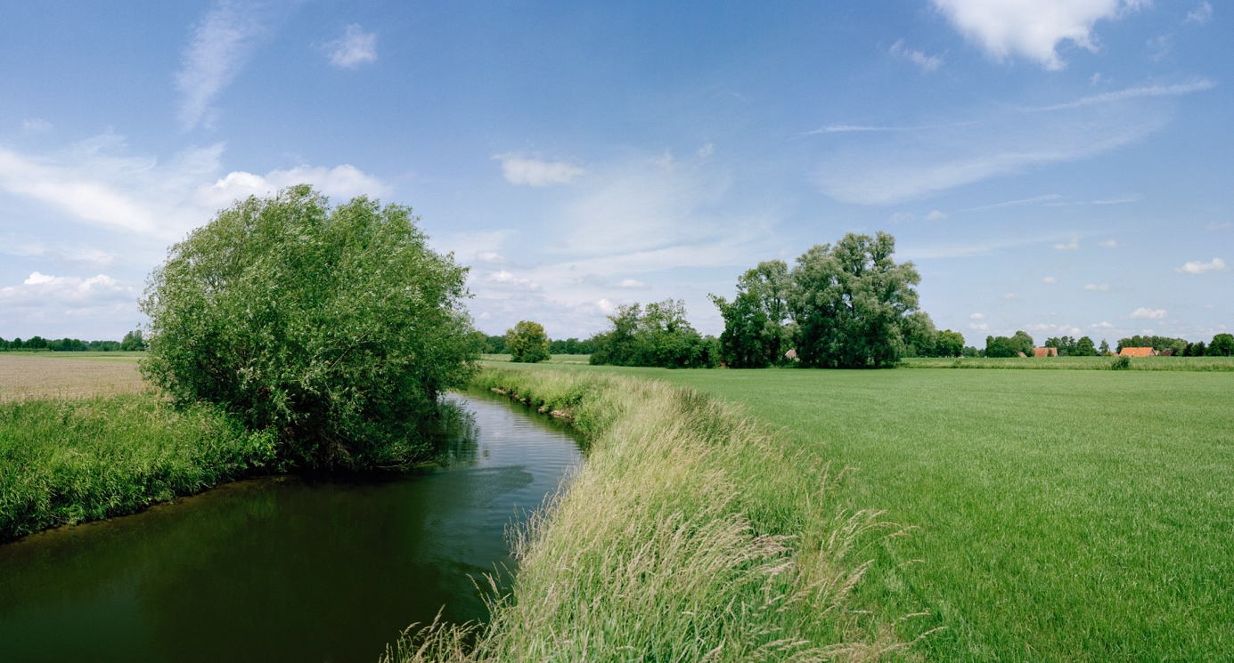

SUSTAINABILITY AND OUR COMPANY CULTURE

THINK SUSTAINABLY – ACT WITH ENVIRONMENTAL AWARENESS

All Niessing precious metals are obtained in a sustainable manner. The gold we use is exclusively from the recovery of secondary resources (recycling) – also referred to as urban mining – and we obtain precious metals from certified German and Swiss refineries. The entire alloying process takes place at Niessing in the manufactory, where recycling and reutilization also have top priority. Recycled precious metal is the most sustainable source for our exclusive pieces of jewelry.

CERTIFIED BY THE RESPONSIBLE JEWELLERY COUNCIL
Niessing – a certified member of the Responsible Jewellery Council since January 2021 – publishes a comprehensive sustainability report once a year with an overview of its commitment to manufacturing and design, supply chains, employees, the environment as well as social responsibility.

Status: June 2023

