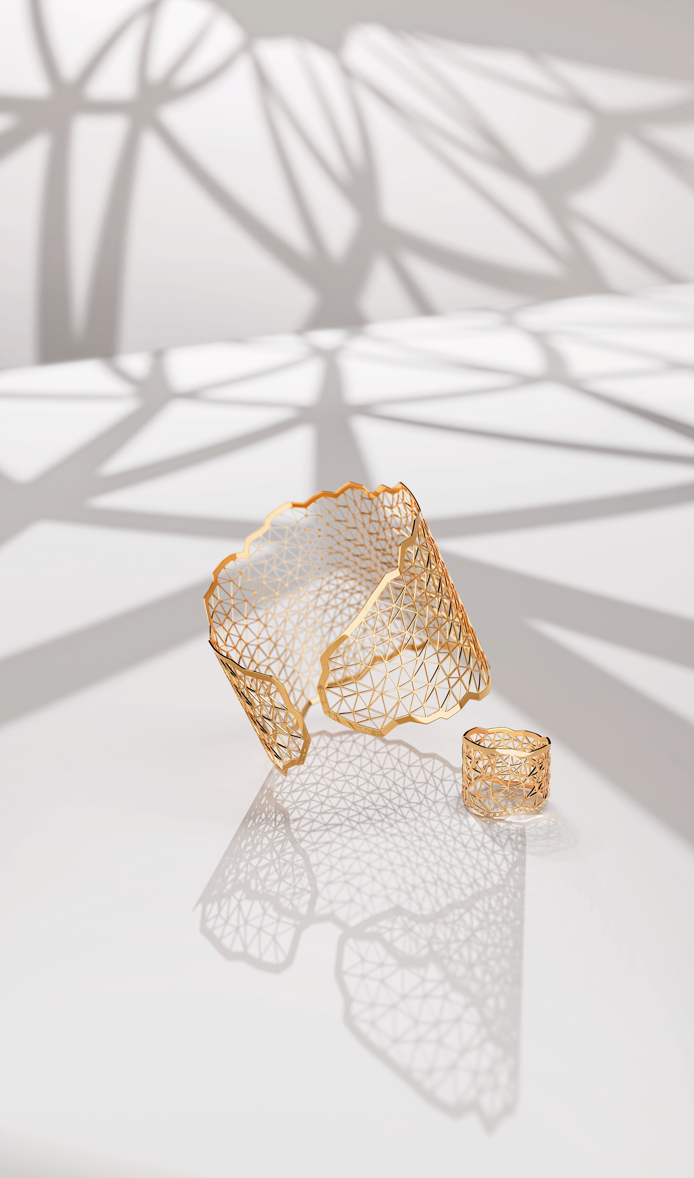

NIESSING TOPIA / TOPIA VISION

EXPRESS YOUR VISIONS IN GOLD

TABLE OF CONTENTS

3 THE POWER OF IDEAS

Innovative Use of Precious Metal

4 NIESSING TOPIA

Crystalline Landscapes in Gold and Platinum

6 NIESSING TOPIA LITTLES / MINI

Topia Prêt-à-porter: Miniature Beauties

7 NIESSING TOPIA VISION

Discover a world full of imaginations

9 SUSTAINABILITY AND OUR COMPANY CULTURE

THE POWER OF IDEAS

INNOVATIVE USE OF PRECIOUS METAL

A FASCINATING TRIP AROUND THE WORLD
Niessing Topia and Niessing Topia Vision are unique examples of Niessing‘s innovative approach to gold and platinum jewelry. Topia, launched in the year 2014, transforms paper-thin precious metal folded by hand into precious jewelry. The design, awarded the »Red Dot: Best of the Best«, is inspired by the vast view of pristine nature, such as dune landscapes in the desert and the highest mountains on earth.

REAL LANDSCAPES BECOME DREAM WORLDS
The luxurious Topia Vision jewelry collection, on the market since 2022, has taken Topia to the next level. For Topia Vision, the view broadens from real landscapes to the imaginary, to the surreal: gossamer soap bubbles, radiant northern lights, glittering reflections on the sea – such phenomena give free rein to the imagination.

Niessing Topia and Niessing Topia Vision invite you to experience gold and platinum in an entirely new way with all of your senses: authentic, original, and unmistakably Niessing.

NIESSING TOPIA

CRYSTALLINE LANDSCAPES IN GOLD AND PLATINUM

TOPIA INVITES YOU TO VISIT NEW TERRITORY
The most beautiful landscapes on earth seem out of this world: spectacular mountain ranges, shrouded in mist and mystery. Gently curving sand dunes, bathed in glistening light; lush green hills, bizarre rock formations in soft ocher and warm red. The colors and shapes of nature are unsurpassed.

We were inspired to design Niessing Topia by the view of the vastness of magnificent landscapes. In gold, the jewelry seems warm and gentle, reminiscent of dune landscapes in a desert. In platinum, Topia is clear, fresh, spectacular – evoking the highest mountains on earth.
THE AESTHETICS OF FOLDED PAPER
Niessing Topia has its origins in the very special aesthetics of folded paper. At the beginning of the design process, they were folded surfaces; over time, they became more complex paper sculptures: fascinating objects with astonishing heights and depths. They evoked associations with mountains, valleys, and natural landscapes. The idea for Niessing Topia was born. This is also where the name originated: Topia means »landscape painting« in Latin.

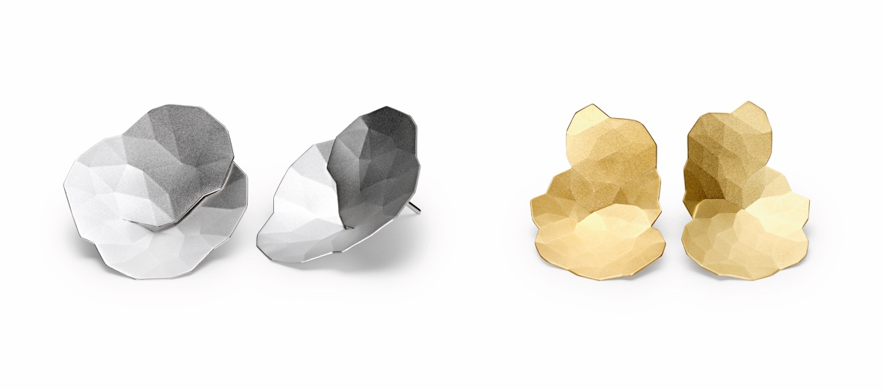

SYMBIOSIS OF HIGH-TECH AND CRAFTSMANSHIP
Folding paper is easy. Gold and platinum, on the other hand, are a challenge. But it is a challenge that we are happy to face, because jewelry design at Niessing also means experimenting and researching, overcoming obstacles, as well as combining high-tech and craftsmanship.

This is why we have developed a new technique especially for Topia. With the help of a laser, the fine folding pattern is first applied to the wafer-thin precious metal plates. An innovative high-tech process – yet it is next to worthless without the craftsmanship of the people who operate the machine. Each piece of jewelry is then folded by hand: this also requires the utmost skill and a considerable amount of practice.

ORGANIC, AUTHENTIC, ORIGINAL
When folded, the shape grows organically, naturally, almost by itself. Its beauty is authentic and original. Whether a pendant, earrings, brooch, bouton or ring: Each piece of Niessing Topia jewelry always evokes fresh associations.

AWARD WINNER! »RED DOT BEST OF THE BEST«
Niessing Topia was awarded the renowned »Red Dot: Best of the Best 2014« design award for highest design quality and groundbreaking design. According to the jury, the jewelry series is innovative and avant-garde in both design and craftsmanship. The latest high-tech processes and traditional craftsmanship create a symbiosis. A trend-setting interplay – and essential for the natural beauty of Topia.

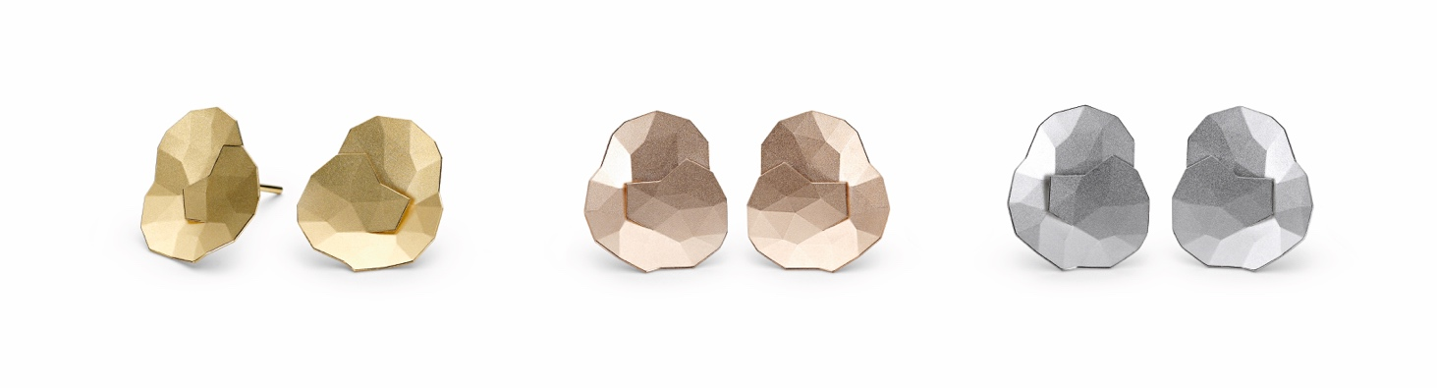

NIESSING TOPIA LITTLES / MINI

TOPIA PRÊT-À-PORTER: MINIATURE BEAUTIES

TOPIA LITTLES: A LITTLE GOES A LONG WAY

Those who see the world with open eyes perceive natural landscapes and crystalline structures even down to the smallest detail: Frost flowers in the morning sun, reflections mirrored in the snow, dancing ice crystals in the glistening sunlight ...
Topia Littles are earrings and pendants to wear every day. They are miniature beauties: a little goes a long way – the perfect add-on for the larger pieces of Topia jewelry. They are perfectly simple: Topia Prêt-à-porter!

NIESSING SELECTION TOPIA MINI: REFLECTIVE FACETS
For the exclusive Niessing Selection – we have made Topia jewelry even more intricate. For the first time, Topia Mini pendants and earrings in the Selection can be selected not only with a velvety matte texture, but also with a high-gloss texture. The reflective facets reveal a whole new world: they are reminiscent of ice crystals melting into their surroundings to create new visions. It‘s a stunning reinterpretation of an award-winning design. Discover uncharted landscapes in
miniature!

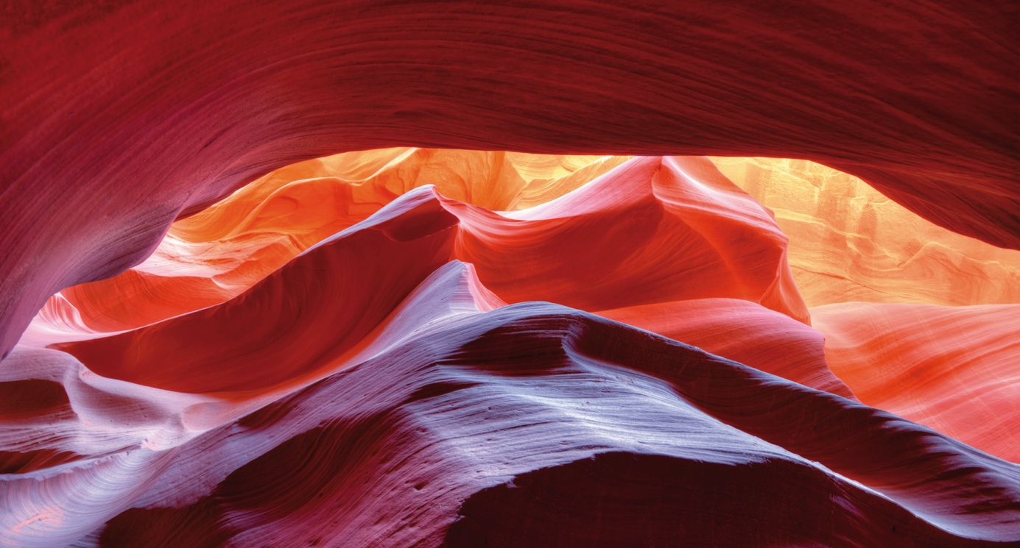

NIESSING TOPIA VISION

DISCOVER A WORLD FULL OF IMAGINATIONS

BE REALISTIC – AND TRY THE IMPOSSIBLE!
Niessing Topia Vision is an exclusive world first that makes the seemingly impossible possible: the collection transforms fascinating visions into precious
jewelry. Bangles, rings, earrings and chain are inspired by the world of natural phenomena: gossamer soap bubbles, radiant northern lights, glittering reflections on the sea …

FROM TOPIA TO TOPIA VISION
The jewelry collection takes the design of Niessing Topia to the next level, expanding the view from real landscapes to the imaginary, the surreal: gossamer soap bubbles, radiant northern lights, mysterious misty clouds, glittering light reflections in the sea – such phenomena give free rein to the imagination. Graphic patterns and abstract structures such as branching sand tracks in a desert or the iridescent play of light in illuminated metropolitan cities also inspire the dream worlds of Topia Vision.

FORM AND FUNCTION IN PERFECT HARMONY
Topia Vision plays with graphic patterns and shapes: The different sized, fine triangles are not merely decorative. They also serve to create tension in the jewelry. Where greater stability is required, such as in the gentle curve of the Topia Vision bangle or ring, the pattern becomes more compact.

GOLD AS IRIDESCENT AS A GOSSAMER SOAP BUBBLE
The expressive outer contours provide the jewelry with fascinating dynamics; the pieces are incredibly fine, full of lightness and transparency. The bracelet and rings playfully embrace the arm and fingers gently. The lustrous surface reflects the light and captures colors from its surroundings. The gold, which is heavy and compact by nature, appears to virtually dissolve, shimmering like a gossamer soap bubble interacting with the ambient light.

VISIONARY DESIGN THAT MAKES DREAMS COME
Niessing Topia Vision is as luxurious and sensual as a gentle touch. The collection translates visionary design into precious jewelry and makes dream worlds come true: Experience the power of visions!

SUSTAINABILITY AND OUR COMPANY CULTURE

THINK SUSTAINABLY – ACT WITH ENVIRONMENTAL AWARENESS

All Niessing precious metals are obtained in a sustainable manner. The gold we use is exclusively from the recovery of secondary resources (recycling) – also referred to as urban mining – and we obtain precious metals from certified German and Swiss refineries. The entire alloying process takes place at Niessing in the manufactory, where recycling and reutilization also have top priority. Recycled precious metal is the most sustainable source for our exclusive pieces of jewelry.

CERTIFIED BY THE RESPONSIBLE JEWELLERY COUNCIL
Niessing – a certified member of the Responsible Jewellery Council since January 2021 – publishes a comprehensive sustainability report once a year with an overview of its commitment to manufacturing and design, supply chains, employees, the environment as well as social responsibility.

Status: June 2023

