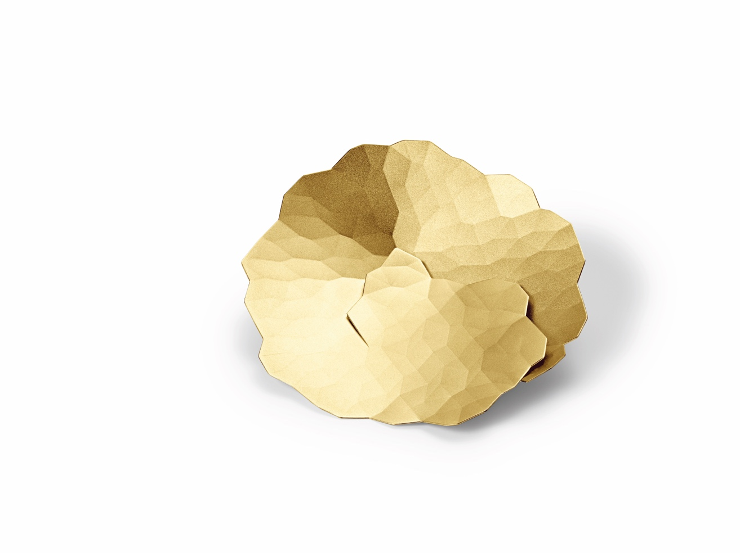

TC NIESSING TOPIA

NIESSING TOPIA

SLOGAN
DISCOVER CRYSTALLINE LANDSCAPES IN GOLD AND PLATINUM!

ESSENCE
Wafer-thin surfaces folded by hand become earrings, pendants, brooches and rings.
Large, delicate and light, Topia is inspired by the view into the vastness of untouched nature. The look is floral and graphic at the same time: crystalline landscapes in gold and platinum.
Which Topia will you discover?

Niessing Topia was awarded the "Red Dot: Best of the Best" design prize in 2014 for the highest design quality and pioneering design.

IDEA
WHICH TOPIA WILL YOU FIND?
Topia, meaning "landscape painting" in Latin, is inspired by the view of untouched nature, a journey around the world. In gold, the jewelry pieces are warm, soft and inspiring, akin to dune landscapes in a desert. In platinum, they are clear, fresh and spectacular, resembling the highest mountains on earth.
Topia captures light in all colors and reflects it with varying intensity, creating an impressive interplay of light and shadow. Gold and platinum shimmer in color nuances never seen before.

DISCOVER NEW TERRITORY, DISCOVER TOPIA
Topia represents a new design generation, with an innovative design language that is both floral and graphically crystalline. Each piece of jewelry has its own character, surprising in its freedom and lightness.
Discover crystalline landscapes in gold and platinum!

FEATURES
A fine surface of precious metal is folded by hand into a fine, three-dimensional shape, reminiscent of classic paper folding. A complex pattern of wafer-thin lines, applied by laser, defines the folded edges and determines the shape and structure of the jewelry.
The small folds stabilize the shape, and with a material thickness of just 0.3 millimeters, large pieces of jewelry that are delicate and light can be created. Each piece of jewelry has its own character.

The velvety matte surface texture emphasizes the three-dimensional appearance, while highly polished edges accentuate the contour. The pieces of jewelry are available in gold in many Niessing colors and in platinum.

NIESSING TOPIA EARRINGS ROUND AND OVAL
The earrings are available in two designs: one shape is between square and round, the other is an elongated, floral oval.

NIESSING TOPIA EARRINGS MINI
Even finer and more delicate, these are the perfect complement to the larger Topia pieces of jewelry.

NIESSING TOPIA PENDANT/BROOCH
The folds give the pendants a gentle, soft-looking texture. Gold and platinum shimmer in color nuances never seen before.
The pendants for the Niessing coil are available in two sizes, generous yet extremely fine and light. Upon request, the Topia pendant can also be worked with a brooch pin, transforming it into a special eye-catcher for your outfit.

NIESSING TOPIA MINI
The fine pendant from the Niessing Selection has a high-gloss texture; the reflective facets open up a whole new world. They resemble ice crystals merging with their surroundings to create new visions. Discover fascinating landscapes in miniature!

NIESSING TOPIA RING
The large, decorative Topia ring looks both floral and crystalline. Its hand-folded shape merges organically into the ring band and winds gently around the finger, making it an unmissable statement piece.

NIESSING TOPIA BOUTON
A small flower for the lapel, the buttonhole, the T-shirt: always different, always new. Uncomplicated, expressive and perfect for anyone who wants to subtly emphasize their style.

ESSENCE OF NIESSING TOPIA LITTLES
If you look at the world with open eyes, you can see natural landscapes and crystalline structures in miniature: ice flowers in the morning sun, reflections in the snow, dancing ice crystals in the glistening sunlight ...
The Topia Littles are Topia Prêt-à-porter: jewelry for every day. Small but beautiful, they are the perfect addition to the prêt-existing Topia set. Discover beauty in miniature with the Topia Littles!

NIESSING TOPIA LITTLES
Pendants, worn on a short Niessing coil, naturally nestle around the neck. Despite their delicacy, the shape is dynamic and powerful. Beauty in miniature - Topia prêt-à-porter.

NIESSING TOPIA LITTLES EARRINGS
The earrings are designed differently for the right and left ear to fit perfectly.

