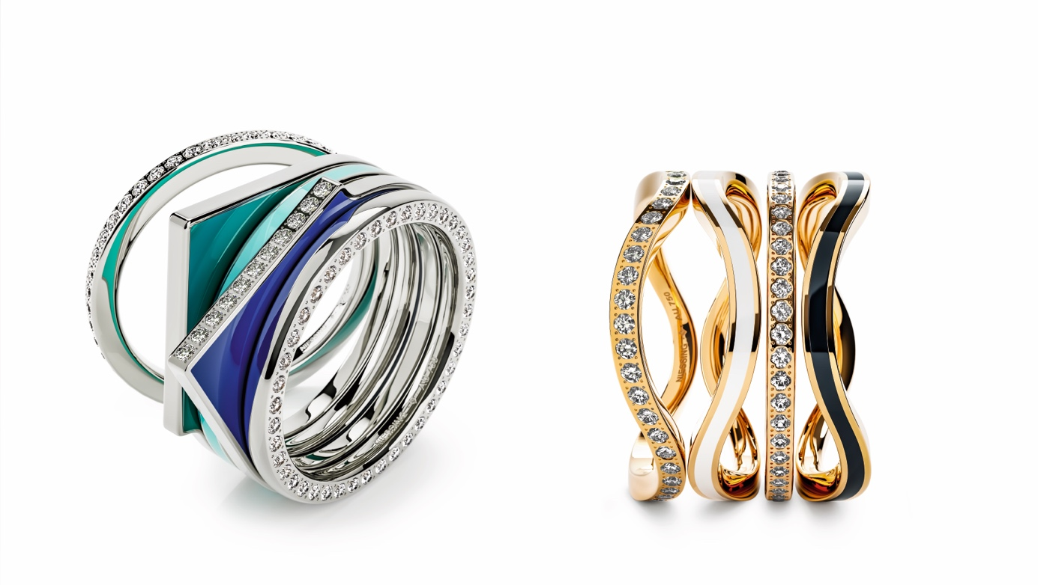

TC NIESSING SETARIO

NIESSING SETARIO

SLOGAN
NIESSING SETARIO - Discover the magical kiss of color!

ESSENCE
In the anniversary year of 2023, we completely reinterpret the first great Niessing jewelry classic: Setario. Inspired by the Bauhaus theory of colors and forms, the elegant rings in gold or platinum play with shapes, exclusive enamel colors and sparkling diamonds. Setario makes trendy ring stacking possible not only with its own kind, but also with a Niessing Spannring®, with Niessing color rings, with Amatis or Satellite. Discover the magical kiss of color!

DESCRIPTION
The new line of Setario rings includes three different models: Setario Line, Setario Wave and Setario Square.

They are crafted in gold in Classic Yellow, Classic Red, Rosewood, Fine Rose and Fine Gray. Setario Line is also available in platinum. Each Niessing Color can be freely combined with all ten enamel colors. The shades are White, Canary, Powder, Orange, Grenadine, Turquoise, Emerald Green, Ice Blue, Night Blue and Black.

The colors of cold enamel are specially mixed at Niessing and prepared by hand. In Setario Line and Setario Wave, the enamel decorates the entire ring centrally, whereas in Setario Square it adorns both sides of the ring. It is possible to choose two different colors for this ring.
As an alternative to the colored design, Setario Wave can be set with the finest diamonds using Niessing's own pointed setting technique. Upon request, Setario Square combines enamel and diamonds. All surfaces are polished to a high gloss in the Gloss texture.
All Setario rings can be combined with one another and also fit perfectly to a Niessing Spannring®, an engagement ring such as Amatis, to Niessing colored rings or Satellite.

COMMENT
The new, elegant Setario rings are modeled after a great design with the same name. In the early 1970s, Niessing launched Setario, the manufactory's first jewelry line, an idea of Ursula Exner, granddaughter of the manufactory's founder. Setario's name is a neologism derived from the words »Set« and »Variation«.

For the 150th anniversary of the manufactory, the new Setario debuts as a tribute to the Bauhaus theory of colors and forms, as well as to the creative, playful approach to jewelry. The delicate Setario rings turn ring stacking into an expression of pure vitality: They provide endless possibilities for individual creations.
Three ring shapes and an Edition ring limited to the year 2023, platinum, five Niessing gold colors and ten exclusive Niessing enamel colors: this selection makes collecting and combining fun. Setario Line is a minimalist, linear color accent; Setario Wave ripples around the finger in delicate curves. Setario Square is gently rounded on the one side, and strikingly rectangular on the other. The Setario Edition ring 2023 has a voluminous tonneau shape.
Will you choose the colorful enamel nuances harmoniously coordinated with the Niessing Colors? Or will you go for striking contrasts? Discover how a complementary color can increase the radiance of gold and platinum! Discover anew every day the colors that suit your mood and your look: Does Setario reflect the color scheme of your wardrobe or do the rings provide a counterpoint

SETARIO EDITION 2023
Exclusively for the 150th anniversary of the manufactory and limited to the year 2023, the Setario Edition ring is available in the iconic Niessing Color Supla Grenadine. This ring combines sparkling diamonds, a historic Niessing Color and colorful enamel: an intricate masterpiece of the goldsmith's artand a valuable collector's item. The enamel decorates the entire ring centrally, and due to the voluminous tonneau shape, it can be crafted with a particularly broad width.

SETARIO DESIGNER´S SELECTION
Niessing's designers have made an exclusive pre-selection of color combinations. In this Designers' Selection, platinum, the Niessing Gold Colors, and the Niessing enamel colors are coordinated to perfection. The selection includes seven Line and three Wave models: for a new look each and every day.

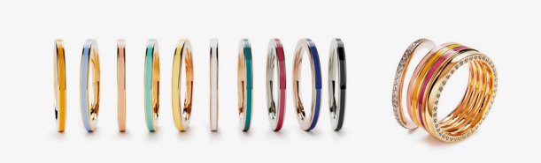

NIESSING ENAMEL

FACT SHEET
- is cold enamel
Cold enamel is a ceramic compound material based on the principle of light-curing material technology. Fine ceramic particles are bonded with a liquid polymer and cured by exposure to light.
- is very durable and colorfast
Due to the material properties, the colors will remain permanently. They do not fade, and the material withstands everyday stress and shocks.
- is impressive due to the radiance of the colors
The enamel colors are individually mixed in our manufactory and carefully applied by hand. Our color palette has its origin in the color theory of the Bauhaus.
- is 100 % biocompatible and very gentle on the skin
Due to its composition and relationship to medical polymer ceramics, Niessing enamel is a 100% biocompatible material that is regularly tested. It does not cause any allergies and is very gentle on the skin.

SERVICE
Width changes are not subsequently possible. Repairs can be performed professionally in our manufactory.

