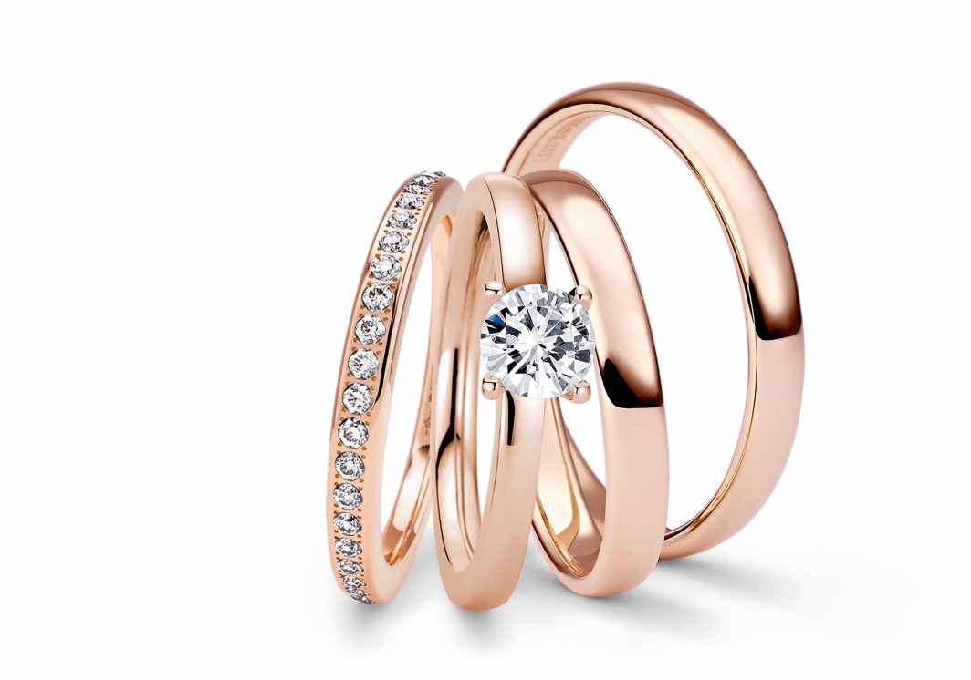

TC NIESSING SUPLA GRENADINE

NIESSING SUPLA GRENADINE

SLOGAN
NIESSING SUPLA GRENADINE - Discover luminous rosé gold with a heart of platinum!

DESCRIPTION
Niessing Supla Grenadine is a rosé-
colored, warmly shimmering gold with a portion of precious platinum. The innovative combination of the two precious metals provides not only the unique color, but also the outstanding technical properties of Supla Grenadine: the hardness, the resilience as well as the elasticity of Supla Grenadine are of the highest order. The new Niessing Color will be fully incorporated into the color wheel of the Bridal Box as well as the palette of Niessing Colors.
An exclusive engraving with a set diamond makes the loveliest Niessing Spannrings in Supla Grenadine even more precious on the occasion of its anniversary. The engraving is strictly limited to the year 2023.
As an anniversary gift, a diamond of 0.005 ct is also set into the inner band of each Niessing wedding ring in Supla Grenadine. This is also limited to the year 2023.

COMMENT
Discovering the unique color spectrum of gold, particularly the subtle nuances beyond the classics of yellow, white and red, has a long tradition at Niessing – and this continues to be honored with renowned design awards to this very day.
On the occasion of the 150th anniversary of the manufactory, the Niessing designers and goldsmiths undertook a special challenge: inspired by the creative spirit of the Bauhaus philosophy of leaving old paths behind and discovering the new. They were driven by the desire to translate the iconic Niessing Color Grenadine – the color for brand lettering and »Heart and Arrow« – into precious metal.
Only the most experienced goldsmiths have mastered the art of blending platinum and gold, as the two precious metals have differing melting points. Niessing has been experimenting with platinum gold for a long time and, after patenting it in 1965, introduced the first Supla Spannrings in the mid-1970s.

Just in time for the big anniversary, the vision of Supla Grenadine has now become reality: a rosé-colored, warmly shimmering gold. Its portion of precious platinum gives it a fascinatingly luminous luster – as if bathed in the cool, clear light of the moon.
The unique Niessing anniversary color radiates even more strikingly when sparkling diamonds join the game. They highlight the best of two color worlds: the cool blue nuance of platinum and the warm rosé of the gold alloy. Niessing Supla Grenadine is a sophisticated, subtle nuance that embodies luxurious understatement. Thanks to its sensuous charm, it is the perfect Niessing Color for Spannrings as well as wedding rings.

ESSENCE
The new Niessing Supla Grenadine is a rosé-colored, warmly shimmering gold. Its portion of precious platinum gives it a fascinatingly luminous luster – as if bathed in the cool, clear light of the moon. The historic Niessing anniversary color translates the iconic Niessing Grenadine from the brand lettering and »Heart and Arrow« into precious metal. Discover luminous rosé gold with a heart of platinum!

FACT SHEET
- Niessing Supla Grenadine is a rosé-colored 750 gold alloy with a portion of precious platinum. Its color combines the warmth of rosé gold and the cool radiance of platinum.
- Supla Grenadine is particularly hard, resistant and scratchproof. The new alloy is 30% harder than a comparable 750 yellow-gold alloy.
- On the occasion of the 150th anniversary, the historic in-house goldplatinum alloy Supla from the 1960s was developed further and a new rosé shade was created. Each gold bar is cast in the manufactory in the Münsterland region with extensive experience, and the secret recipe is preserved.
- »Supla« was registered as a trademark with the German Patent Office back in 1965. Beginning in the 1970s, the alloy was used for

the production of jewelry, wedding rings, and later for tension rings due to its high degree of resilience.
- The historic Niessing Anniversary Color translates the iconic Niessing Grenadine from brand lettering and »Heart and Arrow« into precious metal.
- The new goldplatinum alloy will be fully incorporated into the color wheel of the Bridal Box as well as the palette of Niessing Colors. The only thing that is limited to the anniversary year 2023 is the gift diamond on the inner band of the rings.

