NIESSING NOW

TABLE OF CONTENTS

3 NIESSING NOW MEETS NIESSING SILVER
Exciting design in silver with a touch of gold

3 NIESSING NOW FACET

Discover all the facets of life

4 NIESSING NOW GALAXY
Ready for a space trip?

6 NIESSING NOW TATTOO

Create your message

7 NIESSING TWIST
Twist and turn

9 SUSTAINABILITY AND OUR COMPANY CULTURE

NIESSING NOW MEETS NIESSING SILVER

EXCITING DESIGN IN SILVER WITH A TOUCH OF GOLD

Can silver be re-invented? Exclusively for the Niessing NOW collections, the Niessing designers and goldsmiths spent a long time researching and experimenting, and they created an entirely new silver in the unique shades of Rose, Lime and Lava. It is a silver that is younger, more beautiful and vibrant than ever before. And with a touch of gold, it is more precious than ever. Simply perfect for the modern, exciting design of Niessing NOW Tattoo and Galaxy, NOW Twist, and Facet. NOW is your time to discover!
JUST BE YOU – NOW!

NOW Tattoo makes a message visible to everyone; NOW Galaxy creates its own solar system. NOW Twist casts its spell with sweeping, endlessly sparkling spirals – and NOW Facet celebrates every facet of life. Which exciting Niessing Silver Color highlights the look? Sensual Rose? Fresh Lime – or mysterious Lava? Just be you!

NIESSING NOW FACET

DISCOVER ALL THE FACETS OF LIFE

Life is multifaceted – just as the NOW Facet. Whether pendants, rings, or expressive creoles: the delicate, faceted jewelry is available in four exclusive Niessing Silver Colors. Shine bright – NOW!

CREATE MEANING AND SHINE BRIGHT!
The shining NOW Facet pendants make giving happiness as a gift possible. One pendant for me, the other two for my best friend. Friendship? Bonding? Love? Forever! The pendants are each made of three parts, crafted from a single piece of silver, and they all have the same origin. Create meaning!

The NOW Facet creoles encircle the face with a subtle glow. The interplay of lines and surfaces is fascinating: If you view the earrings from the front, they seem to consist merely of a delicately thin line. Only from the side does the creole reveal its surface, and the facets are highlighted to perfection. Discover all the facets of life!

COLLECTING MEMORIES
Every day feels different with NOW Facet rings: sensuously warm Rose, excitingly fresh Lime, or mystical Lava – the delicate rings, faceted on the outside, can always be combined differently and joined together to form new images. Today a single one, very discreet. Tomorrow several, colorfully mixed. Would you like it pure, or perhaps with a fine diamond? It’s all up to you!
NOW FACET PENDANTS
FACTS AND FIGURES

- Three-part piece of jewelry made from a single piece of Niessing Silver
- In two sizes, with respective diameters of 24 and 43 mm
- Matching chains in several lengths from 40 to 80 cm with bayonet fastener
- Gloss surface texture
- In the Niessing Silver Colors Rose, Lime and Lava

NOW FACET CREOLES
FACTS AND FIGURES

- Three different sizes, with respective diameters of 30, 40 and 50 mm
- Integrated clasp that is easy to use
- Gloss surface texture
- In the Niessing Silver Colors Rose, Lime and Lava

NOW FACET RINGS
FACTS AND FIGURES

- Two different widths of 1.5 and 3 mm, respectively
- Upon request, a fine diamond provides even more radiance
- Gloss surface texture
- In the Niessing Silver Colors Rose, Lime and Lava

NIESSING NOW GALAXY
READY FOR A SPACE TRIP?

Just like planets orbiting the sun, the colorful spheres made of Niessing Silver revolve around the neck, hover at the ear, and encircle the arm and fingers. NOW Galaxy can be combined and collected as you desire. Create your own galaxy!

A LITTLE BIT OF MAGIC

The sphere, symbol of perfection and Niessing design icon, in a completely new interpretation: The chain mysteriously disappears into the Niessing NOW Galaxy sphere. Clear, reduced design – typical of Niessing. You want more? You can add many NOW Galaxy spheres to the Niessing NOW chain. It’s in the stars.

CREATE YOUR OWN GALAXY

One is cool – many are cooler! The NOW Galaxy rings make you want more: spheres in various sizes, both matt and shiny, with and without a sparkling diamond in the center. This creates ever new, fascinating starscapes on the hand. Become the star of your own galaxy! The NOW Galaxy bracelets inspire a passion for collecting. In one bracelet, two spheres form the closure of the open ends; in the other, a single sphere sits in the center. Both clasps can be combined well with one another. It’s in the stars!

SHINE BRIGHT

The sphere as ear stud and dangling earring – it doesn't get much simpler than this, but it doesn't get much more beautiful either! The NOW Galaxy ear studs shining brightly for you, and the dangling earrings are the perfect complement and an expressive eye-catcher. Shine bright!

NOW GALAXY SPHERE PENDANT WITH INTEGRATED CHAIN
FACTS AND FIGURES

- Sphere and chain in one; the chain mysteriously disappears into the sphere
- Chain in two lengths
- Sphere with the surface texture Gloss or Velvet
- In the Niessing Silver Colors Rose, Lime and Lava

NOW GALAXY SPHERES
FACTS AND FIGURES

- Spheres in four different sizes
- Optionally with or without a diamond
- Surface texture Gloss or Velvet
- Matching chains in several lengths from 40 to 80 cm with bayonet fastener
- In the Niessing Silver Colors Rose, Lime and Lava

NOW GALAXY RINGS
FACTS AND FIGURES

- Rings with spheres in three different sizes
- With or without a fine diamond in the center
- Surface texture Gloss or Velvet
- In the Niessing Silver Colors Rose, Lime and Lava

NOW GALAXY ARM JEWELRY
FACTS AND FIGURES

- Bracelets in two different variations: One has a sphere at each of the open ends, while the other has a single sphere crowning the center
- Spheres optionally with or without a diamond

- Spheres can be selected in two sizes
- Surface texture Gloss or Velvet
- In the Niessing Silver Colors Rose, Lime and Lava

NOW GALAXY EAR JEWELRY
FACTS AND FIGURES

- The Galaxy sphere as an ear stud and dangling earring
- Available in various sizes
- Spheres optionally with or without a diamond
- Surface texture Gloss or Velvet
- In the Niessing Silver Colors Rose, Lime and Lava

NIESSING NOW TATTOO

CREATE YOUR MESSAGE

Tattoos are nearly as old as mankind itself: they symbolize belonging and individuality, and they stand for freedom and joy of life. NOW Tattoo reinterprets this art form – for precious jewelry with a very personal message.

GOT THE MESSAGE?

The NOW Tattoo bracelet is forged from paper-thin Niessing Silver and worn like a second skin. The wide jewelry perfectly accentuates the unique silver nuances of Rose, Lime and Lava. It is also the perfect stage for the individual message. Whether an intricate drawing or classic tribal look, whether a monogram or short message – the possibilities are nearly limitless. Niessing NOW Tattoo: As unique as you are.

JUST BE PART OF IT

In addition to the bracelet, the Now Tattoo collection also includes rings and pendants: so, the individual message can also be worn on the hand or the heart. Does Rose, Lime or Lava suit your personal style better? Would you like the silver to radiate sensual warmth, freshness and fruitiness, or mystery? It’s all up to you!

NOW TATTOO ARM JEWELRY
FACTS AND FIGURES

- 30 mm bracelet width
- After being worn, the bracelet springs back to its original shape and fits securely on the arm – no clasp is needed
- Tattoos can be selected from a wide variety, or designed according to your own individual ideas
- Surface texture in Gloss or Nature
- In the Niessing Silver Colors Rose, Lime and Lava

NOW TATTOO RING
FACTS AND FIGURES

- Available in three different widths from 6.8 to 11 mm
- Tattoos can be selected from a wide variety, or designed according to your own individual ideas
- Surface texture in Gloss or Nature
- In the Niessing Silver Colors Rose, Lime and Lava

NOW TATTOO PENDANT
FACTS AND FIGURES

- The NOW Tattoo amulet is available in two sizes with a diameter of 18 or 28 mm
- Tattoos can be selected from a wide variety, or designed according to your own individual ideas
- Surface texture in Gloss or Nature
- Matching chains in several lengths from 40 to 80 cm with bayonet fastener
- In the Niessing Silver Colors Rose, Lime and Lava

NIESSING NOW TWIST

TWIST AND TURN

Delicate, hand-crafted spirals encircle the arm and fingers, sparkle at the ear. They reflect the light like glittering rays of sun on the ocean. NOW Twist: sparkling, captivating, unique. Get a new twist!

TURN AROUND NOW
Be flexible! The radiant NOW Twist bracelets can be slipped easily over the hand. Casual or classy? Opulent or subtle? What is your life’s rhythm today? Does silver in warm Rose go with mystical Lava, or do you prefer it with fresh Lime? Mix & match – express & impress! Get the rhythm!

GET A NEW TWIST
The NOW Twist rings are ever-changing in appearance: The captivating, sparkling spirals are flexible and very comfortable to wear. Each individual piece is wound by the Niessing goldsmith with precision by hand. Just like the NOW Twist creoles. They are perfect for any look: casual during the day, glamourous and sophisticated in the evening. The earrings reflect the light

and give your face a stunning radiance. Which Niessing Silver Color goes best with your complexion? Just try it out – open up NOW!

NOW TWIST ARM JEWELRY
FACTS AND FIGURES

- The bracelets are available in various sizes and two thicknesses of 4.8 and 6.8 mm
- The jewelry is flexible and can be easily slipped over the hand
- Surface texture in Gloss
- In the Niessing Silver Colors Rose, Lime and Lava

NOW TWIST RINGS
FACTS AND FIGURES

- The sparkling spirals are flexible and very comfortable to wear
- Available in many sizes
- Surface texture in Gloss
- In the Niessing Silver Colors Rose, Lime and Lava

NOW TWIST CREOLES
FACTS AND FIGURES

- Sparkling spiral earrings
- The clasp is easy to use and secure
- Surface texture in Gloss
- In the Niessing Silver Colors Rose, Lime and Lava

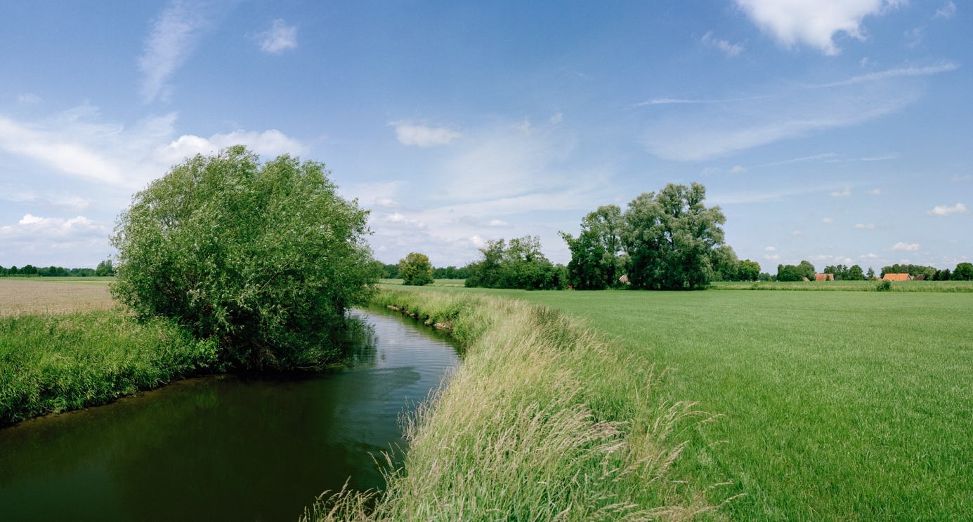

SUSTAINABILITY AND OUR COMPANY CULTURE

THINK SUSTAINABLY – ACT WITH ENVIRONMENTAL AWARENESS

All Niessing precious metals are obtained in a sustainable manner. The gold we use is exclusively from the recovery of secondary resources (recycling) – also referred to as urban mining – and we obtain precious metals from certified German and Swiss refineries. The entire alloying process takes place at Niessing in the manufactory, where recycling and reutilization also have top priority. Recycled precious metal is the most sustainable source for our exclusive pieces of jewelry.

CERTIFIED BY THE RESPONSIBLE JEWELLERY COUNCIL
Niessing – a certified member of the Responsible Jewellery Council since January 2021 – publishes a comprehensive sustainability report once a year with an overview of its commitment to manufacturing and design, supply chains, employees, the environment as well as social responsibility.

Status: October 2023

