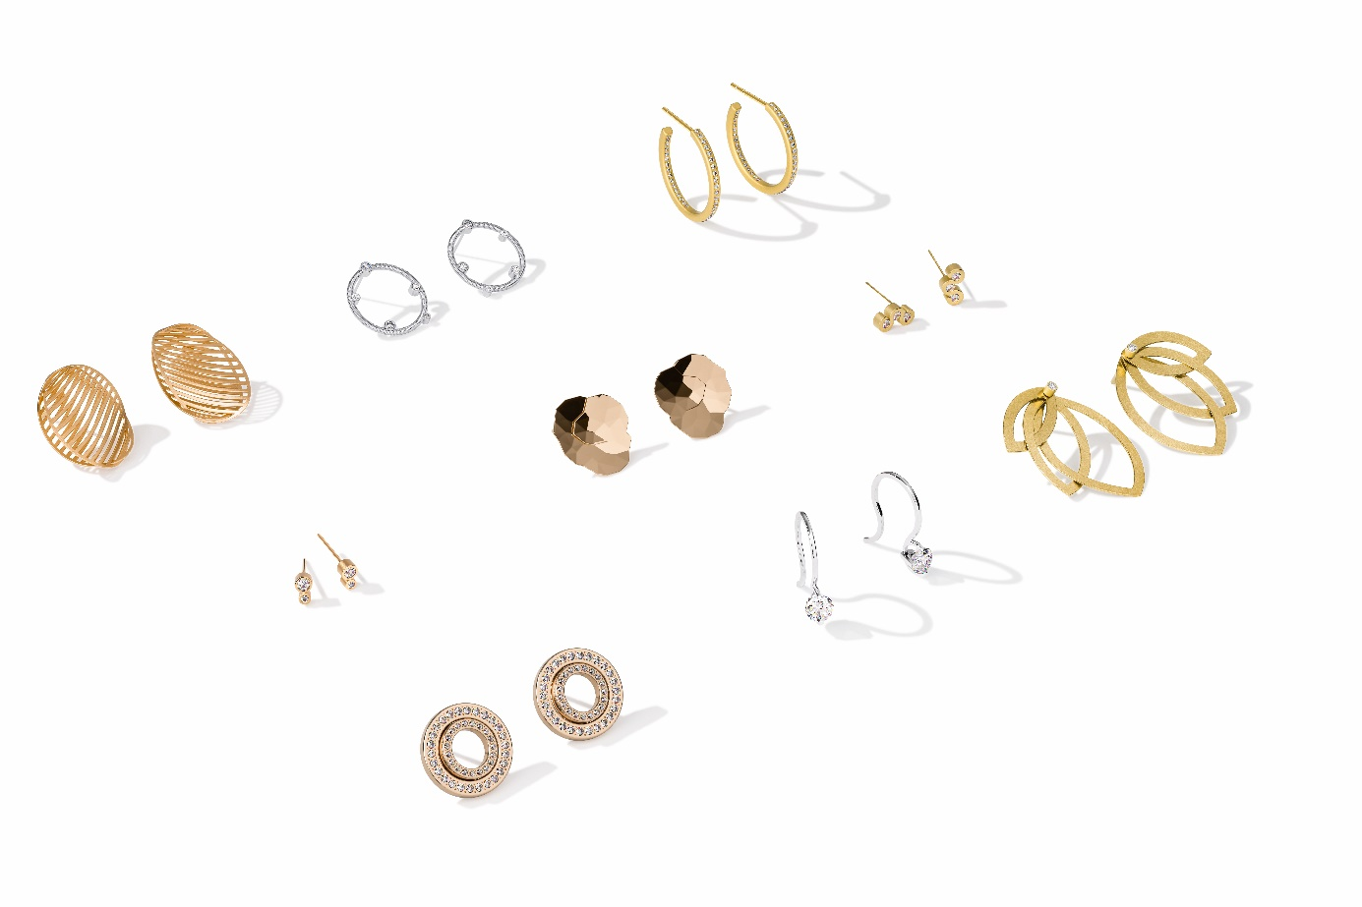

TC NIESSING SELECTION HIGHLIGHTS

NIESSING SELECTION HIGHLIGHTS

SLOGAN

Intricate masterpieces made to love

Intricate masterpieces cast a glow on your face

Intricate masterpieces bring radiance to your face

Discover intricate masterpieces for the ear

Fall in love with intricate masterpieces

Experience the seduction of intricate design masterpieces

Experience the seduction of our »handpicked selection«

Discover the tempting selection of miniature masterpieces

ESSENCE

NIESSING SELECTION EARRINGS

INTRICATE MASTERPIECES BRING RADIANCE TO YOUR FACE

The Niessing Selections take a new look at the familiar: Following the selected pendants, Niessing designers have excitingly reinterpreted and

curated some of the most popular designs as delicate ear jewelry. These fine pieces also embody the perfect interplay of tradition and innovation,

the harmony of contemporary design, exclusive Niessing Gold Colors. The creation of each individual piece of jewelry places the highest demands on the experience and craftsmanship of the Niessing goldsmiths. Simply put, the Niessing Selection is the »Best of the Best«: Fall in love with intricate masterpieces!

NIESSING SELECTION

INTRICATE MASTERPIECES FOR THE NIESSING COIL

Niessing designers have excitingly reinterpreted and curated some of the most popular jewelry pendants for the Niessing Selection. This »handpicked selection« of unique design classics for the Niessing Coil transforms grand ideas, fascinating phenomena, and daring dreams into intricate masterpieces. Whether the Niessing Spannring® or Satellite Orbit, whether Niessing Papyr, Filo d’Oro or sparkling diamonds that seem to float weightlessly on a Niessing Coil: Twelve extraordinary Niessing designs are fashioned with the highest craftsmanship and meticulous attention to detail. Discover our tempting selection of miniature masterpieces: perfect as a gift or simply as a treat for yourself. Experience the seduction of intricate masterpieces!

IDEA

A REINTERPRETATION OF CLASSIC DESIGNS

The Niessing Selection reinterprets some of the most popular Niessing designs. As pendants for the Niessing Coil, the unique selection includes classics such as Niessing Filo d'Oro and Niessing Papyr in an even more delicate form; others, such as Niessing Topia Mini, captivate with a surface texture never before seen.

EXCLUSIVE DESIGNS IN A »HANDPICKED SELECTION«

The Niessing Selection ear jewelry is brand new: This »handpicked selection« also takes a new look at the familiar, such as the Quinta in a particularly delicate form and with a diamond ear stud; for the first time, Niessing Princess is available as a dangling diamond earring, Niessing Satellite as a creole, and Niessing Satellite Orbit as ear jewelry.

NIESSING SELECTION – BEST OF THE BEST

The Niessing Selection and Niessing Selection Earrings embody the perfect interplay of tradition and innovation, the harmony of

contemporary design, exclusive Niessing Gold Colors, and handcrafted surface textures. The creation of each individual piece of jewelry places the highest demands on the experience and craftsmanship of the Niessing goldsmiths.

Simply put, the Niessing Selection is the »Best of the Best«: Fall in love with intricate masterpieces!

FEATURES

NIESSING ARTIST

The artist's performance enchants the audience. She balances along the high rope apparently effortlessly, gingerly placing one step after the other. Likewise, Niessing Artist lets fine diamonds dance on the ear in a light-footed and playful manner. Artist performs two different tricks at once for the Niessing Selection: five sparkling diamonds float on the ear for the Circle earrings. Even more intricate is the ear stud with two fine diamonds that dance upon the ear like radiant spots of light.

NIESSING PRINCESS

As much sparkling diamond as possible, as little precious metal as necessary: The Niessing Princess pendant focuses on the precious diamond and seems to float upon the ear in a fine dangling earring. Diamond jewelry can hardly be more refined and feminine: Do you feel the magic?

NIESSING DIAMOND WAVE

The extravagant ear jewelry is inspired by the beauty of nature: the gentle play of waves, the intricate patterns on a glittering water surface … Three sparkling diamonds for each piece of Diamond Wave ear jewelry hug the undulating precious metal, seeming to sway gently up and down in flowing curves. Let your fascinating sparkle carry you through every day.

NIESSING SATELLITE ORBIT

Niessing Satellite Orbit sends radiant diamonds into their orbit. Niessing Satellite Orbit now reaches its next orbit and begins a fascinating display of constellations. The ear jewelry consists of two diamond circles that create ever changing formations.

The delicate ear jewelry’s diamonds feature Niessing's typical pointed setting technique – for as much dazzling radiance as possible. The

earrings seem to radiate from within: as magical as a night sky full of stars.

NIESSING SATELLITE CREOLE

A sparkling line of light draws all attention to it. The delicate, classic Niessing Satellite Creole is set all around with diamonds – almost

revolutionary in their close proximity, thanks to Niessing's own setting technique. The round creole can be set either only on the outside or also on the inside: In this way, even more fine diamonds catch and reflect the light. Discover ear jewelry that is as precious as it is discreet and that adds a fascinating radiance to your face.

NIESSING MIRAGE OVAL

Discover the shimmering play of illusions! Two ovals with slender strips, artfully intertwined, become an artwork as light as a feather. The ear

jewelry catches and reflects the light with all of its intricate structures: the air inside seems to shimmer and flicker, adding an intense glow to the Niessing Colors. Niessing Mirage is a vision of weightlessness in gold and

platinum: architectural and sculptural, yet more light and delicate than ever before.

NIESSING TOPIA MINI

Paper-thin precious metal folded by hand becomes delicate ear jewelry. Topia means »landscape painting«, and the jewelry is inspired by the vastness of pristine nature, evokes natural landscape and crystalline structures in miniature. The ear jewelry from the Niessing Selection now has a high gloss texture, and the reflective facets reveal a whole new world: they are reminiscent of ice crystals melting into their surroundings to create new visions. Discover fascinating landscapes in miniature!

NIESSING QUINTA NAVETTE

Niessing Quinta Navette offers five different ways of expressing your own personality again and again: romantically dangling, classically compact or with an avant-garde look. A great Niessing classic – now crafted in the Niessing Selection more delicately than ever before and with a fine diamond in the ear stud. Discover the extraordinary interplay of line and form!