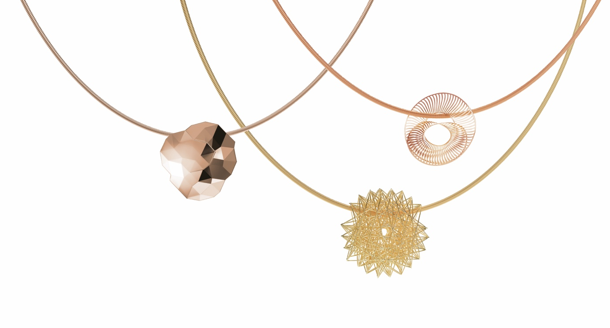

TC NIESSING SELECTION

NIESSING SELECTION
PENDANTS FOR THE NIESSING COIL

SLOGAN
Intricate masterpieces made to love
Fall in love with intricate masterpieces
Experience the seduction of intricate design masterpieces

Experience the seduction of our »handpicked selection«
Discover the tempting selection of miniature masterpieces

ESSENCE
Niessing designers have excitingly reinterpreted and curated some of the most popular jewelry pendants for the Niessing Selection. This »handpicked selection« of unique design classics for the Niessing Coil transforms grand ideas, fascinating phenomena, and daring dreams into intricate masterpieces. Whether the Niessing Spannring® or Satellite Orbit, whether Niessing Papyr, Filo d’Oro or sparkling diamonds that seem to float weightlessly on a Niessing Coil: Twelve extraordinary Niessing designs are fashioned with the highest craftsmanship and meticulous attention to detail. Discover our tempting selection of miniature masterpieces: perfect as a gift (for Christmas) or simply as a treat for yourself. Experience the seduction of intricate masterpieces!
IDEA
EXCLUSIVE DESIGNS IN A »HANDPICKED SELECTION«
The Niessing Selection reinterprets some of the most popular pendants for the Niessing Coil. The unique selection includes classics such as Niessing Filo d'Oro and Niessing Papyr in an even more delicate form; others, such as Niessing Topia Mini, captivate with a surface texture never before seen. Our »handpicked selection« takes a new look at the familiar, such as the Niessing Sphere, which we are working with for the first time in the color flows of the Niessing aura® and Niessing Iris. New shapes such as the Niessing Diamond Wave and Niessing Diamond Accent Duet complete this special selection.

NIESSING SELECTION – BEST OF THE BEST
The Niessing Selection embodies the perfect interplay of tradition and innovation, the harmony of contemporary design, exclusive Niessing Gold Colors, and handcrafted surface textures. The creation of each individual pendant places the highest demands on the experience and craftsmanship of the Niessing goldsmiths. Simply put, the Niessing Selection is the »Best of the Best«: Fall in love with intricate masterpieces!

THE STAR OF THE SHOW ON THE NIESSING COIL
Whether as soloists or in combination with pendants from your own Niessing collection, they will always create a new impression: The pendants from the Niessing Selection make their grand entrance on the Niessing Coil.

STORY
THE NIESSING COIL: WONDERFULLY CHANGEABLE
Since its invention in the mid-1980s, the Niessing Coil has been the up-to-date alternative to the link chain and a real quick-change artist: With a wide variety of jewelry pendants, they can be presented again and again in entirely new ways – there is hardly any other piece of jewelry that is as versatile as the Niessing Coil.

NIESSING JEWELRY PENDANTS: UNIQUE VERSATILITY
However, both the Coil itself and the Niessing jewelry pendants are proof of the great innovative strength of the Niessing designers and goldsmiths. For example, the Niessing S disc, designed back in the 1980s, for which Niessing platinum and fine gold are inseparably combined: The first flat Niessing jewelry was a milestone in terms of the manufactory‘s design language.

From sleek to extravagant, from discreet to lavish – over the years, many unique designs have been added: from fascinatingly discreet spheres to delicately set diamonds, from award-winning jewelry objects made of gossamer-thin, folded precious metal to delicate pendants made of the finest gold or platinum threads…

The exquisite selection of Niessing jewelry pendants makes it easy to find the precise design that perfectly highlights one's own personality – and at the same time inspires the joy of collecting.
The Niessing Selection now reinterprets some of the most popular pendants for the Niessing Coil, and never before seen designs complement the unique selection. Simply put, the Niessing Selection is the »Best of the Best«. Fall in love with intricate masterpieces!

FEATURES
All pendants of the Niessing Selection are worn on a Niessing Coil with a thickness of 1.2 mm.

NIESSING AURA® SPHERE HORIZONTAL
NIESSING IRIS SPHERE HORIZONTAL
The sphere is the most perfect and primordial of all shapes – and it has been a source of fascination for Niessing designers right from the very start. The Niessing Spheres combine a natural, harmonious shape with a unique range of Niessing color tones. Niessing aura® flows smoothly from gentle red to suave gray: memories of a cool, reddish-gray horizon in the morning. Niessing Iris unites pure silver and pure gold, cool white merges into warm yellow. Opposites attract – and create intimate togetherness. Discover the beauty of the sphere and the unique Niessing universe of color!
The spheres have a diameter of 14 mm, and they are available in Niessing aura® and Niessing Iris.

NIESSING DIAMOND ACCENT DUET
The setting gently cushions the diamond, as if on a velvet pillow. The rounded front encloses the precious stone like a dewdrop at dawn. Two diamonds play their perfectly balanced, sparkling game in the Niessing Diamond Accent Duet. Set a refined accent!
The pendant is crafted in the Niessing Gold Colors and platinum with two diamonds of 0.01 ct each.

NIESSING DIAMOND WAVE
The extravagant pendant is inspired by the beauty of nature: the gentle play of waves, the intricate patterns on a glittering water surface … Six sparkling diamonds hug the undulating precious metal, seeming to
sway gently up and down in flowing curves. The Niessing Diamond Wave ripples gently on the neck while floating upon the Niessing Coil: Let your fascinating sparkle carry you through every day.
The Niessing Diamond Wave is available in either Niessing Gold Colors or platinum with six 0.03 ct diamonds. The length of the pendant is 15 mm.

NIESSING MIRAGE LOOP
Niessing Mirage Loop has neither a beginning nor end – a pendant that plays with illusions. It is an iridescent band with slender strips, artfully intertwined: architectural, sculptural – and now as light and delicate as never before.
The delicate, shimmering structure of the strips and the layering of the bands make the pendant appear different from every new perspective and change of light. Niessing Mirage Loop is architecture in miniature. Discover the magic of eternity!
Niessing Mirage Loop is available in the Niessing Gold Colors and platinum, and the pendant’s size is 20 mm.

NIESSING SPANNRING® PENDANT
One of the greatest Niessing design icons as a pendant for the Niessing Coil. The finely proportioned Niessing Spannring® pendant places the highest demands on the craftsmanship of our goldsmiths and diamond setters. The brilliant-cut diamond is laterally set. Showing off its beauty, it is free, yet secure: a precious, sparkling diamond in the moment of tension.
The Niessing Spannring® pendant is available in the Niessing Gold Colors and platinum, and its diameter is 12 mm, with a diamond of 0.15 ct.

NIESSING LINEAR DIAMOND
On the Niessing Linear Diamond, sparkling diamonds are set as freely as possible. They seem to float on the front edge of the delicate pendant – boldly balancing, they even slightly rise above the fine edge. Let the intricate perfection cast its spell on you!
It is available in either Niessing Gold Colors or platinum with twelve 0.01 ct diamonds. The length of the pendant is 23 mm.

NIESSING SATELLITE ORBIT
Niessing Satellite Orbit sends radiant diamonds into their orbit: a symbol of endless love. The delicate pendant’s diamonds feature Niessing's typical pointed setting technique – for as much dazzling radiance as possible. The pendant seems to radiate from within: as magical as a night sky full of stars.
It is available in Niessing Gold Colors and platinum. Niessing Satellite Orbit measures 14 mm in diameter, and the 24 diamonds are each 0.01 ct.

NIESSING TOPIA MINI
Paper-thin precious metal folded by hand becomes a delicate pendant. Topia means »landscape painting«, and the jewelry is inspired by the vastness of pristine nature, evokes natural landscape and crystalline structures in miniature.
The pendant from the Niessing Selection now has a high gloss texture, and the reflective facets reveal a whole new world: they are reminiscent of ice crystals melting into their surroundings to create new visions. Discover fascinating landscapes in miniature!
Niessing Topia Mini is crafted in the Niessing Gold colors and Platinum, and the surface texture is highly polished (Gloss). The pendant’s size is 20 mm.

NIESSING PAPYR
A strip of paper, playfully intertwined and very gently knotted: this is the inspiration for the Niessing Papyr. With seeming effortlessness and the greatest craftsmanship, the Niessing goldsmiths transform this gesture into precious, intricate jewelry: as fine and weightless as paper, full of lightness and pure beauty.
It is available in either Niessing Gold Colors or platinum; the delicate strip of precious metal has a width of 4 mm.

NIESSING PRINCESS
As much sparkling diamond as possible, as little precious metal as necessary: The Niessing Princess pendant focuses on the precious diamond and seems to float on the neckline. Brownish Rosewood gold blends with the cinnamon-colored diamond to form a magical whole.
Diamond jewelry can hardly be more refined and feminine: Do you feel the magic?

Niessing Princess is crafted in Niessing Rosewood Gold, and the cinnamon-colored diamond is 0.23 ct.

NIESSING ARTIST BIG
The artist enchants his audience. Seemingly effortlessly he balances over the high wire, carefully putting one step in front of the other. Just as light-footed and playful, Niessing Artist lets fine diamonds dance on the Niessing Coil. Niessing Artist Big sends seven larger diamonds dancing on the Niessing Coil. Whereas the diamonds in the Niessing Artist pendant followed their own rhythm, the Niessing Artist Big pendant displays perfect symmetry: the largest of the diamonds shines in the center of the pendant, while the other diamonds emphasize its beauty with their sparkle.

Niessing Artist Big is available in either Niessing Gold Colors or platinum. The sizes of the seven diamonds range from 0.03 ct to 0.12 ct (4 x 0.03 ct, 2 x 0.08 ct, 1 x 0.12 ct).

NIESSING FILO D‘ORO
A gossamer thread of gold or platinum, artfully woven into a precious. At first glance, the gleaming network of threads seems chaotic, but at second glance, you will realize: the golden thread interconnects it all in the most beautiful order.
The Niessing Filo d'Oro pendant floats upon the neckline as delicately and lightly as never before: Let it captivate you!
Niessing Filo d’Oro has a size of 20 mm, and it is crafted in either the Niessing Gold colors or Platinum.

