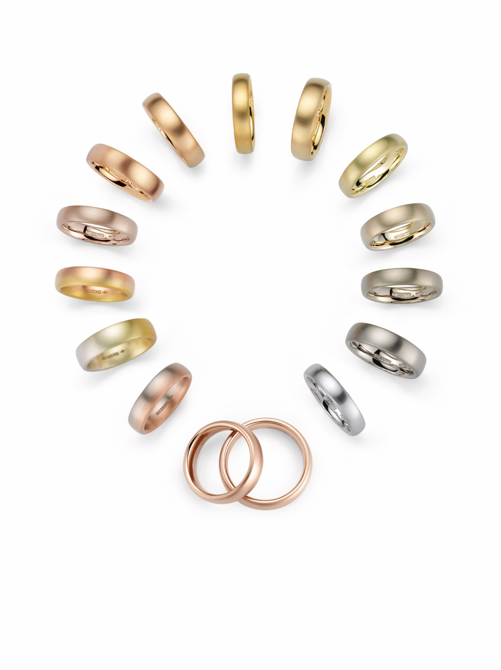

NIESSING COLORS

THE MOST BEAUTIFUL GOLD AND SILVER COLORS

TABLE OF CONTENTS

3 OUR HEART BEATS FOR COLORS

Colors are Pure Emotion

In Search of the Most Beautiful Niessing Gold Colors

9 THE NIESSING COLOR WHEEL

Niessing Colors Gallery

12 LIMITED COLOR EDITIONS
Niessing Colors That Touch the Heart

13 SILVER WITH A TOUCH OF GOLD

Niessing NOW Meets Unique Silver Colors

14 EMAILLE KISSED BY COLOR
Niessing Setario Meets Exclusive Enamel Colors

16 SUSTAINABILITY AND OUR COMPANY CULTURE

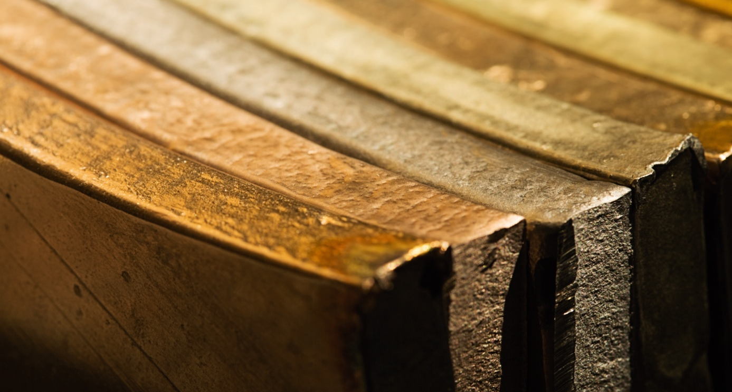

OUR HEART BEATS FOR COLORS

COLORS ARE PURE EMOTION

Our world is full of colors. Without colors, everything would be drab and gray. Colors capture our attention and influence us almost unconsciously. Colors express personality and touch our innermost being: colors are pure emotion.

UNIQUE COLOR SPECTRUM OF GOLD
At Niessing, we are convinced: the color of a piece of jewelry is at least as crucial as its shape. That is why the designers and color alchemists in our workshop have been working intensely on the most extraordinary colors of gold for a long time. Gold of radiant freshness and fascinating warmth; gold as beautiful as if kissed by the sun; gold with a warm, reddish shimmering shade of brown; gold, soft and warm as a sandy beach, as gently shimmering as a rose blossom …

LUMINOUS ROSÉ GOLD WITH A HEART OF PLATINUM
Our color creation for the 150th anniversary of the manufactory has even succeeded in translating the historic Niessing color Grenadine into pure gold: The iconic Niessing Supla Grenadine is a luminous rosé gold with a heart of platinum.

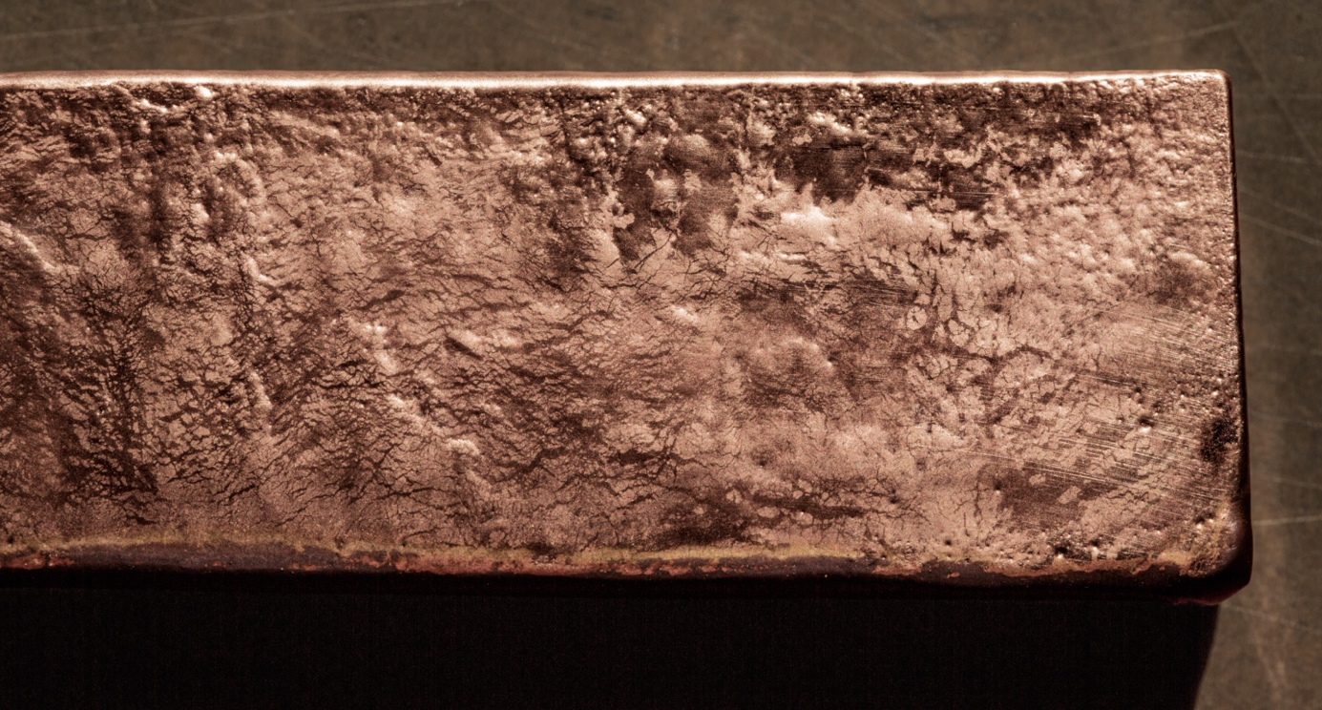

THE MAGICAL KISS OF COLOR
In the new Niessing Setario ring collection, exclusive Niessing Colors merge with unique enamel shades as well. These colors are specially mixed at Niessing and prepared by hand. Discover the magical kiss of color!

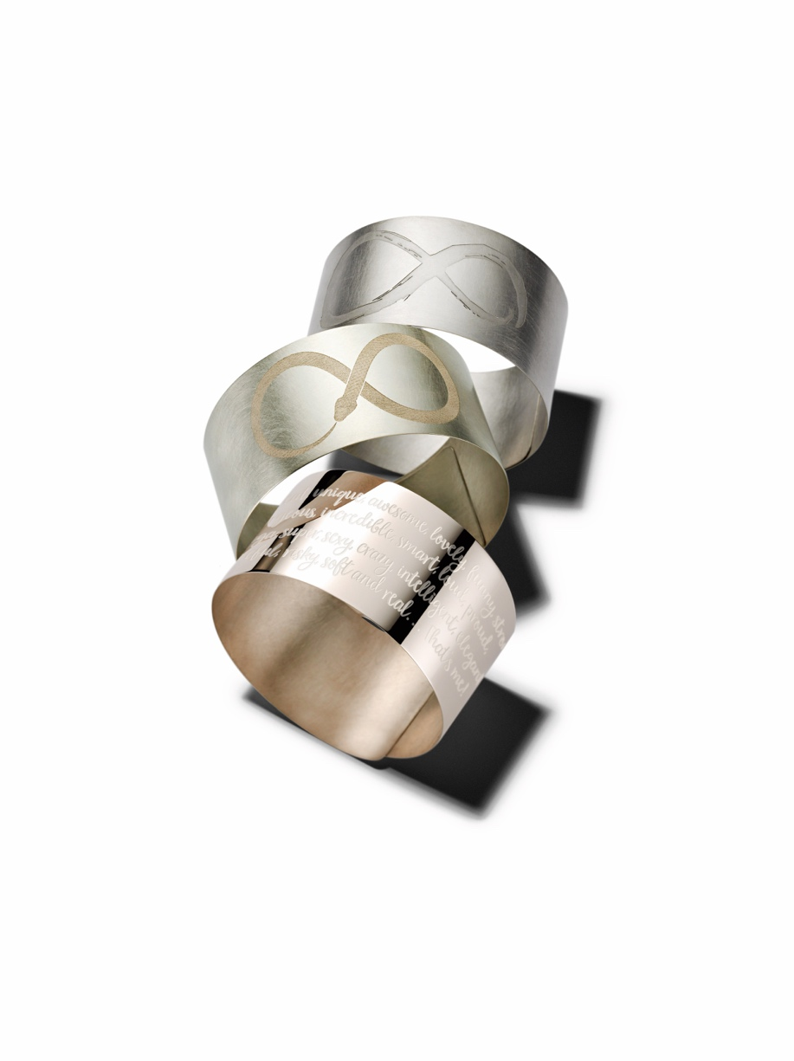

SILVER WITH A TOUCH OF GOLD
The silver we have developed for the Niessing NOW Collections is also proof of the manufactory‘s unique color expertise: This silver with a hint of gold shimmers in three nuances: sensuous rosé, refreshingly green, and mystical gray.

Our heart beats for colors! Which of the unique Niessing Colors makes your heart beat faster?

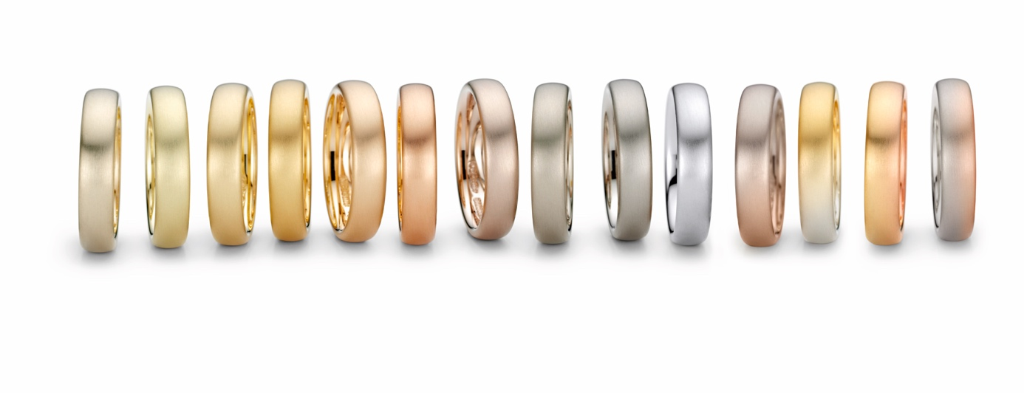

IN SEARCH OF THE MOST BEAUTIFUL GOLD COLORS

In order to find something new, you have to leave the familiar behind. »When we develop a new gold color, we allow ourselves all the freedom in the world for our thoughts«, says Niessing designer Nina Friesleben-Laue. »And we even put aside our extensive knowledge of technologies, precious metals, and alloys at the beginning. If you always focus only on what‘s feasible, you won‘t be able to discover new territory.«

CLEAR DESIGN – SENSUOUS COLORS
The color of a piece of jewelry is at least as crucial as its shape – the interplay of clear design and sensuous gold or silver colors is unique to Niessing jewelry. The Niessing design philosophy has its origins in the clear aesthetics of Bauhaus in Weimar, the most important school for architecture, design, and art in the 20th century.

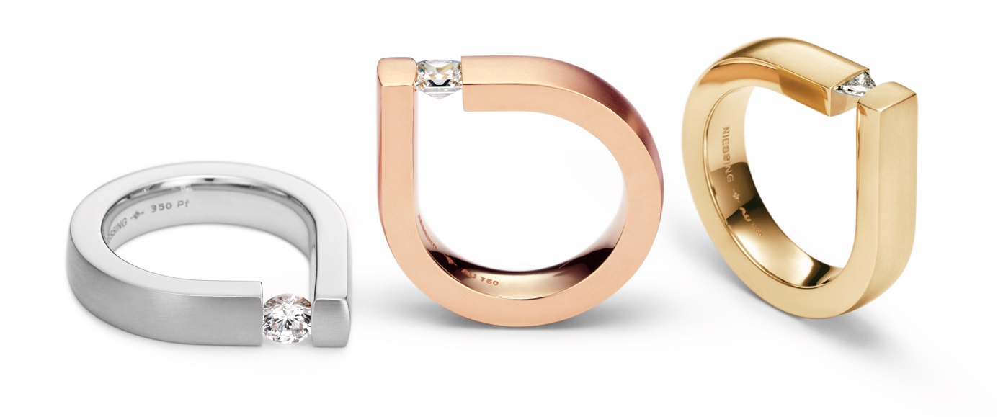

THE COLOR WHEEL OF GOLD
Discovering the unique color spectrum of gold, particularly the subtle nuances beyond the classics of yellow, white and red, has a long tradition at Niessing – and this continues to be honored with renowned design awards to this very day. It has long since been possible for the color wheel of gold to come full circle.

UNIQUE COLOR FLOWS: FROM IRIS …
»Our first milestone was Iris«, recalls Niessing Head of the Development Department, Hans Verwohlt, regarding the exciting development period of the early 1980s. »The flow of fine silver into fine gold remains unique to this very day.«

… TO AURA AND SOLARIS
If this change of color works, the Niessing designers thought a few years later, then shouldn‘t it also be possible to transform gray gold into red gold? And indeed, together they solved even this difficult task: Niessing aura® is a unique, infinitely variable color flow from fine gray to soft red.

Ultimately, with Solaris, Niessing created a color flow with the chromatic splendor of a sunset: the gold transforms from warm red into delicate peach nuances and radiant yellow. The radiance of the sun has left its mark on Niessing Solaris.

ICONIC COLOR FOR THE 150TH ANNIVERSARY
The latest creation, Supla Grenadine, was a special challenge for the 150th anniversary of the manufactory. It takes the iconic brand color Grenadine while simultaneously reflecting the radiance of the moon. What makes it special is the platinum content of this gold alloy. With much experimentation and research, it was possible to develop a goldplatinum alloy that is resistant, colorfast and produces an aesthetic shine.

UNIQUE COLOR SPECTRUM WORLDWIDE
The Niessing color spectrum is one of a kind in the world. It’s just as unique as the extensive knowledge that has become second nature to all the goldsmith employees over the years. Anyone who watches the Niessing alloy experts at their melting work feels something magical. »The old hands don‘t even need the temperature display on the furnace: they simply monitor the gold, its color, how it moves in the melting vessel – and they know everything they need to know«, says Hans Verwohlt admiringly. Courage and passion, intuition and perhaps even a pinch of gold in the blood: all this is needed to discover the most incredible colors of gold and silver.

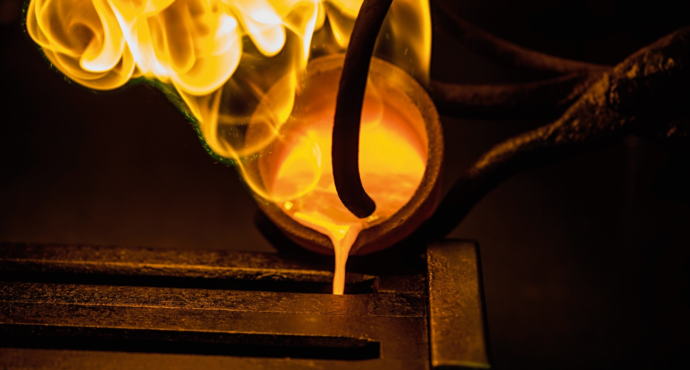

THE NIESSING COLOR WHEEL

NIESSING COLORS GALLERY

Shimmering moon white Niessing Platinum, ten unique Niessing Gold Colors, as well as three fascinating color flows: the spectrum that Niessing conjures up from precious metals is unique worldwide.

NEW: NIESSING SUPLA GRENADINE
Luxurious understatement – warmly shimmering with fascinating luster
The historic Niessing Anniversary Color translates the iconic Grenadine from »Heart and Arrow« in precious metal. Discover the luminous rosé gold with a heart of platinum!

NIESSING PLATINUM
Radiant clarity – enchanted by moonlight
Platinum is thrillingly cool and excitingly warm, pleasantly heavy and soft as a feather. Its natural, radiant white shimmer is reminiscent of lustrous moonlight.

NIESSING FINE GRAY
True understatement – pure, clear, reduced to the essentials
A most delicate, nearly hidden golden hue shimmers through the Fine Gray. It‘s just enough to provide warmth. Fine Gray is true understatement.

NIESSING SAND GRAY
Natural beauty – as soft and warm as a sandy beach
Inspired by nature: Sand Gray is gold as soft and warm as a sandy beach. Who could have imagined that gray can be so colorful and warm!

NIESSING CLASSIC YELLOW
Primordial power – golden yellow radiance
Primordial, warm, luminous: Classic Yellow is gold in classic golden yellow. Sensuous and precious; treasured from the very beginning.

NIESSING WARM YELLOW
Radiant warmth – the purest shade of gold Uncompromisingly gold! Warm Yellow is the shade closest to pure gold: deep yellow with a trace of orange.

NIESSING SPRING GREEN
Vibrant freshness – with a touch of soft green Like the sun rising over a spring meadow: A trace of mist still lingers over the scene, yet the warmth can already be felt ... Spring Green is a light-yellow gold with a hint of fresh green.

NIESSING IVORY
Silken ivory – warmth meets clarity
Ivory is true to its namesake and combines the warmth of yellow with the clarity of gray gold. A fascinating confluence of light yellow, white and light green.

NIESSING ROSEWOOD
Profound security – gold with an indescribable shimmer
Gold with a warm brown tone and a subtle hint of reddish violet. The shimmer that envelops Niessing Rosewood is simply indescribable – it appears stunningly different with each change in lighting.

NIESSING CLASSIC RED
Blazing power – Only gold has this special glow!
Gold that shines like the sun in that special moment in the evening just before it disappears into the horizon. Classic Red is red yet golden: as red as only gold can be.

NIESSING FINE ROSE
A tender glow – the gentle shimmer of rose petals
A gold of such beauty that it seems to blush … Fine Rose shimmers like delicate rose petals: fine yellow with a hint of red.

NIESSING COLOR FLOWS

NIESSING IRIS
Intimate togetherness – opposites attract
One and one make – more! Iris is where pure silver meets pure gold, and cool white dissolves into warm yellow. Who feels like always staying the same? Turn the ring just a bit, and the sun begins to shine.

NIESSING AURA®
Sensuous temptation – an extraordinary play of colors
aura shines in shades never seen before, from soft red to fine gray: an original sensuousness. It’s as if this gold has been waiting all along to be discovered …
Niessing aura® was honored with the »Red Dot Design Award« in the year 2011.

NIESSING SOLARIS
An incandescent play of colors – kissed by the sun
From warm red to delicate peach nuances and radiant yellow: this gold has the chromatic splendor of a sunset. The radiance of the sun has left its traces on Solaris.
Solaris was recognized with the »Red Dot Design Award« in 2017.

LIMITED COLOR EDITIONS

NIESSING COLORS THAT TOUCH THE HEART

Unique Niessing Colors for special jewelry creations: Time and time again, our designers and the color alchemists in the Niessing workshop develop exclusive gold colors that are only available for a limited time or only for selected pieces of jewelry. The Niessing Colors Purple Gray and Peach Pink, for example, are reserved for the Niessing Spannring® Round – only 202 pieces are made in each of these extraordinary gold shades.

NIESSING PURPLE GRAY
Mysterious aura – luxurious, mystical, feminine
Gray gold with a shimmer of violet: it appears cool and warm at the same time; a gold with a mysterious aura. Purple Gray is sensuous like a beguiling perfume and mystical like purple shimmering clouds at sunset.

NIESSING PEACH PINK
Delightful sweetness – velvety, warm, feminine Peach Pink is a peach-colored gold, iridescent reddish-orange and with a hint of pink. Intensely radiant, kissed by the sun. Doesn’t it smell almost as sweet as a ripe, velvety peach?

SILVER WITH A TOUCH OF GOLD

NIESSING NOW MEETS UNIQUE SILVER COLORS

Can silver be re-invented? The Niessing designers and goldsmiths have spent a long time researching and experimenting exclusively for the Niessing NOW collections, and they have created an entirely new silver in the unique shades of Rose, Lime, and Lava. It is silver that is fresher, more beautiful, and more vibrant than ever before. And a touch of gold makes it more precious than ever. Simply perfect for the modern, contemporary design of Niessing NOW Tattoo and Galaxy, Twist, and Facet. NOW is your time to discover!

NIESSING NOW LAVA
Mystical energy – Do you feel the magical power of attraction?
NOW Lava possesses a magical glow: iridescent, radiant and mysterious. Discover the mystical power within the depths of the earth!

NIESSING NOW LIME
Fresh splendor – Savor every new day!
A fresh, fruity and bright silver; reminiscent of budding clover and a lush meadow on a summer morning. Add an accent with NOW Lime!

NIESSING NOW ROSE
Pure romance – Fall in love with life!
So in love with the romantic NOW Rose: Depending on the lighting, the silver varies in iridescence between Apricot and soft Violet. A feeling of pure joy!

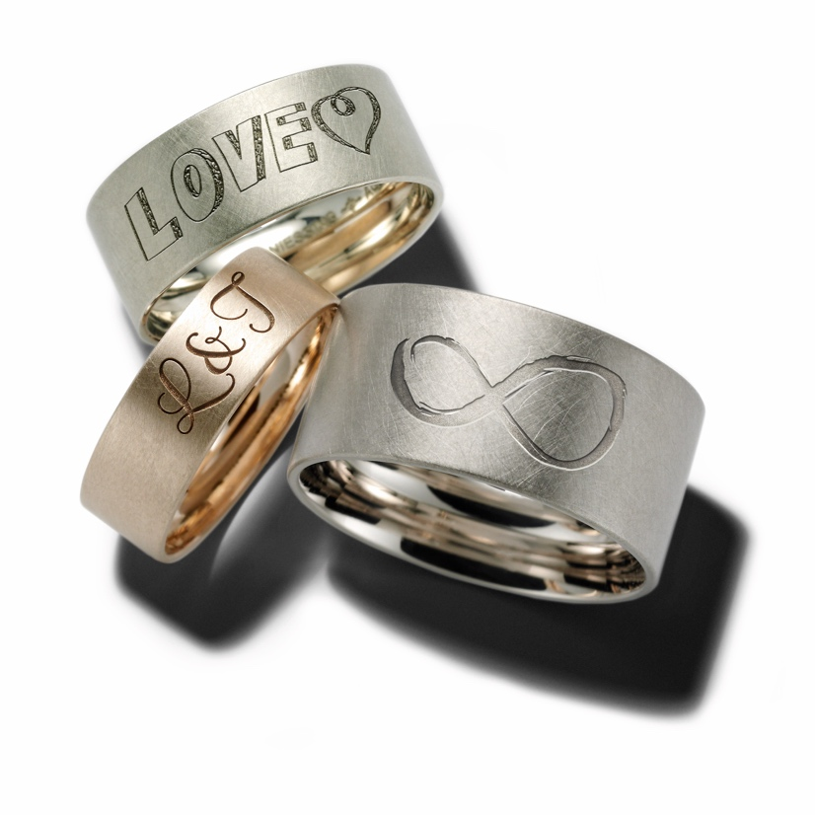
EMAILLE KISSED BY COLOR

NIESSING SETARIO MEETS EXKLUSIVE ENAMEL COLORS

For the 150th anniversary of the manufactory, the new Setario debuts as a tribute to the Bauhaus theory of colors and forms, as well as to the creative, playful approach to jewelry. The delicate Setario rings turn ring stacking into an expression of pure vitality: They provide endless possibilities for individual creations – new every single day, according to how the spirit moves you.

The rings are crafted in many gold colors and in platinum. They are totally versatile and can be combined with ten exclusive Niessing enamel colors to suit every taste. The colors are specially mixed at Niessing and elaborately prepared by hand.

WHITE
Subtle and sophisticated
White goes with everything – and it stands confidently alongside every shade of Setario enamel.

CANARY
Vibrant and bold
Canary goes beautifully with White or Orange, and any combination simply puts you in a good mood. Wear happiness on your hand!

POWDER
Pastel and understated
Powder enhances all of the Setario colors with its sophisticated subtlety. It is also a harmonious complement to Orange or Grenadine.

ORANGE
Attractive and exciting
Orange makes a splash! The hue creates harmony with Canary, and the effect is powerful with Emerald Green or Turquoise.

GRENADINE
Sensuous and luminous
Grenadine radiates straight to the heart. Nuances such as Night Blue or Black make the iconic Niessing Color glow with even greater intensity.

TURQUOISE
Lively and upbeat
Turquoise is the color of the sea, and it stands for pure vitality. And its effect is even stronger with White!

EMERALD GREEN
Soothing and refreshing
Emerald Green possesses depth, and it is the perfect partner for Turquoise and other Setario shades of blue.

ICE BLUE
Cool and reserved
The icy blue eye-catcher blends perfectly with all of the Setario shade of blue. Ice Blue is also a fine partner for Black and White!

NIGHT BLUE
Elegant and timeless
Only Night Blue shimmers so uniquely! A confident counterpoint to nuances such as Canary or Orange.

BLACK
Clear and striking
Black is a statement, and it is a timeless classic as »Black & White« – it also lends a special depth to all of the Setario shades of enamel.

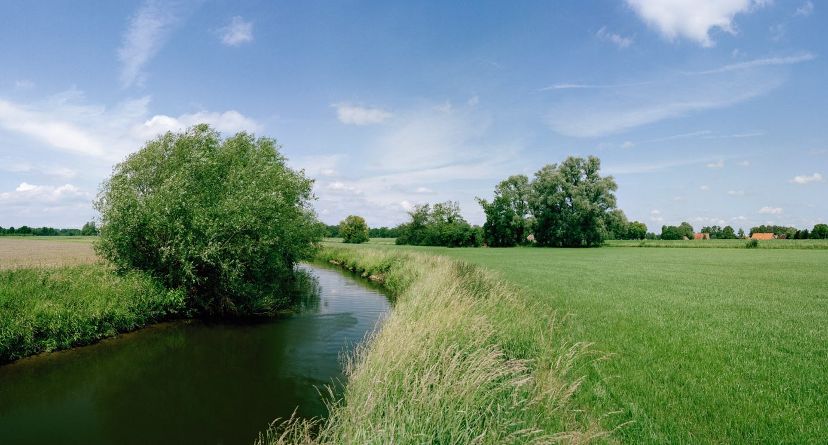

SUSTAINABILITY AND OUR COMPANY CULTURE

THINK SUSTAINABLY – ACT WITH ENVIRONMENTAL AWARENESS

All Niessing precious metals are obtained in a sustainable manner. The gold we use is exclusively from the recovery of secondary resources (recycling) – also referred to as urban mining – and we obtain precious metals from certified German and Swiss refineries. The entire alloying process takes place at Niessing in the manufactory, where recycling and reutilization also have top priority. Recycled precious metal is the most sustainable source for our exclusive pieces of jewelry.

CERTIFIED BY THE RESPONSIBLE JEWELLERY COUNCIL
Niessing – a certified member of the Responsible Jewellery Council since January 2021 – publishes a comprehensive sustainability report once a year with an overview of its commitment to manufacturing and design, supply chains, employees, the environment as well as social responsibility.

Status: June 2023

