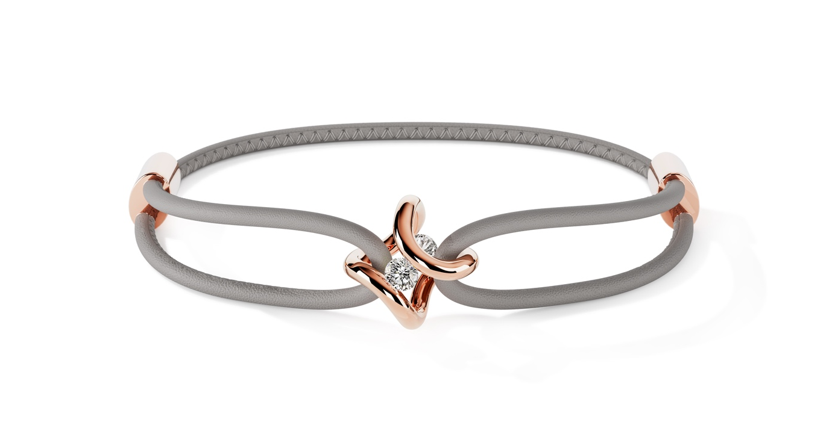

TC NIESSING SPANNRING® ERA BRACELET

NIESSING SPANNRING® ERA BRACELET
Bracelet

SLOGAN
NIESSING SPANNRING® ERA BRACELET – charming look of a new era

Essence: The Niessing Spannring® Era arm jewelry embodies an homage to the original shape of the Niessing Spannring, reinterpreted in a spectacular manner. The iconic shape, organically curved into two fine arches, gently and securely holds two diamonds. The double-looped, fine leather strap echoes the infinite shape and transforms the bracelet into a stylish everyday companion - extravagant, casual, bold, and light. A fusion of contemporary nonchalance and iconic design, prepared to be the original of a new era.

Idea: The idea of the Niessing Tension Ring® Era bracelet is a spectacular redesign of the original shape of the Niessing tension ring. Organically curved into two fine arches, the shape holds two diamonds. The double-looped, fine leather strap echoes the infinite

shape and makes the bracelet a stylish companion. Paying homage to its deep roots in Bauhaus, Niessing celebrated the 150th anniversary of
the manufactory with a design that transforms the Niessing Spannring® into an opulent statement ring and fascinating pendant.

Features:
- Organic shape: The iconic shape of the Niessing Spannring® Era bracelet is organically curved into two fine arcs that gently and securely hold two diamonds.
- Double-looped leather strap: The fine, double-looped leather strap echoes the infinite shape of the jewelry and creates a stylish, casual look.
- Variety of materials: Niessing offers Platinum and Gold in various colors, including Classic Yellow, Classic Red, Fine Rose, Rosewood, and Supla Grenadine. Various surface textures such as Gloss and Nature offer additional customization options.
- Sustainable materials: The straps are made from European organic nappa leather, processed using vegetable tanning and heavy metal-free dyeing. Certifications such as the IVN certificate and ECARF certification stand for the highest quality and unlikeliness of an allergic reaction.
- Individual clasp: The sliding clasp allows easy operation and individual size adjustment of the bracelet. The clasp can be made in Niessing NOW silver or in the same Niessing Color as the pendant.

The Niessing Spannring® Era bracelet is an impressive fusion of modern nonchalance and iconic design that completely redefines the look of the Niessing Spannring®. This piece of jewelry, paying tribute to its deep roots in Bauhaus, celebrates the 150th anniversary of the manufactory and presents itself as an opulent statement ring and fascinating pendant. The double-looped bracelet, held by the infinite shape of the jewelry, is ready to shape a new era in style.

