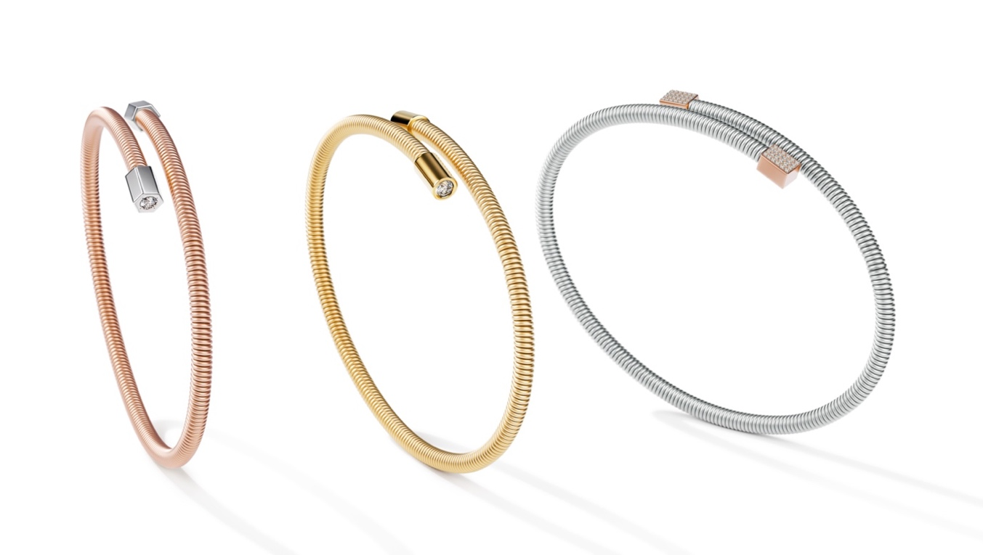

TC Niessing Colette Elementyx
NIESSING COLETTE ELEMENTYX
Bracelets

Niessing Colette Elementyx: A new dimension is born!

ESSENCE
Discover the unique world of the Colette Elementyx jewelry collection - a true masterpiece inspired by the timeless design language of Bauhaus architecture. Colette Elementyx fascinates with its sensual yet minimalist design that radiates a powerful presence. An icon of timeless style, Colette combines design, aesthetics and perfection. Handcrafted with the highest precision "Made in Germany", the new bracelet embodies the minimalism of absolute understatement. Each piece of jewelry is more than just an accessory; it is an expression of your individuality and personality. Enter a new dimension and discover how you can express your uniqueness with Colette Elementyx.

Experience your own dimension with Colette Elementyx!

Colette Elementyx - Innovation meets personality.
Colette Elementyx - Unmistakable. Individual. Authentic.
Colette Elementyx - Expressive. Powerful. Self-confident.

A MASTERPIECE OF YOUR INDIVIDUALITY
The combination of the Niessing cord with geometric shapes makes Niessing Colette Elementyx a milestone in purist design. The innovative soul and the personalization by selecting elements in different shapes, Niessing Colors and individual engravings give the jewelry a unique

characteristic. Colette Elementyx is not just an accessory, but a personal statement that unites tradition and innovation in a unique way. A masterpiece of your individuality.

A TECHNICAL MASTERPIECE
with a diameter of 3.2 mm and an innovative core, Colette Elementyx is an avant-garde piece of jewelry that makes a clasp superfluous. Thanks to the elasticity and memory function of the core, the bracelet retains its aesthetic shape.

COLETTE BRACELETS FOR YOUR UNIQUE PERSONALITY
Design your bracelet according to your individual wishes. With a variety of customizable options, your piece of jewelry will be a true expression of your individuality and style.

Find your favorite design!

Two different bracelets

CHOOSE FROM TWO DIFFERENT DESIGN VARIANTS
An open design presents itself with a dynamic space between the two elements – a modern and minimalist design for those who prefer subtle yet striking jewelry. The perfect choice for a unique expression.

A closed design is characterized by parallel cords that give it a dynamic and powerful appearance. This variant invites you to collect pendants and adds a unique touch to your personal style.

Create your incredible Look!
Choose the right Niessing Color to give your Colette Elementyx a unique touch. Immerse yourself in the world of Niessing Colors and select the color of your Niessing coil. From Fine Rose, Rosewood and Classic Red to Platinum and Classic Yellow, you have a wide range of gold colors to choose from. The innovative Anniversary Color Supla Grenadine, which combines gold with a platinum heart, is particularly outstanding.

Form, Color and Diamonds!

Opt for caps in hexagon, cube or cylinder shapes to give your bracelet a special character. The clear geometric shapes harmonize perfectly with the minimalist design of the Niessing coil. Choose contrasting accents that underline the design and add extra sparkle. Brilliant-cut diamonds and diamonds set on the side in front of the cap create radiant accents. Complete your design with the option for an individual engraving!

Niessing Colette Elementyx is more than just jewelry - it is a personal statement, an expression of individuality and style. Customize your piece of jewelry according to your wishes and wear a masterpiece that combines tradition and innovation in a unique way. Your Colette bracelet will become a unique companion that tells your story and expresses your personality in a striking way.

Vreden, February 2024

