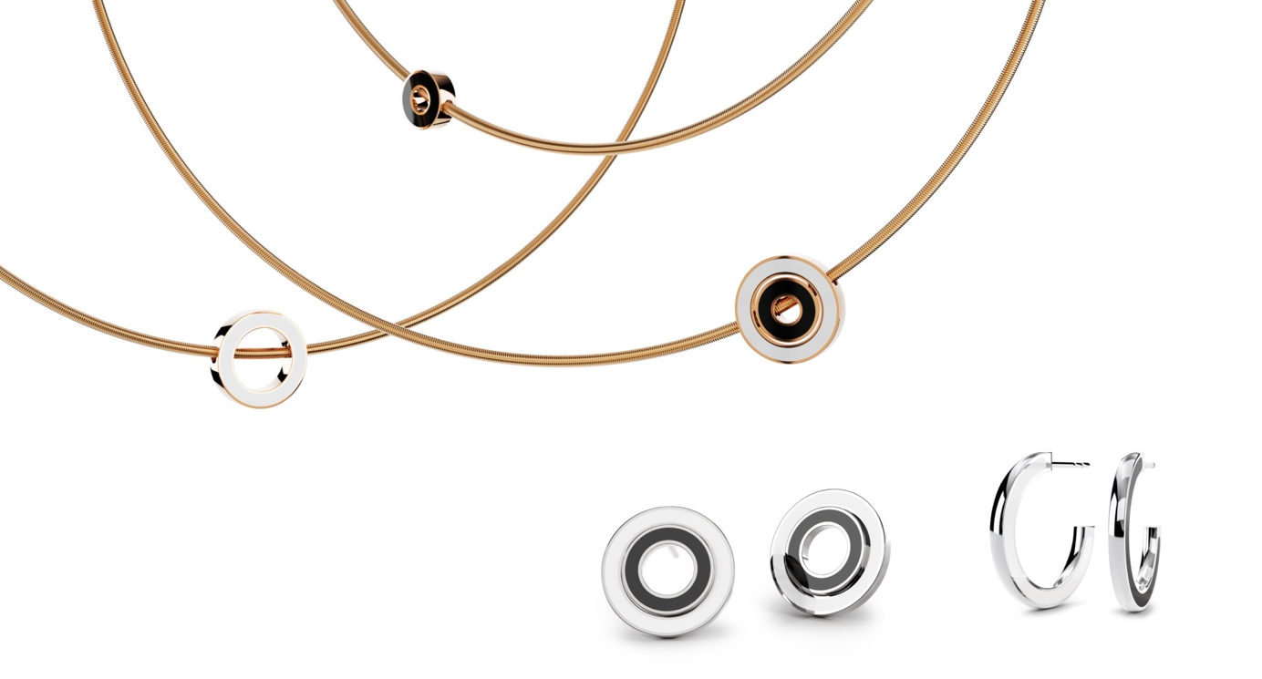

TC Anniversary Collection Setario

NIESSING SETARIO ANNIVERSARY COLLECTION
Jewelry rings

SLOGAN
NIESSING SETARIO JEWELRY KISSED BY COLOR.

ESSENCE
The Setario Anniversary Collection, »Niessing Setario Jewelry Kissed By Color«, celebrates 50 years of outstanding jewelry design by reinterpreting the design classic. Setario has been setting standards for half a century. Niessing proudly presents a collection inspired by timeless Bauhaus design.

IDEA
The Setario Anniversary Collection combines 50 years of innovation and craftsmanship in a bold expression of creativity and style. The collection is characterized by clear shapes and exciting enamel colors that reflect the graphic heritage of Bauhaus design. The centerpiece are pendants that combine Niessing gold with colored enamel and can be worn and combined in multiple ways.

FEATURES

NIESSING SETARIO PENDANT
The pendants are undoubtedly the heart of the collection. They consist of two differently sized circles that cleverly combine the beauty of Niessing Gold with colored enamel. Both the alloy and the enamel color can be selected following your individual taste. The circles not only offer aesthetic splendor but also versatility in how they can be worn - they can be worn together, next to each other or separately. The possibility of combining them with other pieces of jewelry such as cylinder setting pendants or Niessing spheres expands range of variations and emphasizes the uniqueness of the collection.

NIESSING SETARIO CREOLES
The hoop earrings are an innovative statement with colors on the inside and outside. Simply switch sides and your look changes - a game of contrasts and harmony. Available in two sizes, they symbolize individuality.

NIESSING SETARIO STUD EARRINGS
The stud earrings, consisting of two circles, can be playfully combined. Countless combinations of our Niessing Colors and exciting enamel colors are possible. Create as you please.

MATERIAL AND WORKMANSHIP
The anniversary collection is characterized by high quality. Each piece is
made from an ingot and consists of solid precious metals. A mat or gloss
surface can be chosen to emphasize your personal style.

PLACE OF MANUFACTURE
The pieces of jewelry are created using the finest goldsmith craftsmanship in the manufactory in Vreden. Each piece is crafted with the utmost precision and attention to detail. The enamel, mixed by hand from color pigments and applied very thinly, is characterized by exceptional color quality and radiant brilliance. Small diamonds are hand-set into the enamel with the utmost expertise, and the play of light and color is fascinatingly emphasized.

The Niessing Setario anniversary collection is an expression of appreciation for 50 years of passion, innovation and beauty in jewelry design.

Vreden, January 2024

