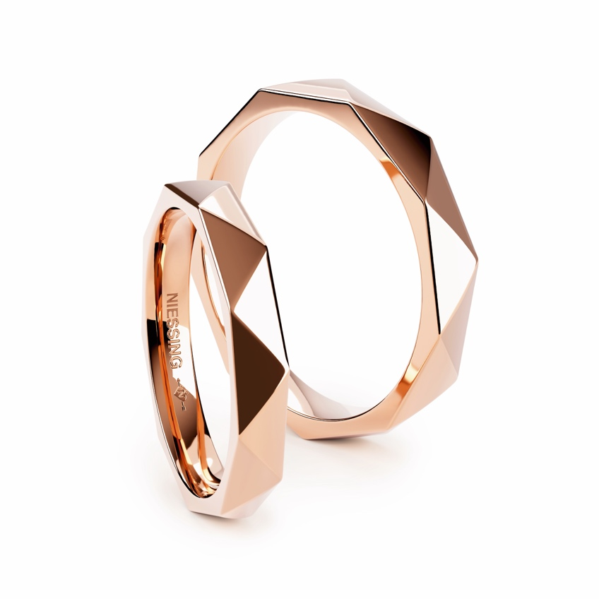

TC Niessing Triangle Love Story Ring

NIESSING TRIANGLE
Wedding ring and jewelry ring

SLOGAN
Niessing Triangle - As multifaceted as your love
Niessing Triangle - A symbol of stability and solidarity
Niessing Triangle - As multifaceted as your love

ESSENCE
Niessing Triangle - A three-dimensional journey
The triangular geometry of Niessing Triangle wedding rings symbolizes not only a bond but also a journey through space and time. In line with the Bauhaus philosophy, they embody the art of love and the harmonious stability of a partnership.

IDEA
Niessing Triangle wedding rings not only form a captivating triangle of precise elements but also reflect the threefold dimension of your love - past, present and future. Like the clear lines and harmonious angles that narrate your shared story, the rings symbolize the foundation of your collective past, future and present.

Matching companions such as Niessing Memory, Niessing Satellite rings or tension rings can be added to emphasize the multifaceted nature of your love. This versatility allows you to highlight different aspects of your relationship.

The geometry of the triangle in the Niessing Triangle wedding rings symbolizes not only the strength and balance of your relationship, but also the three-dimensionality of your journey together. In keeping with the Bauhaus philosophy of combining art and functionality, these rings embody the art of love and the harmony of a steady relationship over time.

The fascinating shape of the Niessing Triangle wedding rings reveals an eternal bond, captured in a triangle of love. These rings are not only an essential part of your shared history, but also radiate in the present and create the basis for a future full of shared moments and adventures.

FEATURES
Niessing Triangle is a wedding and jewelry ring that explores the fascination of the triangular shape. The rings are skillfully crafted from precise triangles, which serve not only as decorative elements but also narrate the story of love. The option to set a diamond within a triangle adds a personalized touch to the rings.

Therefore, Niessing Triangle wedding rings are more than just aesthetic companions; they are a living expression of love, encapsulated in the geometric perfection of triangles.
Textures available include Satin, Velvet, Nature, and Gloss, with a glossy surface further accentuating the striking design language. Available in Niessing Platinum and in a variety of Niessing Colors.

Vreden, January 2024

