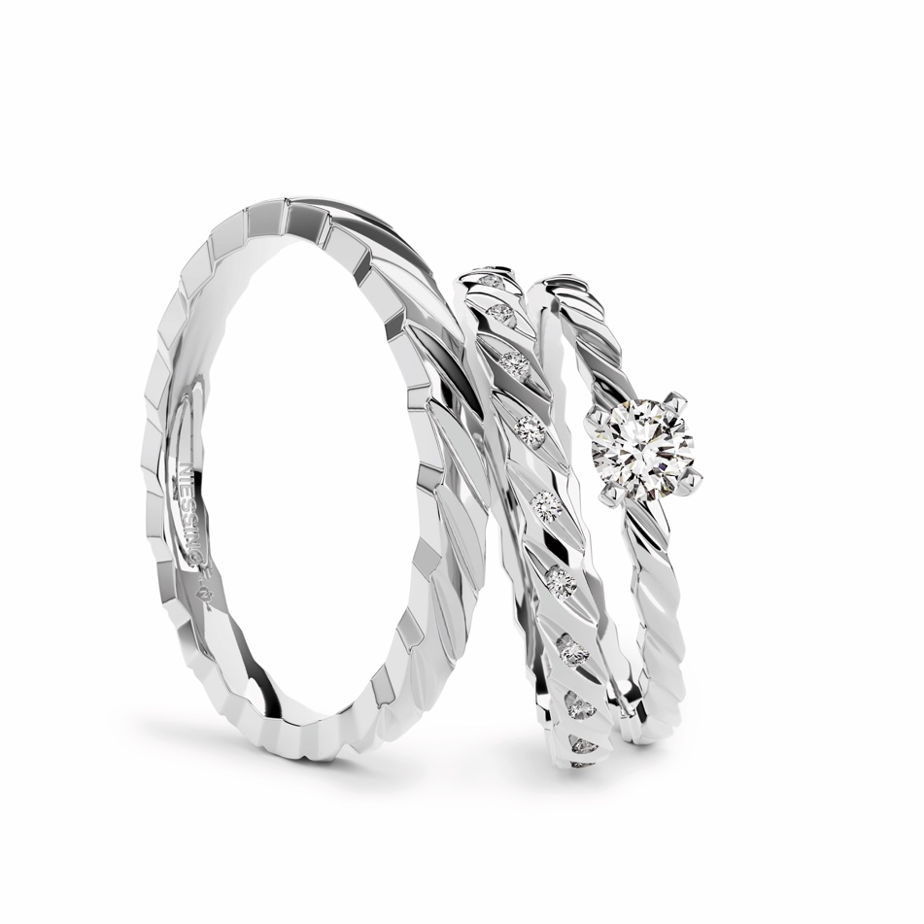

TC Niessing Woven Love Story Ring

NIESSING WOVEN LOVE
Wedding ring, jewelry ring and engagement ring

SLOGAN
NIESSING WOVEN LOVE - connected for eternity
NIESSING WOVEN LOVE - The infinite bond of love
NIESSING WOVEN LOVE - Forever interwoven

ESSENCE
Niessing Woven Love – connected for eternity

The unique wedding rings and engagement ring of the Niessing Woven Love triset embody the timeless bond between two hearts, encapsulated in artistic wedding rings and an accompanying engagement ring. The Woven Love rings not only symbolize the continual development and strengthening of love over time but also signify constancy.

The triset symbolizes the inseparable bond between two souls and bears witness to a love strong enough to withstand challenges and grow ever closer together.

IDEA
The unique wedding rings and engagement ring from the Niessing Woven Love triset embody the timeless bond between two hearts. The artfully woven wedding rings and the engagement ring are symbols of a love that is destined to last forever. The appearance of corded rings represents the constant development and strengthening of love over time. The shape of the rings is delicate and gently flowing.

The Niessing Woven Love triset embodies the essence of the unique Niessing heritage. These special wedding rings are part of our Heritage collection, reissued and reworked for modern times. The Woven Love engagement ring harmonizes seamlessly with the wedding rings. The artful interweaving of the rings defines their shape and symbolizes the inseparable bond between two souls. When worn, both rings nestle gently against each other, making Niessing Woven Love a powerful symbol of love.

The Woven Love engagement ring presents the diamond in a delicate setting that floats gracefully above the ring.

The Niessing Woven Love rings draw their inspiration from Niessing's heritage, which has been creating masterpieces of wedding rings for generations.

FEATURES
The artful interweaving and filigree shaping imbue the wedding rings and engagement ring with a unique, aesthetic lightness and elegance.

Niessing Woven Love stands for the endurance of love, symbolized by a fine textile cord that binds endlessly. The artful interweaving represents the inseparable bond between two souls that is strengthened over time.

The inspiration for these masterpieces is drawn from the rich heritage of Niessing, who has been producing outstanding wedding rings for generations.

The graceful presentation of the brilliant-cut diamond on the engagement ring, floating in a delicate setting, creates a radiant highlight. Niessing Woven Love thus embodies not only a piece of jewelry but also a timeless tale of the everlasting bond between two people. The textures Satin and Gloss are available in Niessing Platinum and in many Niessing Colors.

Vreden, January 2024

