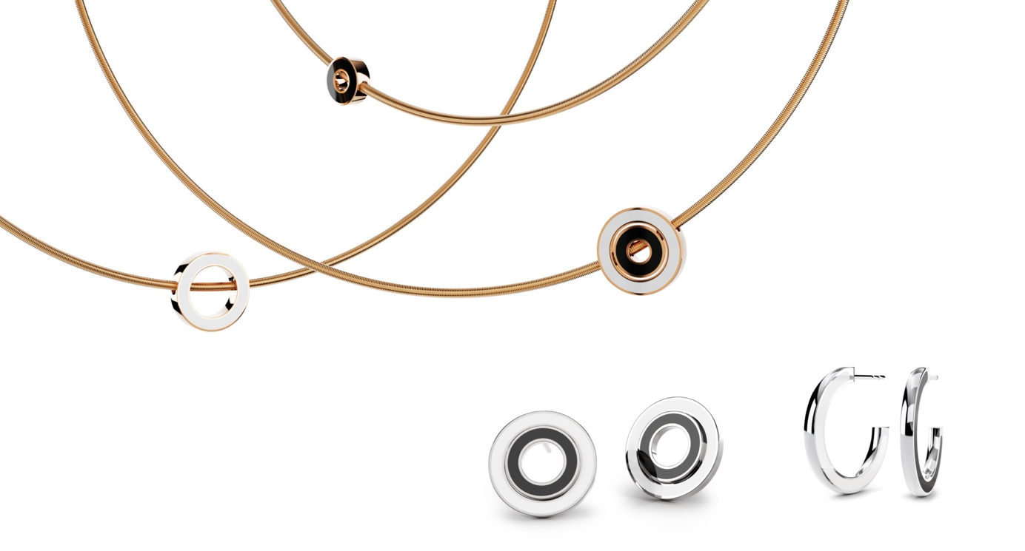

TC Anniversary Collection Setario

NIESSING SETARIO ANNIVERSARY COLLECTION
Jewelry rings

SLOGAN
NIESSING SETARIO JEWELRY KISSED BY COLOR.

ESSENCE
The Setario Anniversary Collection, »Niessing Setario Jewelry Kissed By Color«, celebrates 50 years of outstanding jewelry design by reinterpreting the design classic. Setario has been setting standards for half a century. Niessing proudly presents a collection inspired by timeless Bauhaus design.

IDEA
The Setario Anniversary Collection combines 50 years of innovation and craftsmanship in a bold expression of creativity and style. The collection is characterized by clear shapes and exciting enamel colors that reflect the graphic heritage of Bauhaus design. The centerpiece are pendants that combine Niessing gold with colored enamel and can be worn and combined in multiple ways.

FEATURES

NIESSING SETARIO PENDANT
The pendants are undoubtedly the heart of the collection. They consist of two differently sized circles that cleverly combine the beauty of Niessing Gold with colored enamel. Both the alloy and the enamel color can be selected following your individual taste. The circles not only offer aesthetic splendor but also versatility in how they can be worn - they can be worn together, next to each other or separately. The possibility of combining them with other pieces of jewelry such as cylinder setting pendants or Niessing spheres expands range of variations and emphasizes the uniqueness of the collection.

NIESSING SETARIO CREOLES
The hoop earrings are an innovative statement with colors on the inside and outside. Simply switch sides and your look changes - a game of contrasts and harmony. Available in two sizes, they symbolize individuality.

NIESSING SETARIO STUD EARRINGS
The stud earrings, consisting of two circles, can be playfully combined. Countless combinations of our Niessing Colors and exciting enamel colors are possible. Create as you please.

MATERIAL AND WORKMANSHIP
The anniversary collection is characterized by high quality. Each piece is
made from an ingot and consists of solid precious metals. A mat or gloss
surface can be chosen to emphasize your personal style.

PLACE OF MANUFACTURE
The pieces of jewelry are created using the finest goldsmith craftsmanship in the manufactory in Vreden. Each piece is crafted with the utmost precision and attention to detail. The enamel, mixed by hand from color pigments and applied very thinly, is characterized by exceptional color quality and radiant brilliance. Small diamonds are hand-set into the enamel with the utmost expertise, and the play of light and color is fascinatingly emphasized.

The Niessing Setario anniversary collection is an expression of appreciation for 50 years of passion, innovation and beauty in jewelry design.

Vreden, January 2024

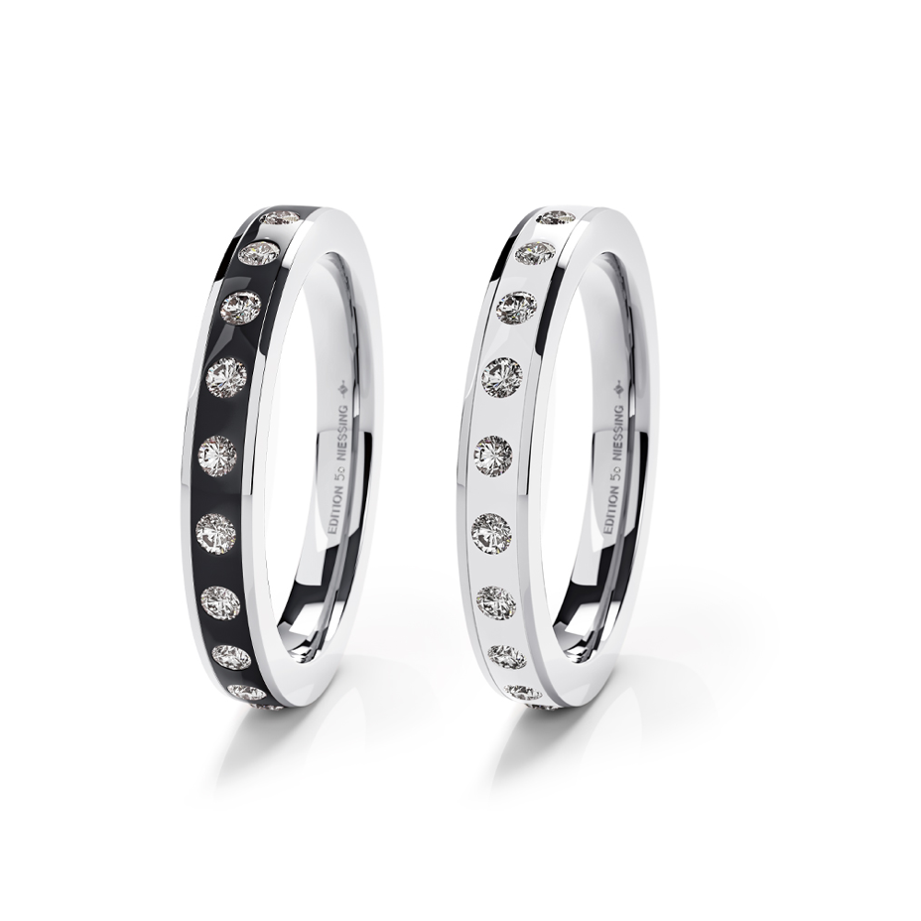

TC Special Edition Setario
NIESSING SETARIO EDITION 50TH ANNIVERSARY
Jewelry rings

Essence:
The Niessing Setario special edition "NIESSING SETARIO EDITION 50TH ANNIVERSARY" is an essential must-have that captures the timeless beauty of black and white in masterfully crafted platinum rings. This limited-edition collection, characterized by artful contrasts and a clear separation of light and shadow, not only celebrates the Setario Anniversary year, but also sets a new standard in jewelry design. In a world flooded with stimuli, this edition rises as an unshakeable constant and speaks a timeless language of style.

Idea:
Inspired by the beauty and expressiveness of black and white, two Setario Edition rings were created to mark the anniversary. Niessing unites these fundamental contrasts of the universe to create a clear distinction between light and shadow. The Edition ring embodies not only the contrast, but the purity and clarity that these colors radiate as well.

Features:

- Edition rings: The Setario Edition 50 Black and White rings are crafted by master craftsmen in the Vreden manufactory and bear the "950 platinum" stamp, signifying the highest quality and craftsmanship. These rings are adorned with the "Anniversary 50" logo and diamonds on the inside. The platinum alloy imparts a clear, moonlit white tone to the rings, showcasing the exceptional purity.

- Black & white combination: Niessing presents two tonneau-shaped, highly polished rings that epitomize the essence of the black and white contrast. The first ring, crafted from platinum, features black enamel accents and white diamonds. The second ring embodies the purity of white by combining platinum with pearlescent white enamel and radiant diamonds. The simplicity of black and white often speaks louder than any color.

- Design concept: This special edition celebrates the secret of good design, which often lies in the harmonious interplay of black and white. It symbolizes the duality of opposites that complement each other—a timeless language of style celebrating day and night.

Comment:

The Niessing Setario special edition "NIESSING SETARIO WHERE ICONS UNITE BLACK & WHITE " embodies an irresistible homage to the timeless beauty of black and white. Inspired by Coco Chanel's visionary recognition of the pure harmony of these contrasting colors, the Setario Edition 50 Black and White ring presents a captivating union of sophistication and clarity. This limited-edition collection celebrates not only the Setario Anniversary year, but also the timeless appeal of the black and white combination. With carefully crafted platinum rings that reveal the secret of good design, this special edition offers understated elegance and purity that transcends passing fashions. In a world awash with stimuli, this edition rises as an unshakeable constant in the realm of design, speaking a timeless language of style. The duality of black and white, symbolized by artful contrasts and clear separation of light and shadow, makes this edition an essential must-have for anyone who appreciates the simple beauty and cultural significance of these timeless contrasts.

Product information
NIESSING COLETTE C SETARIO

DISCOVER THE MAGICAL KISS OF COLOR

Immerse yourself in the fascinating world of colors with the new Colette C Setario pendant. This unique charm pendant is inspired by the famous Niessing jewelry classic Setario, which has undergone a modern interpretation in its anniversary year.

The Colette C Setario charms are the perfect way to add a joyful splash of color to your Colette C charm collection. The intricate rings made of gold or platinum, in combination with exclusive enamel colors, add colorful accents to your Colette C bracelet.

You can combine the Setario pendant with other Colette C charms. The variety of colors will inspire you to create a unique piece of jewelry every day.

Discover the magical versatility of Colette C Setario – a tribute to the interplay of colors and shapes.

Collect, explore – and discover the magical kiss of color!

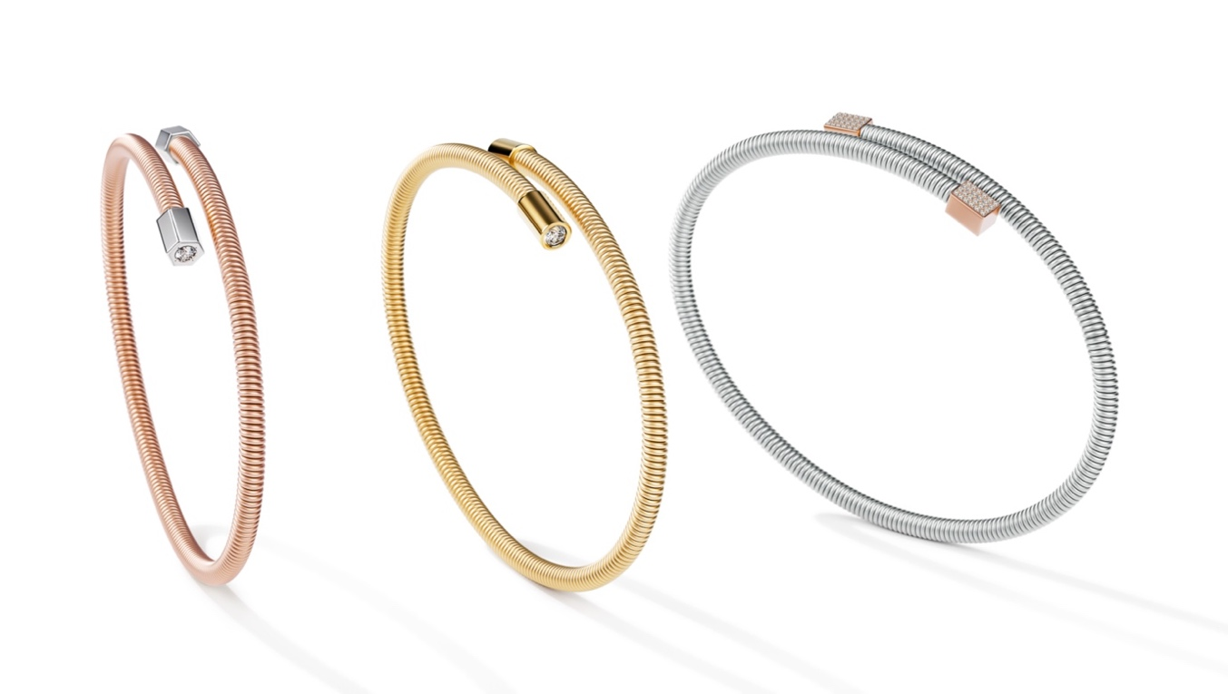

TC Niessing Colette Elementyx
NIESSING COLETTE ELEMENTYX
Bracelets

Niessing Colette Elementyx: A new dimension is born!

ESSENCE
Discover the unique world of the Colette Elementyx jewelry collection - a true masterpiece inspired by the timeless design language of Bauhaus architecture. Colette Elementyx fascinates with its sensual yet minimalist design that radiates a powerful presence. An icon of timeless style, Colette combines design, aesthetics and perfection. Handcrafted with the highest precision "Made in Germany", the new bracelet embodies the minimalism of absolute understatement. Each piece of jewelry is more than just an accessory; it is an expression of your individuality and personality. Enter a new dimension and discover how you can express your uniqueness with Colette Elementyx.

Experience your own dimension with Colette Elementyx!

Colette Elementyx - Innovation meets personality.
Colette Elementyx - Unmistakable. Individual. Authentic.
Colette Elementyx - Expressive. Powerful. Self-confident.

A MASTERPIECE OF YOUR INDIVIDUALITY
The combination of the Niessing cord with geometric shapes makes Niessing Colette Elementyx a milestone in purist design. The innovative soul and the personalization by selecting elements in different shapes, Niessing Colors and individual engravings give the jewelry a unique

characteristic. Colette Elementyx is not just an accessory, but a personal statement that unites tradition and innovation in a unique way. A masterpiece of your individuality.

A TECHNICAL MASTERPIECE
with a diameter of 3.2 mm and an innovative core, Colette Elementyx is an avant-garde piece of jewelry that makes a clasp superfluous. Thanks to the elasticity and memory function of the core, the bracelet retains its aesthetic shape.

COLETTE BRACELETS FOR YOUR UNIQUE PERSONALITY
Design your bracelet according to your individual wishes. With a variety of customizable options, your piece of jewelry will be a true expression of your individuality and style.

Find your favorite design!

Two different bracelets

CHOOSE FROM TWO DIFFERENT DESIGN VARIANTS
An open design presents itself with a dynamic space between the two elements – a modern and minimalist design for those who prefer subtle yet striking jewelry. The perfect choice for a unique expression.

A closed design is characterized by parallel cords that give it a dynamic and powerful appearance. This variant invites you to collect pendants and adds a unique touch to your personal style.

Create your incredible Look!
Choose the right Niessing Color to give your Colette Elementyx a unique touch. Immerse yourself in the world of Niessing Colors and select the color of your Niessing coil. From Fine Rose, Rosewood and Classic Red to Platinum and Classic Yellow, you have a wide range of gold colors to choose from. The innovative Anniversary Color Supla Grenadine, which combines gold with a platinum heart, is particularly outstanding.

Form, Color and Diamonds!

Opt for caps in hexagon, cube or cylinder shapes to give your bracelet a special character. The clear geometric shapes harmonize perfectly with the minimalist design of the Niessing coil. Choose contrasting accents that underline the design and add extra sparkle. Brilliant-cut diamonds and diamonds set on the side in front of the cap create radiant accents. Complete your design with the option for an individual engraving!

Niessing Colette Elementyx is more than just jewelry - it is a personal statement, an expression of individuality and style. Customize your piece of jewelry according to your wishes and wear a masterpiece that combines tradition and innovation in a unique way. Your Colette bracelet will become a unique companion that tells your story and expresses your personality in a striking way.

Vreden, February 2024

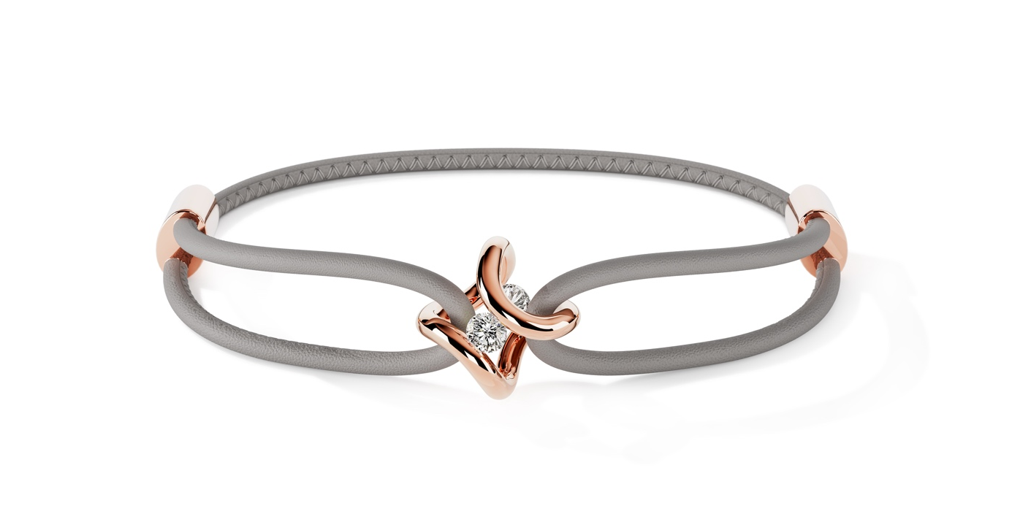

TC NIESSING SPANNRING® ERA BRACELET

NIESSING SPANNRING® ERA BRACELET
Bracelet

SLOGAN
NIESSING SPANNRING® ERA BRACELET – charming look of a new era

Essence: The Niessing Spannring® Era arm jewelry embodies an homage to the original shape of the Niessing Spannring, reinterpreted in a spectacular manner. The iconic shape, organically curved into two fine arches, gently and securely holds two diamonds. The double-looped, fine leather strap echoes the infinite shape and transforms the bracelet into a stylish everyday companion - extravagant, casual, bold, and light. A fusion of contemporary nonchalance and iconic design, prepared to be the original of a new era.

Idea: The idea of the Niessing Tension Ring® Era bracelet is a spectacular redesign of the original shape of the Niessing tension ring. Organically curved into two fine arches, the shape holds two diamonds. The double-looped, fine leather strap echoes the infinite

shape and makes the bracelet a stylish companion. Paying homage to its deep roots in Bauhaus, Niessing celebrated the 150th anniversary of
the manufactory with a design that transforms the Niessing Spannring® into an opulent statement ring and fascinating pendant.

Features:
- Organic shape: The iconic shape of the Niessing Spannring® Era bracelet is organically curved into two fine arcs that gently and securely hold two diamonds.
- Double-looped leather strap: The fine, double-looped leather strap echoes the infinite shape of the jewelry and creates a stylish, casual look.
- Variety of materials: Niessing offers Platinum and Gold in various colors, including Classic Yellow, Classic Red, Fine Rose, Rosewood, and Supla Grenadine. Various surface textures such as Gloss and Nature offer additional customization options.
- Sustainable materials: The straps are made from European organic nappa leather, processed using vegetable tanning and heavy metal-free dyeing. Certifications such as the IVN certificate and ECARF certification stand for the highest quality and unlikeliness of an allergic reaction.
- Individual clasp: The sliding clasp allows easy operation and individual size adjustment of the bracelet. The clasp can be made in Niessing NOW silver or in the same Niessing Color as the pendant.

The Niessing Spannring® Era bracelet is an impressive fusion of modern nonchalance and iconic design that completely redefines the look of the Niessing Spannring®. This piece of jewelry, paying tribute to its deep roots in Bauhaus, celebrates the 150th anniversary of the manufactory and presents itself as an opulent statement ring and fascinating pendant. The double-looped bracelet, held by the infinite shape of the jewelry, is ready to shape a new era in style.

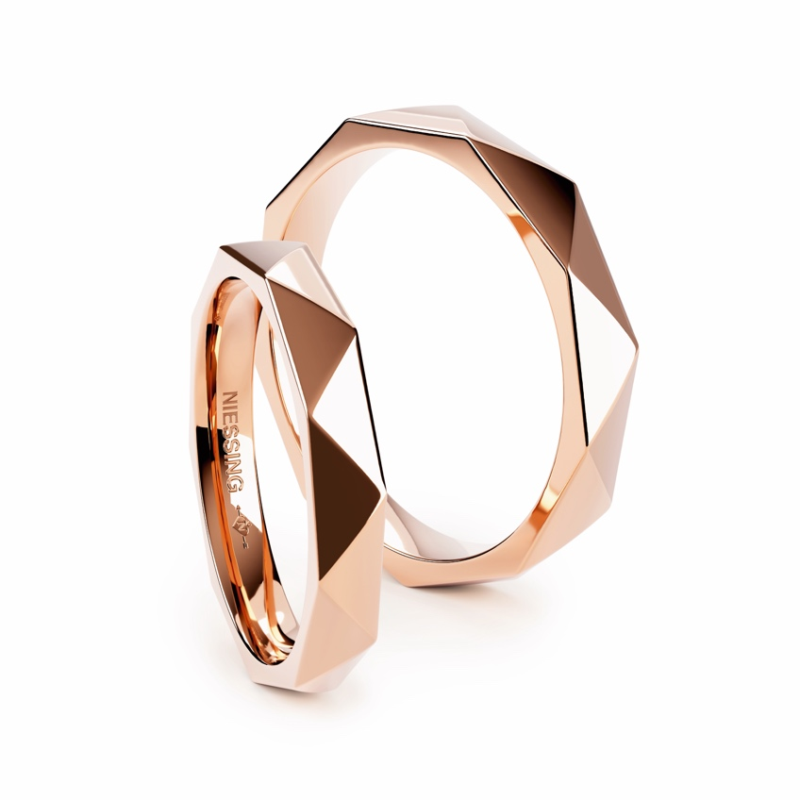

TC Niessing Triangle Love Story Ring

NIESSING TRIANGLE
Wedding ring and jewelry ring

SLOGAN
Niessing Triangle - As multifaceted as your love
Niessing Triangle - A symbol of stability and solidarity
Niessing Triangle - As multifaceted as your love

ESSENCE
Niessing Triangle - A three-dimensional journey
The triangular geometry of Niessing Triangle wedding rings symbolizes not only a bond but also a journey through space and time. In line with the Bauhaus philosophy, they embody the art of love and the harmonious stability of a partnership.

IDEA
Niessing Triangle wedding rings not only form a captivating triangle of precise elements but also reflect the threefold dimension of your love - past, present and future. Like the clear lines and harmonious angles that narrate your shared story, the rings symbolize the foundation of your collective past, future and present.

Matching companions such as Niessing Memory, Niessing Satellite rings or tension rings can be added to emphasize the multifaceted nature of your love. This versatility allows you to highlight different aspects of your relationship.

The geometry of the triangle in the Niessing Triangle wedding rings symbolizes not only the strength and balance of your relationship, but also the three-dimensionality of your journey together. In keeping with the Bauhaus philosophy of combining art and functionality, these rings embody the art of love and the harmony of a steady relationship over time.

The fascinating shape of the Niessing Triangle wedding rings reveals an eternal bond, captured in a triangle of love. These rings are not only an essential part of your shared history, but also radiate in the present and create the basis for a future full of shared moments and adventures.

FEATURES
Niessing Triangle is a wedding and jewelry ring that explores the fascination of the triangular shape. The rings are skillfully crafted from precise triangles, which serve not only as decorative elements but also narrate the story of love. The option to set a diamond within a triangle adds a personalized touch to the rings.

Therefore, Niessing Triangle wedding rings are more than just aesthetic companions; they are a living expression of love, encapsulated in the geometric perfection of triangles.
Textures available include Satin, Velvet, Nature, and Gloss, with a glossy surface further accentuating the striking design language. Available in Niessing Platinum and in a variety of Niessing Colors.

Vreden, January 2024

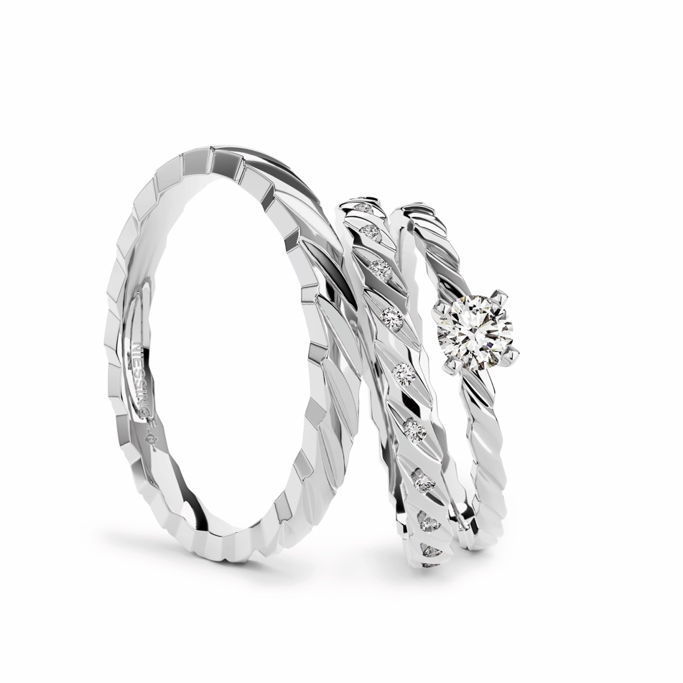

TC Niessing Woven Love Story Ring

NIESSING WOVEN LOVE
Wedding ring, jewelry ring and engagement ring

SLOGAN
NIESSING WOVEN LOVE - connected for eternity
NIESSING WOVEN LOVE - The infinite bond of love
NIESSING WOVEN LOVE - Forever interwoven

ESSENCE
Niessing Woven Love – connected for eternity

The unique wedding rings and engagement ring of the Niessing Woven Love triset embody the timeless bond between two hearts, encapsulated in artistic wedding rings and an accompanying engagement ring. The Woven Love rings not only symbolize the continual development and strengthening of love over time but also signify constancy.

The triset symbolizes the inseparable bond between two souls and bears witness to a love strong enough to withstand challenges and grow ever closer together.

IDEA
The unique wedding rings and engagement ring from the Niessing Woven Love triset embody the timeless bond between two hearts. The artfully woven wedding rings and the engagement ring are symbols of a love that is destined to last forever. The appearance of corded rings represents the constant development and strengthening of love over time. The shape of the rings is delicate and gently flowing.

The Niessing Woven Love triset embodies the essence of the unique Niessing heritage. These special wedding rings are part of our Heritage collection, reissued and reworked for modern times. The Woven Love engagement ring harmonizes seamlessly with the wedding rings. The artful interweaving of the rings defines their shape and symbolizes the inseparable bond between two souls. When worn, both rings nestle gently against each other, making Niessing Woven Love a powerful symbol of love.

The Woven Love engagement ring presents the diamond in a delicate setting that floats gracefully above the ring.

The Niessing Woven Love rings draw their inspiration from Niessing's heritage, which has been creating masterpieces of wedding rings for generations.

FEATURES
The artful interweaving and filigree shaping imbue the wedding rings and engagement ring with a unique, aesthetic lightness and elegance.

Niessing Woven Love stands for the endurance of love, symbolized by a fine textile cord that binds endlessly. The artful interweaving represents the inseparable bond between two souls that is strengthened over time.

The inspiration for these masterpieces is drawn from the rich heritage of Niessing, who has been producing outstanding wedding rings for generations.

The graceful presentation of the brilliant-cut diamond on the engagement ring, floating in a delicate setting, creates a radiant highlight. Niessing Woven Love thus embodies not only a piece of jewelry but also a timeless tale of the everlasting bond between two people. The textures Satin and Gloss are available in Niessing Platinum and in many Niessing Colors.

Vreden, January 2024

