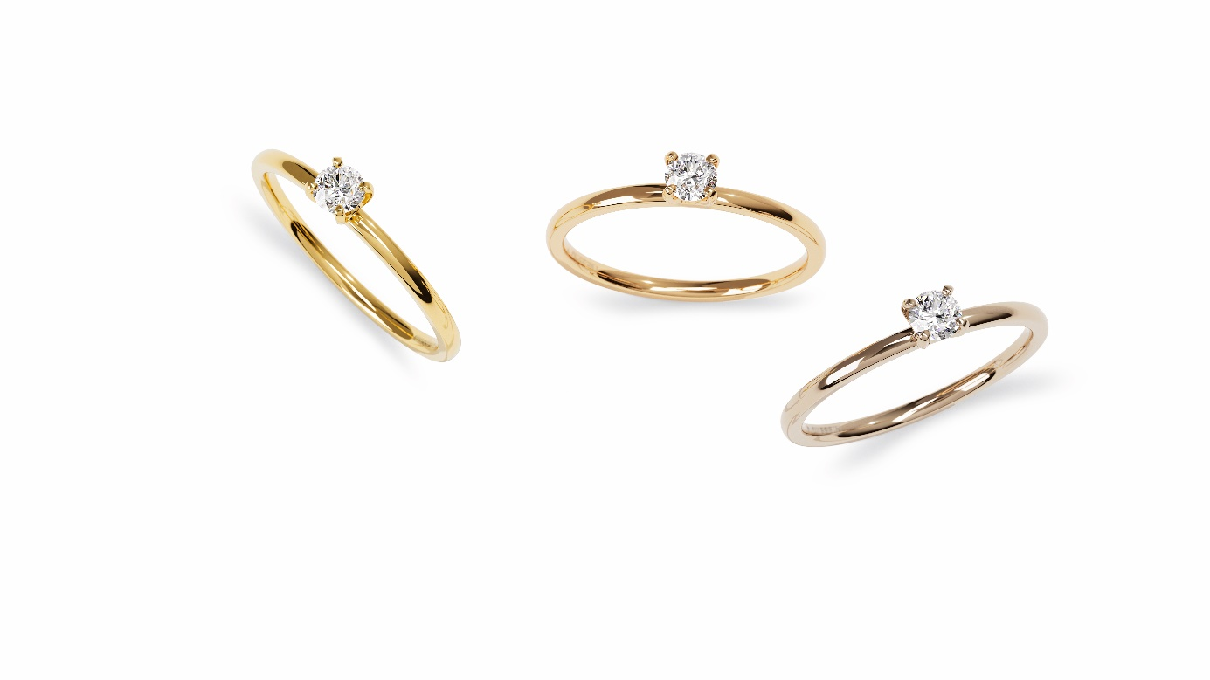

TK Niessing Amatis Fine + Amatis Fine C

NIESSING Amatis + Amatis Fine C

SLOGAN
Inspired by love

We are united in love
United in love – forever and ever

ESSENCE
NIESSING AMATIS FINE A modern Niessing classic in even finer dimensions: Niessing Amatis Fine is an intricate engagement ring with four delicate prong elements that set the stage for the particular beauty of the diamond. Crafted from a single piece of precious metal, it signifies the unique symbiosis of two lovers. It is the perfect companion for the Niessing wedding ring. We are united in love.

NIESSING AMATIS FINE C A gently rounded ring that holds the precious diamond safely and securely in a delicate crown. The four graceful prong elements are slightly curved and make every diamond sparkle perfectly. What lovelier symbol could there be to pledge eternal love?

NIESSING AMATIS Inspired by love. A feminine engagement ring, crafted from a single piece of solid precious metal. Amatis unites finest quality with the pursuit of perfect, holistic form. The Niessing classic with a timeless, clear design now holds diamonds up to 2.0 ct. Amatis is the perfect partner for the wedding ring; a timeless beauty and the embodiment of romance.

IDEA
GENTLE CURVES, FINER PROPORTIONS
The design of Amatis unites the principles of holistic form with pure beauty: a contemporary interpretation of a classic engagement ring. As the Niessing Amatis Fine and Niessing Amatis Fine C, this modern Niessing classic now has finer proportions and gentle curves.

DELICATE PRONGS, NARROW BAND
Niessing Amatis Fine is as gracefully crafted as possible. The four prong elements are particularly delicate, looking modern and even a bit sporty. They hold the diamond securely and magnify its appearance. The ring is narrower than ever before, and it nestles perfectly against its companion, the wedding ring. The sparkling diamond floats high above the hand. A unique ring design for the most important vow: We are united in love – forever and ever.

A PLEDGE OF ETERNAL LOVE
Niessing Amatis Fine is a gently rounded ring that holds the precious diamond safely and securely in a delicate crown. The four graceful prong elements are slightly curved and make every diamond sparkle perfectly. What lovelier symbol could there be to pledge eternal love?

FEATURES
A CLASSIC IN FINER DIMENSIONS
Amatis unites the principles of holistic design with pure beauty: a contemporary interpretation of a classic engagement ring – and now available as Amatis Fine in even finer dimensions.

Niessing Amatis Fine is crafted from a piece of solid precious metal and artfully opened with the latest laser technology in our goldsmith workshop: this is how the ring head opens to set the diamond. Held securely by four prongs: The one-piece design gives the prong elements the highest possible stability.

Niessing Amatis Fine C perfectly accentuates every diamond with its narrow band, rounded on the inside and outside, as well as its slightly curved prong elements.

EXTRA WEARING COMFORT
Both engagement rings are available in Niessing Platinum and in gold in the Niessing Colors Classic Yellow, Classic Red, and Rosewood. The surface textures are either Gloss or Satin. The delicate ring is rounded by hand with great sensitivity on the inside and outside for extra wearing comfort.

Vreden, February 2022

