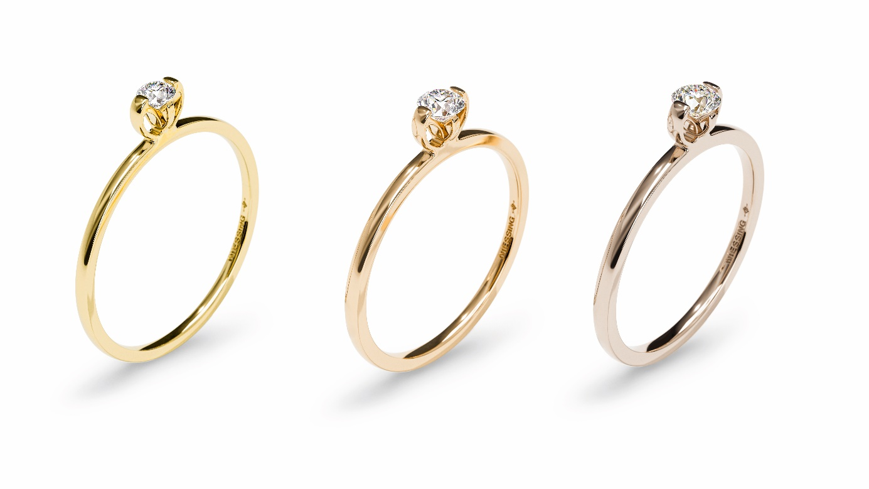

TK Niessing Princess C

NIESSING Princess C

SLOGAN
Princess for my princess

A crown for my princess

This crown makes you the princess of my heart
This crown will protect you forever
Forever yours, my princess
You are my princess for all eternity
You are the princess of my heart
My promise for all eternity

ESSENCE
NIESSING PRINCESS C An engagement ring with new curves: The circular setting floats above the delicate band. Like a miniature crown, it raises the precious diamond high above the hand and lends it a unique presence. Niessing Princess C appears soft and feminine, crowns every vow, and fits perfectly with every Niessing wedding ring: A crown for my princess.

NIESSING PRINCESS A delicate engagement ring in a new dimension, the magnificent diamond appears to be set invisibly with only two prongs. Niessing Princess is the perfect companion for the Niessing wedding ring: thanks to the clearly elevated position of the diamond, the slender ring nestles against its neighbor naturally. Princess for my princess!

The NIESSING PRINCESS COLLECTION takes the unique Niessing Princess design to the next level. The precious diamond is the focus, even with neck and ear jewelry: two fine, rounded strips embrace it, crafted as delicately as possible. Diamond jewelry can hardly be more refined and feminine: This fascinating sparkle magically draws the eye. The Niessing Princess Collection is the perfect bridal jewelry – and it casts a spell of radiance upon every day!

IDEA
A VOW FOR ETERNITY
Geometric clarity gives way to flowing curves: The Niessing Princess C engagement ring takes the unique design of Niessing Princess to the next level and completely reinterprets the modern Niessing classic. The setting consists of two circular elements: The circle, the most elemental of all shapes, stands for infinity, harmony, the origin of all life – and for the two lovers. Could there be a more beautiful symbol of your most important vow?

A CROWN FOR THE DIAMOND
Viewed from the side, the two circles appear like an exquisite, miniature crown: it seems to float above the delicate band, raising the diamond high above the hand. In this way, the Niessing Princess C nestles perfectly against the Niessing wedding ring, placing a magnificent crown upon it: A crown for my princess.

NEARLY INVISIBLE SETTING
When viewed from above, the Niessing Princess C shows two delicate prongs, as in the case of the Niessing Princess, which seem to invisibly hold the diamond: as much diamond as possible, as little precious metal as necessary.

FOREVER YOURS, MY PRINCESS
Niessing Princess C is romantic and delicate; playful and feminine: This crown will protect you forever.

FEATURES
MORE DIAMOND, LESS PRECIOUS METAL
The Niessing Princess C engagement ring takes the design of the classic Niessing Princess to the next level, while retaining its original concept: as much diamond as possible, as little precious metal as necessary.

The ring head consists of two circles that appear like a miniature crown. They embrace the stone, raise it into the air and provide it with more presence: The design of the Niessing Princess C makes the engagement ring the perfect companion for a Niessing wedding ring. When viewed from above, the two delicate prongs seem to invisibly hold the diamond.

FOUR NIESSING COLORS, THREE DIAMOND SIZES
Niessing Princess C is available in Niessing Platinum and in gold in the Niessing Colors Classic Yellow, Fine Rose, and Rosewood. The surface textures are either Gloss or Velvet. The delicate ring is rounded by hand with great sensitivity on the inside and outside for extra wearing comfort. The diamond size is 0.08 ct, 0.14 ct or 0.18 ct, corresponding to the band widths of 1.1 mm, 1.2 mm and 1.3 mm, respectively.

Vreden, February 2022

